Learning for Gorillas Week beginning 03/01/21
Spellings and Reading  Bug Club book reading books  World around Us  Create your own “Iced Sun Catchers”. The instructions and pictures to help are below.  We would love to see pictures of your creations.  Have fun!  Ice Sun Catchers  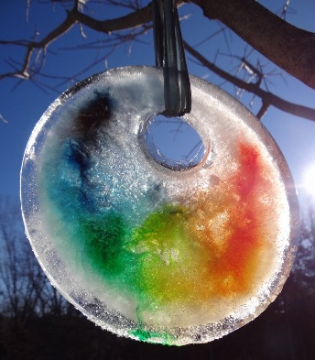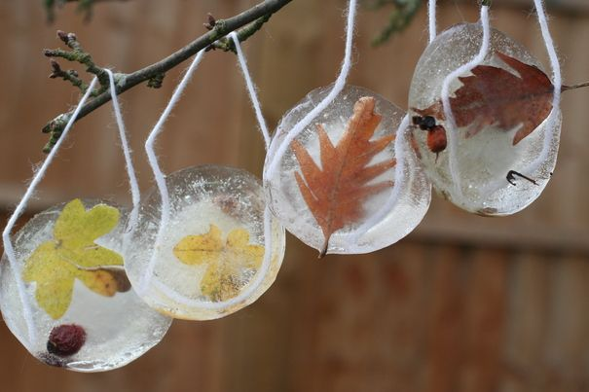  Materials Muffin baking tray/tin, string or wool, leaves, petals, pieces of chopped fruit, water.  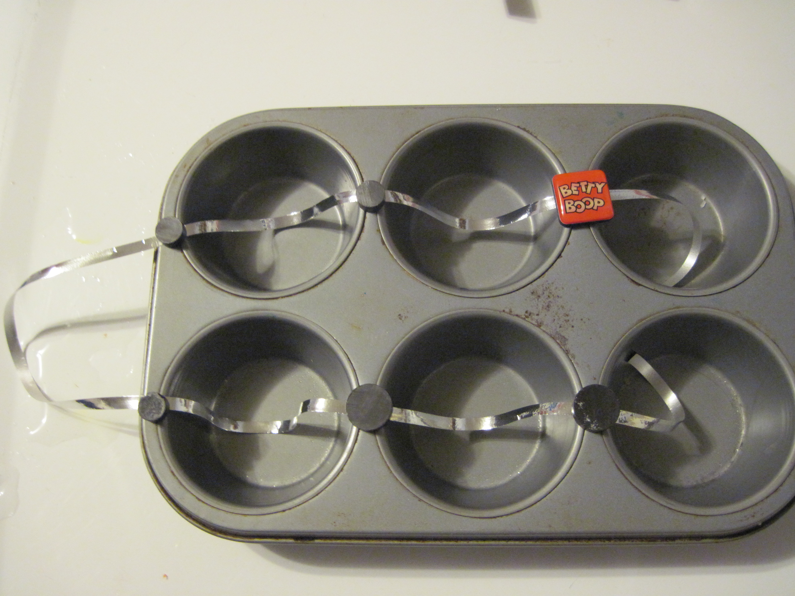  Step 1 Place a piece of string into the muffin tray.  Step 2 place your leaves and petals into the muffin tray and fill with water. Add food colouring if you wish.  Step 3 Place in the freezer for a couple of hours.  Step 4 Remove from the freezer and hang from a tree. Watch the sun light bouncing off the ice.  How long does it take to melt?  Is there a difference on sunny and cloudy days?  Alternatively If you want to go bigger you could use a cake tin and a plastic cup or a plastic bowl and ribbon.  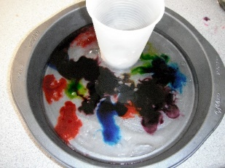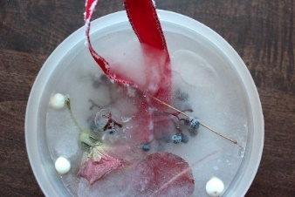  Or if you want to go smaller use ice cube trays. 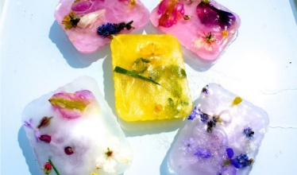 | Numeracy - tables  Tuesday – add 10  10 + 10 =  11 + 10 =  12 + 10 =  13 + 10 =  14 + 10 =  15 + 10 =  Wednesday – add 20  10 + 20 =  11 + 20 =  12 + 20 =  13 + 20 =  14 + 20 =  15 + 20 = | Numeracy - tables  Thursday – add 30  10 + 30 =  11 + 30 =  12 + 30 =  13 + 30 =  14 + 30 =  15 + 30 =
  Term 2 Week 33
  1 Tuesday | 2 Wednesday | 3 Thursday
  int | int | unt
  mint  tint  print  sprint | hint  flint  splint  squint | hunt  blunt  grunt  stunt
  A | B | C
  take  children | ask  letter | help  write
 | Art, PE, Music  On the website in P4 World around Us open Art, PE and Music. Open January Art Lesson – Winter Tree. Enjoy!  Brain Breaks (in Art, PE, Music)  Go to Brain Breaks section of Home Learning in P3&P4 The World Around Us. Click on Can’t Stop the Feeling. Turn up the sound and get dancing! | Religious Education  Go to the RE section of Home Learning in P3&P4 The World Around Us.  Bible Stories – Jonah and the Whale  Watch the Story of Jonah and the Whale.  Write 5 open ended questions to ask Jonah.  Remember open ended questions usually start with – who, where, when, what, why?

