 breakfast  branch

You know the sound you make when you see b
You know the sound you make when you see r
Put them together and you have a new sound br
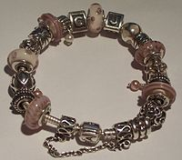 bracelet  brushes

See how many things you can find beginning with our new sound br
Get a page and write br in the middle
Now draw as many things that you can think of beginning with this sound
Some words like “bring” are hard to draw…so just try to write them instead
Or if you have an old magazine you could cut out pictures and stick them on
Can you find 10 things??
Don’t forget you can email me your work or just send me a message!!
mbeatty737@c2kni.net

