This week’s poem is another one by Dennis Lee.
It’s called Bundle-Buggy Boogie!
I like how every word in the title starts with the same sound!
Dennis will explain what the title means before he starts to read. He is from Canada and there is a list of some of the towns in Northern Canada in this poem. They sound really strange to us! But they sound really good in the poem!
Google Childrens poetry archive. Scroll halfway down Home page. Put Bundle Buggy Boogie in search bar. Press and go!!

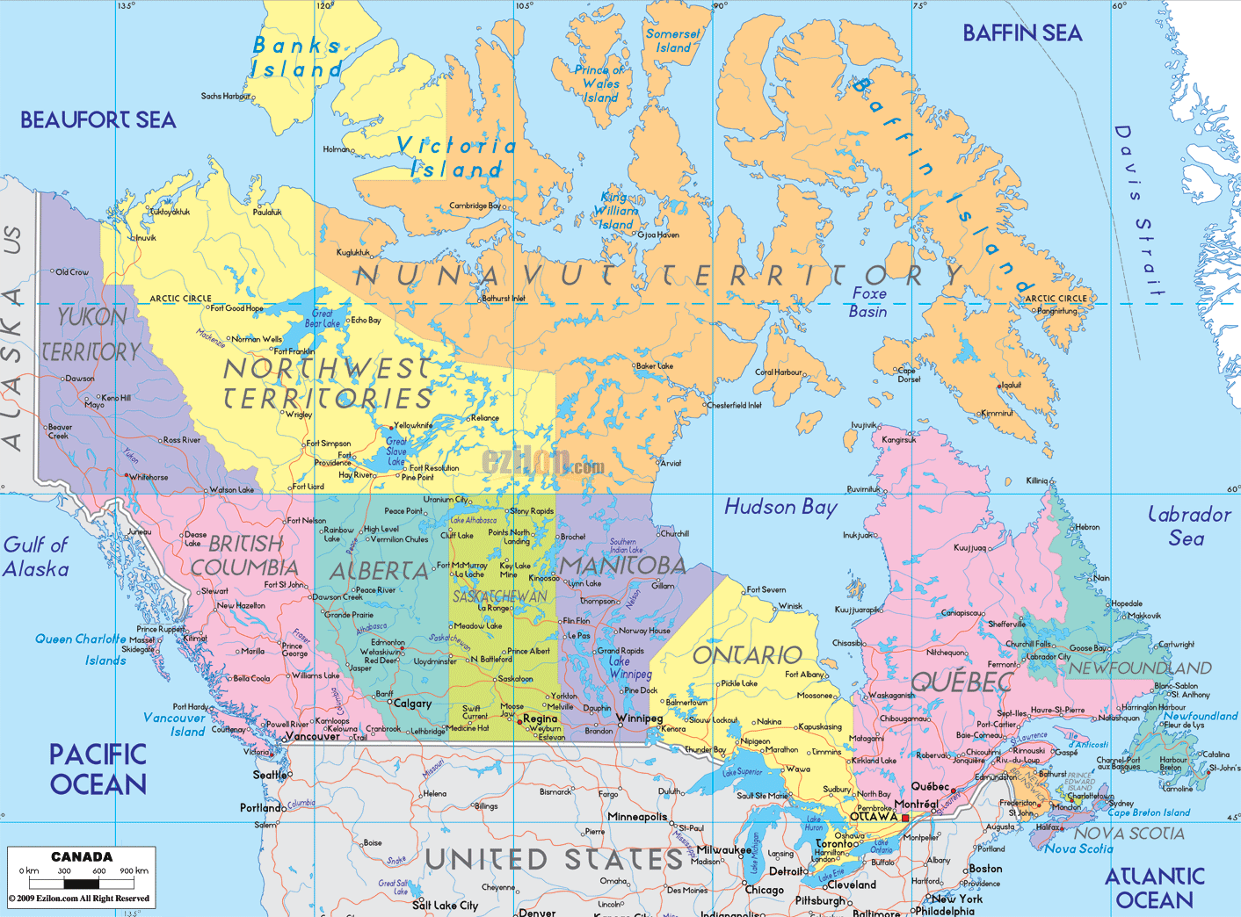

You could google some of the towns in the poem and see if they are on the map above!!-

