Here is a short story for you to read. Remember our Reading Strategies? If you are stuck on a word, try…looking at the picture…thinking of a word that makes sense…looking at the first sound….hop over the tricky word and skip to the end then jump back!!
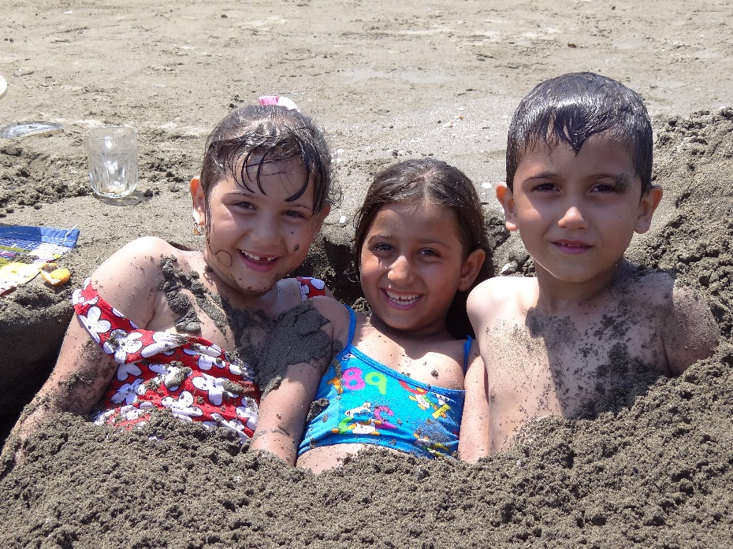
Jenny, Amber and Ben were on holiday. After breakfast, Mum said “OK. Let’s pack up all our things for a trip to the beach”. The children were very excited. Jenny got the tennis rackets and a ball. Amber brought the football and Ben looked for three buckets and three spades.
When they arrived at the beach, they decided to dig a hole in the sand.
“ Let’s see if we can dig a hole that’s big enough for the three of us” suggested Ben . So they began to dig…and dig…and dig!
At last they had a massive hole! In jumped Jenny. In jumped Amber. And last of all, in jumped Ben.
“Mum, mum” shouted Amber “ Come and cover us in sand!”.
And that is what mum did. “ Don’t move till I get my phone” she said, “I ‘ll take a photo and send it to your granny back home. She will laugh when she sees this!”

