When this letter c and this letter r are together they make the sound cr like at the beginning of the word

crash 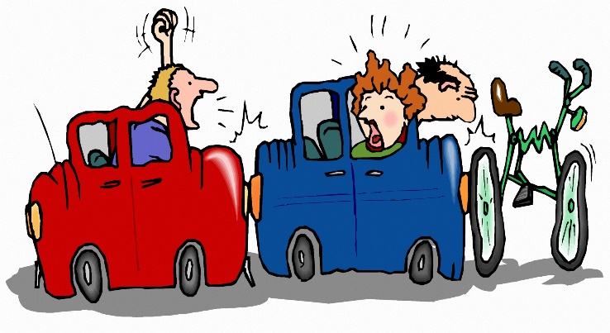

write cr in the middle of your page. Can you find 8 words that start with this sound?

cr

finish the sentence
Look out!! I see a cr___ and it is being chased by a cr____!!

