Junior Newsdesk
This week one of your tasks is to log on to Junior Newdesk, read an article and comment on it.

- Log on to C2K using your log in details.
These were the ones on the white card that you were given in school.
It has your name with a number then a password underneath.
If you haven’t got your password let your teacher know.

- Click on the Newsdesk Icon

- Find Junior Newsdesk at the top right hand side.

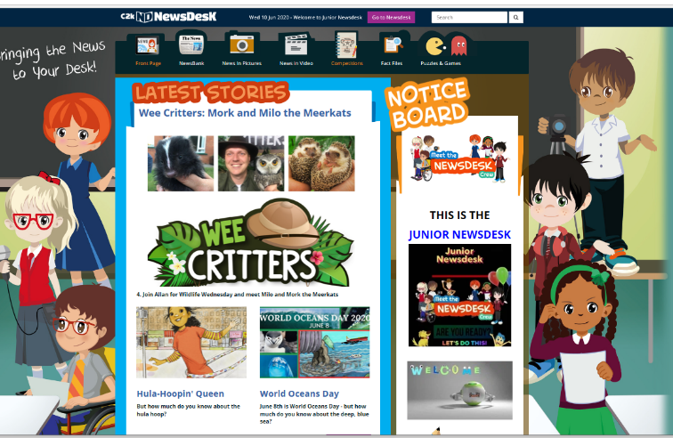
- Click on it.

- Click on Newsbank

- Choose an article to read by scrolling down the list or searching on the left hand side from the article archive.

- You can read the article or listen to it by clicking on the bar at the top.

- Leave a comment on the article. You do this by clicking on the send a comment button.

If you search Space there are lots of really interesting articles! If you want to send in any reports or writing you have done there are instructions in the other documents.
Enjoy!

