How to get your written work published on C2K Newsdesk.
You have two options:
- You can type your article/report straight onto newsdesk and add images from the internet
- You can take a photo of your report/work and save it onto your computer and then upload it to send.
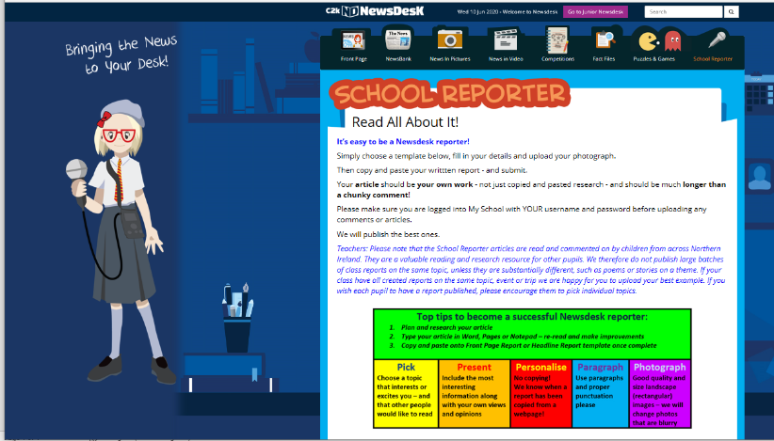
Step 1 – go onto Newsdesk and click the Reporter section ( the microphone)

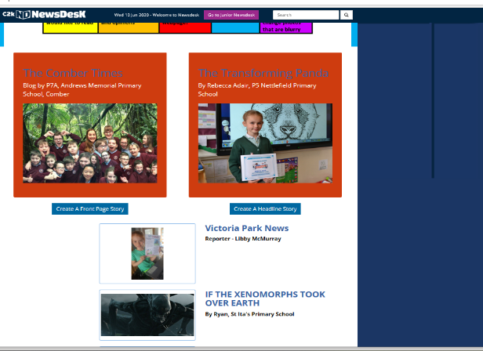
Step 2 -scroll down the page the page and click on CREATE A HEADLINE STORY

Step 3 – either write straight on to the newsdesk page and add images from the CHOOSE IMAGE Browse section. Or having taken a photo of your work and saved it – then you have to go to the CHOOSE IMAGE Browse button and select your work to upload.

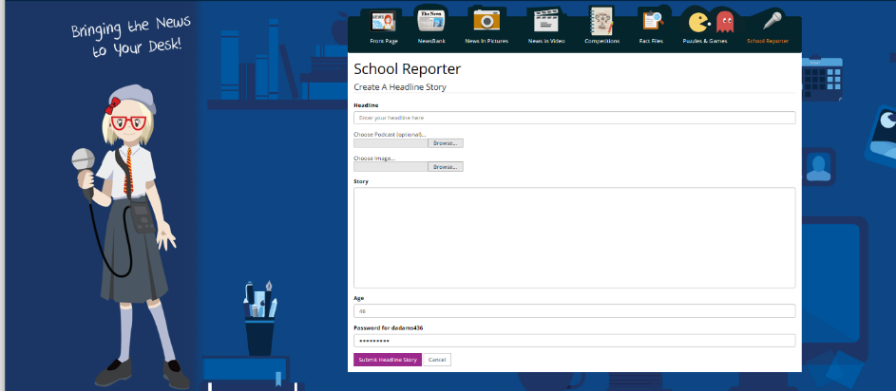

Step 4 – Fill in as much detail as you can (including your school)and finish by adding you age and C2K password – the one you used to log on

We can’t wait to see some of the excellent work on report writing
From Mrs.Adams/ Ms Youde and Miss Dunn
Good Luck

We are talking to C2K about posting some photos of all the amazing things you have been doing/making during Home schooling and hope to get some of those shared in the News in Pictures section! We will keep you posted.

