C2K Newsdesk – Publish your work!
Instructions on how to send any of your photos of great work, or things you have made during Lockdown, to the Newsdesk. They may then Publish it in the News in Photos Bank.
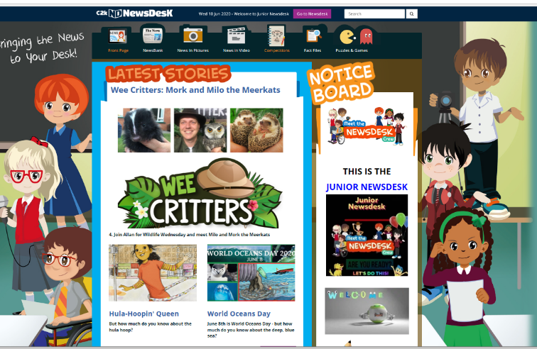
Step 1 -On the main Newsdesk Home page select the Competition Button on the top

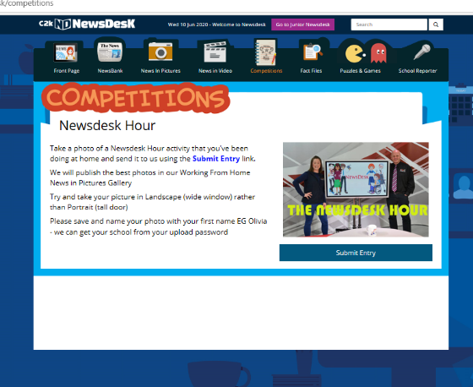
2. The on the competition page select the button that says SUBMIT ENTRY – under the Newsdesk Hour photo.

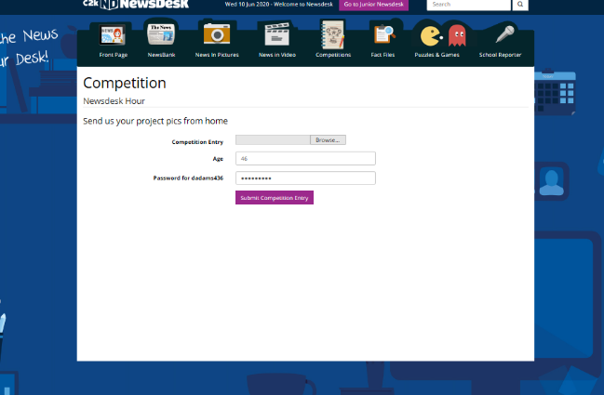
3. Add your saved photo/document from your computer by clicking the Browse Button and complete your age and C2K Password.

Go On Have A Go!!

