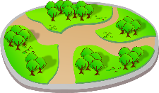

The P4 Vicky Park Trail
The P4 teachers have put together a treasure trail around Victoria Park. You need to do it with at least one adult with you. The trail is on the main path. Follow the yellow arrows and the one-way system around the park. Send a photo of you doing the trail and we’ll post the answers on the website! Write your answers on the sheet or you can just write them on a piece of paper.
Have fun!!!
Start at the Welcome to Victoria Park sign
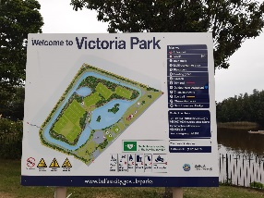
Look at the sign
- How many numbers are on the map?
- What’s at number 3?
- What should you beware of?
Stay on the path by the lake and follow the arrows.
Stop at the sign post.
- How many rivers beneath your feet?
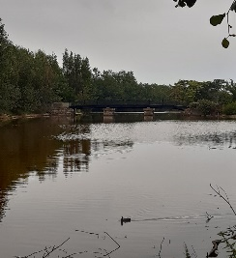
- How many plant pots are there?
- How many bike stands?
- Look back- What colour is the bridge?
- How many arch supports are there for the bridge?

Follow the path around.
When it forks;
- What numbers and letters are on the red and white tipped post?
Go straight on
- How many benches are on the left?
- Look at the crane. How many windows are on the red box on the top?
Look at the wooden post (on your right)
12.What number and letter are on the post?
13. How much is the fine for littering? (on your left)

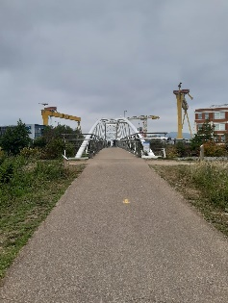
Walk until you reach the path for the Sam Thompson bridge
Look at the sign post.
14. When was the first crane built?
15. What was its name?
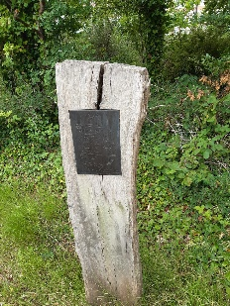
Look for a plaque on a post.
16. Who wrote the poem?
17. What colour are the leaves in the poem?

Walk straight on.
Keep going until you get to the willow archway.
Walk up through it.
Look at the sign on the left.
18. Where does the Connswater river run into?
Look at the sign on the right.
19. Which famous Belfast Born person is on the sign?
Go back to the main path.
Keep walking around.
Look for a metal plaque on the ground
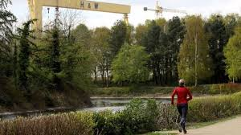
20. If you were running the Parkrun how many metres would you have done?
Walk on until you get to the bin and the bench on your left.
21. What has happened to the picnic table?
Keep walking until you get to the bend in the path.
22. What colour is the shelter on your left?
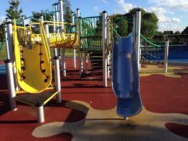
Walk around past the BMX track.
23. What is not allowed in the basketball court?
24. What colours are the slides in the playground?
25. Add together the number of picnic tables outside the play area and the marquee?
Keep walking- almost done! 26. What animal is on the Athletics club sign?
YOU HAVE FINISHED! Well done for finishing our trail! Don’t forget to send a photo.

