Describing an alien
We are going to write a description of an alien using adjectives which we have been learning about in the last few weeks. You can draw your own alien in the box or use the one on the page. I have given you lots of adjectives to help, and there is an example of a description at the bottom. Be really creative and use your imagination! Remember, you don’t have to print this page out, you can do it on a piece of paper.

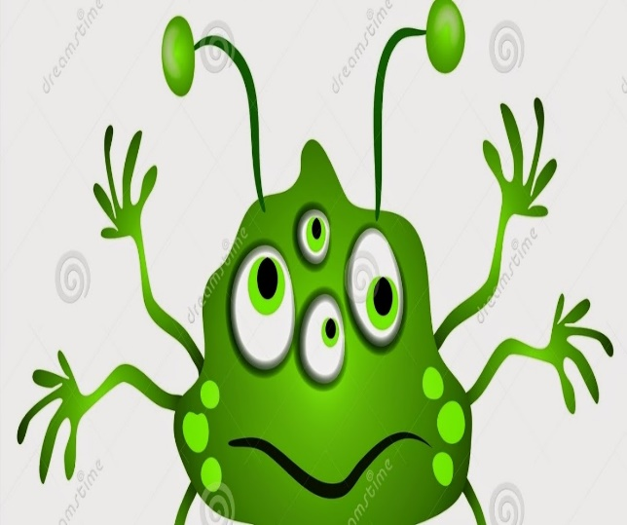

green | wobbly | smooth | rough | happy | spotty
shiny | noisy | sparkly | colourful | tall | thin
friendly | scary | round | short | spindly | unhappy

My Alien Description


This is the alien who landed in a spaceship on the school field. He has green, shiny skin which glistens in the light. He has four bright oval eyes which move around all the time and are all different sizes. He has two pairs of long arms with wriggling fingers at the end of them. His two antennae come right out of the top of his head with two extra swivelling eyes at the end. He has two spindly legs. His mouth is wide and smiling. He looks like a kind and friendly alien who would like to be your friend.

