To P4 Room 7,
I miss you all! So sorry I can’t see you all to say goodbye. Instead I have written a funny poem to remember you all by! Enjoy!
Lots of love Miss Dunn

My Class
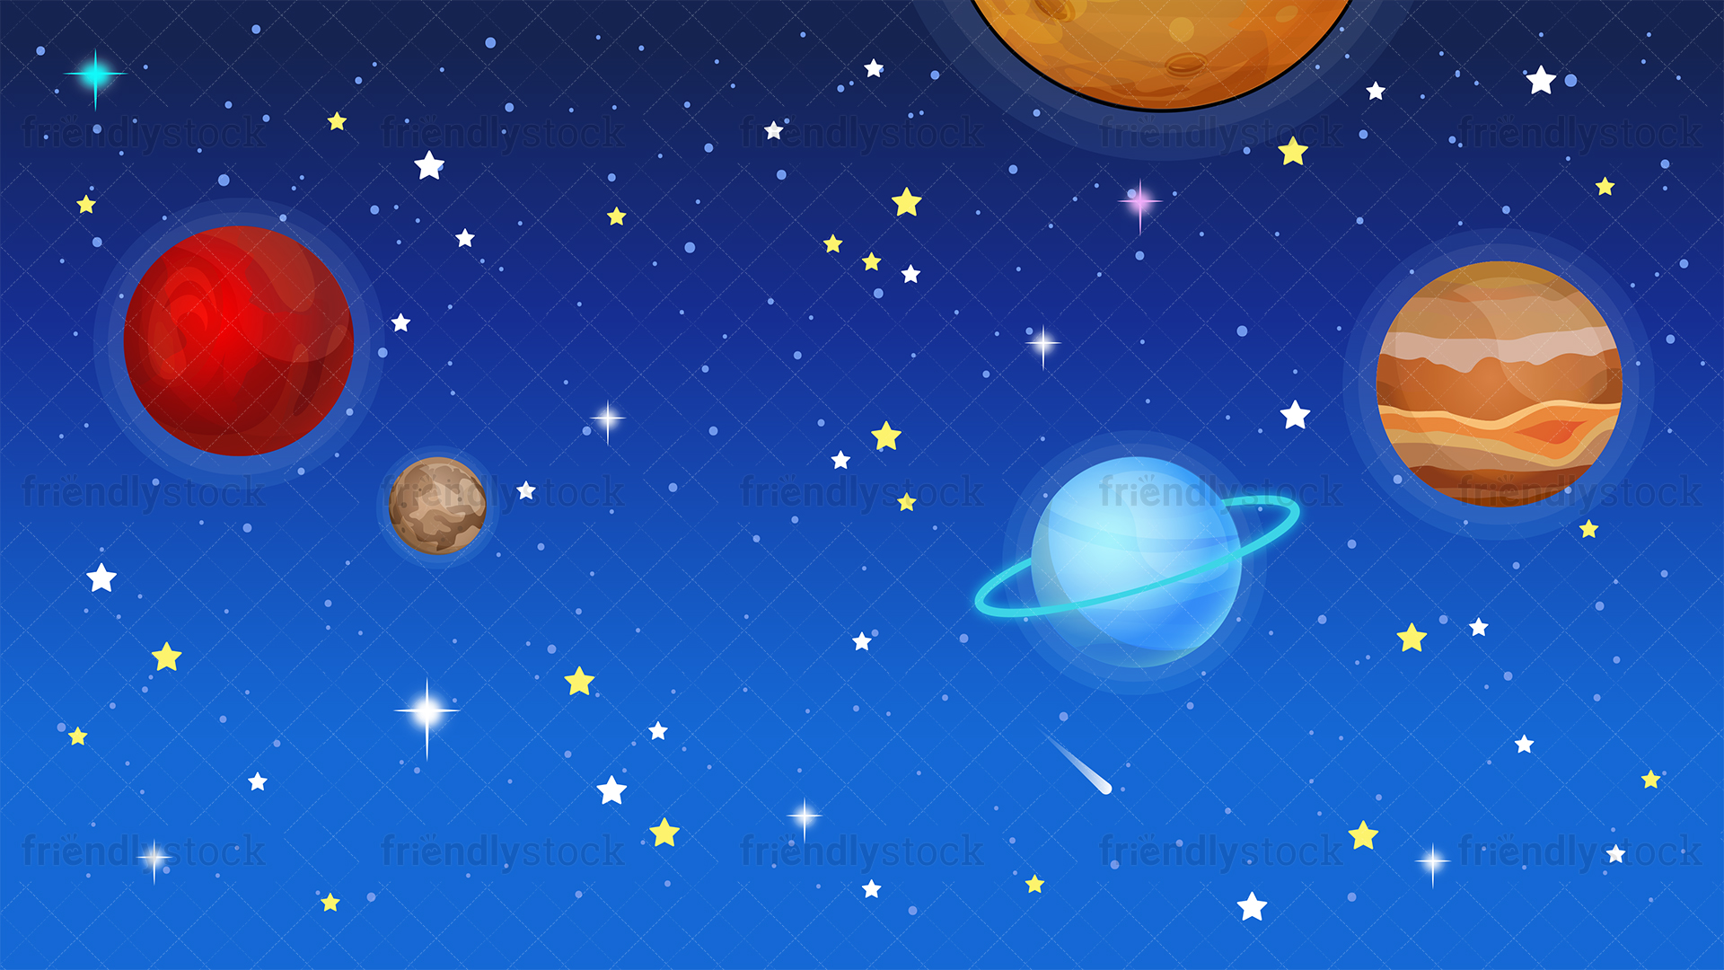
To infinity and beyond,
Flo and Emma will always respond.
Hocus pocus time to focus,
Cayden and Tobbi giggling on the bus.
Mac and cheese everyone freeze,
Lucy and Ryan will always try to please.

Holy moly, guacamole,
Mrs Mornin hates ravioli!
Scooby Doo, where are you?
David and Zak love blue.
Easy peasy lemon squeezy,
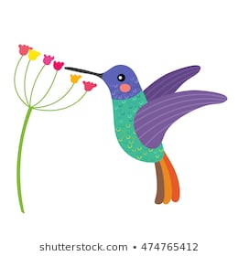
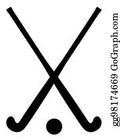
Zoe and Lydia find numeracy easy.
Okie dokie artichokey,
Ted and Brodie enjoy hockey.
What’s the word hummingbird?
Lexie and Abbie came in third.
Ready set, you bet,
Olivia and Emily never forget.
Dinosaurs roar, dinosaurs snore,
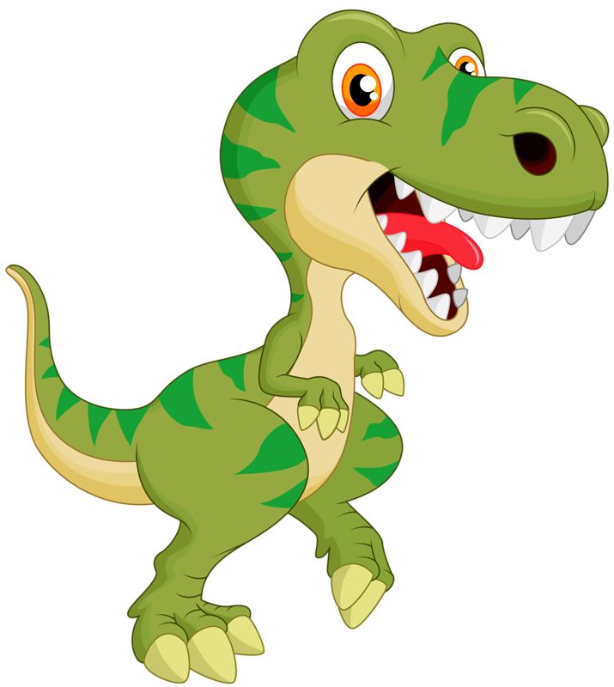
Joshua’s facts never bore.
Hands on top, that means stop!
Selena and Lili are off to the shop.
Hands up buttercup,
Noah wants a new pup.
Yakety yak don’t talk back,

Alan and Drake were good craic!
Zip zip zap we’re all that,
Nicholas and Reuben love to chat.
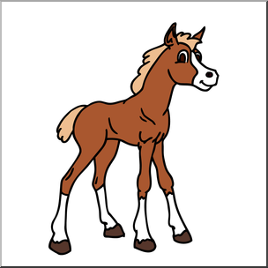
Ready to rock, ready to roll
Abbie-Grace and Aimee dream of owning a foal.
Eeny meeny miny mo,
Ryle and Reece never go slow.

By Miss Dunn

