WALT – write an acrostic poem about BELFAST

Think about all the places we can visit and all the attractions that Belfast has to offer. Remember the famous people we studied from Belfast to!
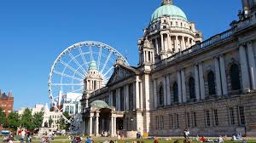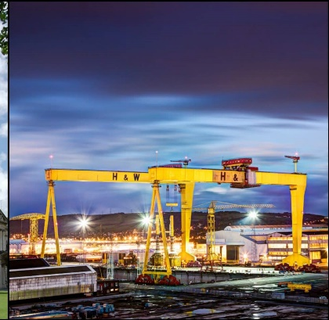

- Write the letters for BELFAST down the side of the page
- Take the first letter B and make up a sentence about Belfast e.g.

Belfast is where the Titanic was built

- Then start the next sentence with the second letter E
Everyone should visit W5 it is amazing!
L
F
A
S
T

