
On Yer Bike
Parent Cycle
Friday 28th^{th} May 10:30am

- Ever wanted to try out the Belfast bikes but unsure how they work?
- Do you know where the community greenway goes?
- Do you want to be more active?
Sustrans are going to take us on a parent cycle down the community greenway. Starting + finishing from their travel hub at CS Lewis Square. No experience needed
- All equipment provided!
Please let me know if you would like to attend
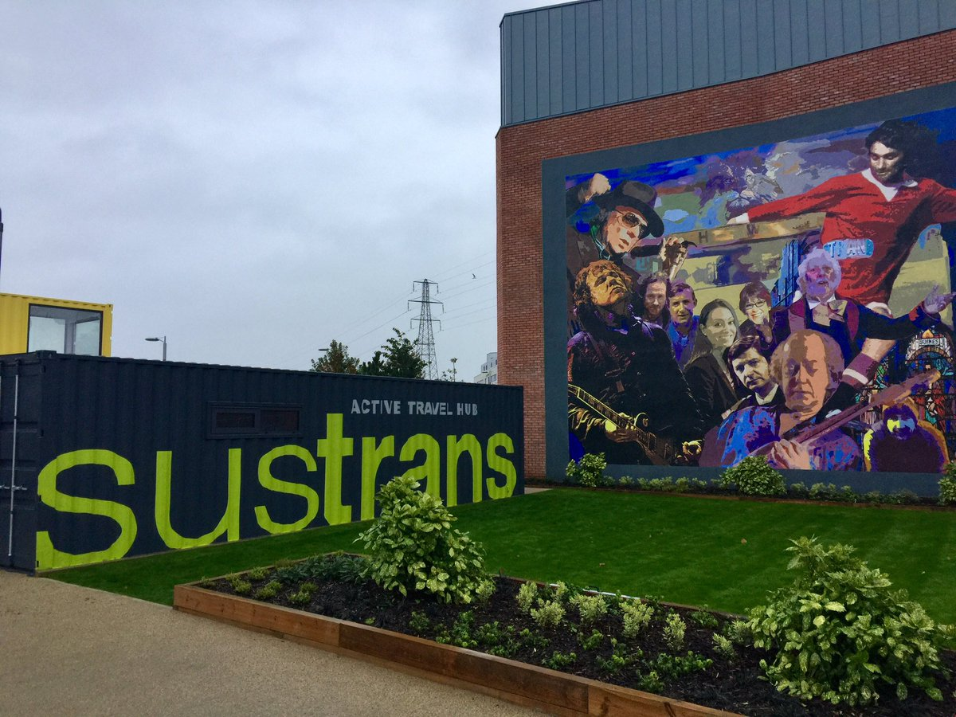
Rhowe534@c2kni.net / 02890471274

