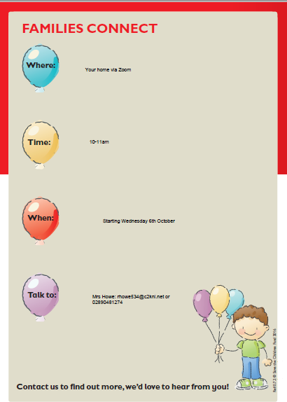
Zoom – Please register with
Mrs Howe
10-11am
Same time each week
Starting Wednesday 6th October.
Additional dates: 13th & 20th October
3rd, 10th &17th November

Mrs Howe: Parent Support Officer
Rhowe534@c2kni.net
02890 471274

