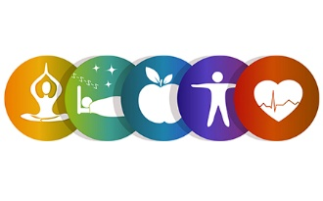
Family Wellness Ideas

It is our Wellness Week once again and we have a range of ideas for you to try as a family.
Recent research conducted by the National Literacy Trust showed that many of us struggle to fit in simple activities such as playing or reading with our children. These things can have huge benefits for both parent and child.
In our own wellness survey last year some parents said it was difficult to get 1-1 time with their children but usually found it easier to help with a child’s wellbeing compared to their own. With this in mind it would be great to try out a few activities to reconnect.
Take 5!
5 seems to be a good number when it comes to wellness, whether it’s taking 5 minutes to recharge, getting our 5 a day.
Our wellness week in school will have a range of opportunities for staff and pupils based on the following areas, Mind, Body, Soul.
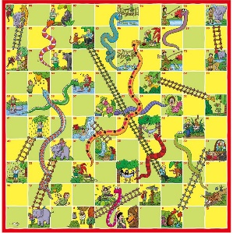

Why not use the week (and beyond) to try a few new healthy habits? Can you pick 5 to try from the suggestions below?

Mind:
- Games: a great way to connect and doesn’t need to be anything fancy. Card Games, scavenger hunt, obstacle course, board games etc. Take your pick!
- Reading: It doesn’t matter if you are 5 or 55, a good book can do wonders! Not sure where to start, head to your local library for lots of recommendations.
https://www.librariesni.org.uk/
- Essential Skills: Last year a number of parents expressed interest in finding out about doing more for themselves. There are lots of options available. Most courses now have a face to face option again but do check with the provider. Most places will have new courses starting in September.
http://greenwaywomenscentre.org/training-education/
https://www.ebm.org.uk/employability/
https://www.belfastmet.ac.uk/part-time/essential-skills/ : Belfast Met will often put on courses in a range of community venues free of charge or for a small donation. Please contact to see where your nearest option might be.

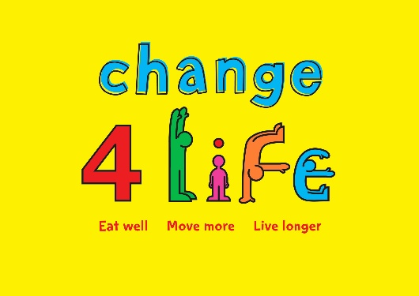
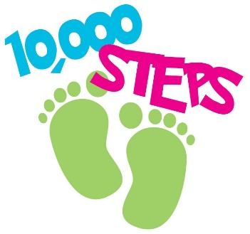

Body
Trying to find ways to eat healthier as a family or be better with your food budgeting. Please see the links below for some good ideas
- https://www.safefood.net/healthy-eating: Great website and often the source for many regional/National campaigns. Lots of tips and ideas for the family alongside good recipes

- https://www.choosetolivebetter.com/; Website designed by the public health agency specific to NI. Lots of simple ideas for healthy lifestyle changes.

Looking for Ways to be more active: See below
- Local Treasure Trails: https://www.connswatergreenway.co.uk/trails - Variety Of local trails, maps can be downloaded on link above or collected from Eastside Visitor Centre and Holywood Arches Library
- https://outmoreni.com/: Interactive website to assist finding places to explore all over NI. Walking, cycling, canoeing, forest parks and many more!
- Step Challenge routes: Please see suggestions below for more routes to increase your step count. Options for 5/10k.
https://www.connswatergreenway.co.uk/connswater-community-greenway-step-challenge-routes
- Jog Belfast: https://www.jogbelfast.co.uk/
Group led couch to 5K, options all over Belfast
- WISPNI: https://www.wispani.co.uk/
- Active Travel Challenge : https://atc.getmeactive.org.uk/content/about ; Thinking about ways to be more active with your journeys. Please see website for more information.
- Sustrans NI: https://www.sustrans.org.uk/about-us/our-work-in-northern-ireland/
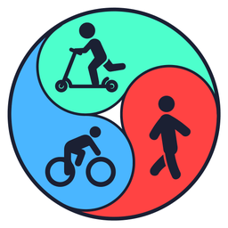
Lots of cycle programmes and active travel assistance. Please see their social media for most up to date events.

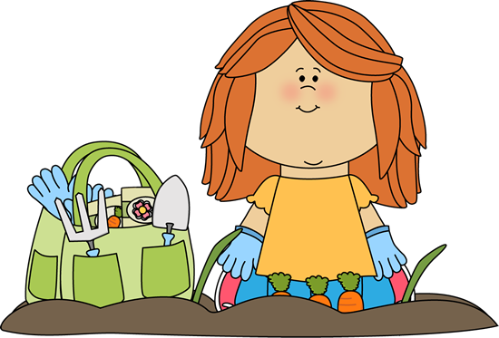

Soul
Financial Wellness
The cost of living is a big thing to contemplate at the moment and can understandably cause a lot of stress and anxiety. Our financial habits start to form at a young age. It is OK to talk to young children about money and let them understand how things work. There are a few useful places to look if you aren’t sure where to start.
- Bank of Ireland: Great resource for talking with young children – Parents guide and savings poster available to download.
https://www.bankofirelanduk.com/personal/what-is-youth-financial-wellbeing/talking-quids-with-ollie/
- NI4Kids Magazine: Useful article for some top tips with involving children
https://edition.pagesuite-professional.co.uk/html5/reader/production/default.aspx?pubname=&pubid=e64ac943-82ac-4861-be70-0b27d69b40c1
- Love Food Hate Waste: Did you know the average family of 4 throws away approx. £60 of food per month, this is over £700 per year. Lots of useful tips, ideas and recipes on how to reduce this waste and hopefully save you some £££.
https://www.lovefoodhatewaste.com/
Other
Garden/Outdoor Activities; Lots of easy activities to try below.
- RHS Family activities: https://www.rhs.org.uk/education-learning/gardening-children-schools/family-activities/activities
- https://ccea.org.uk/growing/about.php
- https://www.gardeningwithchildren.co.uk/
Arts and Craft: It is no surprise that adult colouring in books, jigsaws etc. are becoming more and more popular again. Simple activities can be very calming no matter what your age. If you are feeling very creative and want a few extra ideas have a look below.
- Victoria Park School website: https://www.victoriaparkprimaryschool.co.uk/art-design-ideas/
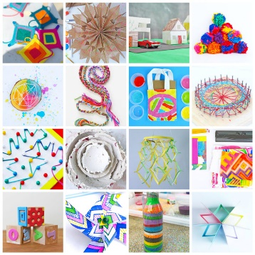
- Baker Ross: https://www.bakerross.co.uk/craft-ideas
- Hobbycraft: https://www.hobbycraft.co.uk/ideas/

