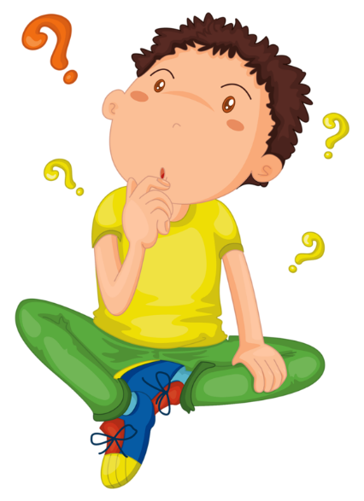
Let’s play “What’s my number?”
My number will have tens and ones.
Ready?? Here we go!

I have 6 tens and 7 ones I have 4 tens and 5 ones
What’s my number? What’s my number?

I have 3 tens and 2 ones I have 2 tens and 1 one
What’s my number? What’s my number?

I have 9 tens and 9 ones I have 5 tens and 6 ones
What’s my number? What’s my number?

I have 1 ten and 3 ones I have 7 tens and 8 ones
What’s my number? What’s my number?

Can you put all the numbers in order from smallest to biggest??

