Adding 10……and then adding 11!!
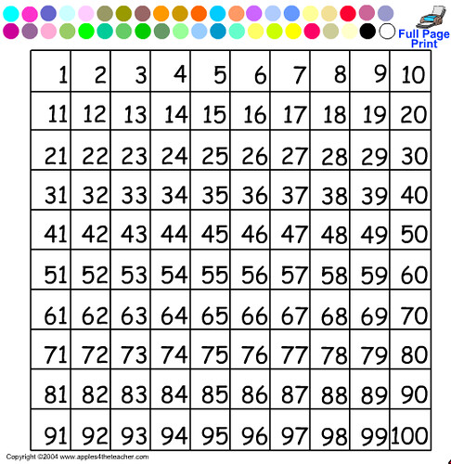

You can use the 100 square above to help you to add 10. Try these!
- 56+10 b) 29+10 c)31+10 d) 85+10 e) 48+10

Did you notice what happens to the tens digit? Yes! It increased by one!!
Did you notice what happens to the ones digit? Yes! It stays the same

If you need to add 11, a good way is to add on 10 first, then 1 more, because 11 is equal to 10 plus one more!
So, if I wanted to know the answer to this sum, 67+11=?,
I would say well, I know that 67+10=77 but now I need to add on one more, so 77+1=78, so the answer to 67+11 is 78. Try these!

- 56+11 b) 29+11 c) 31+11 d) 85+11 e) 48+11

