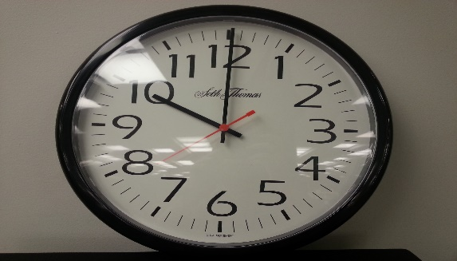
Estimate time in minutes and seconds
This Photo by Unknown Author is licensed under CC BY
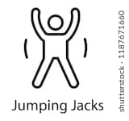

Activity | Estimate | Actual Measurement | Difference
10 star jumps
Write your full name
Say the alphabet
Write the numbers 1-20
Write your name 20 times
Go and get a glass of water and drink it!

