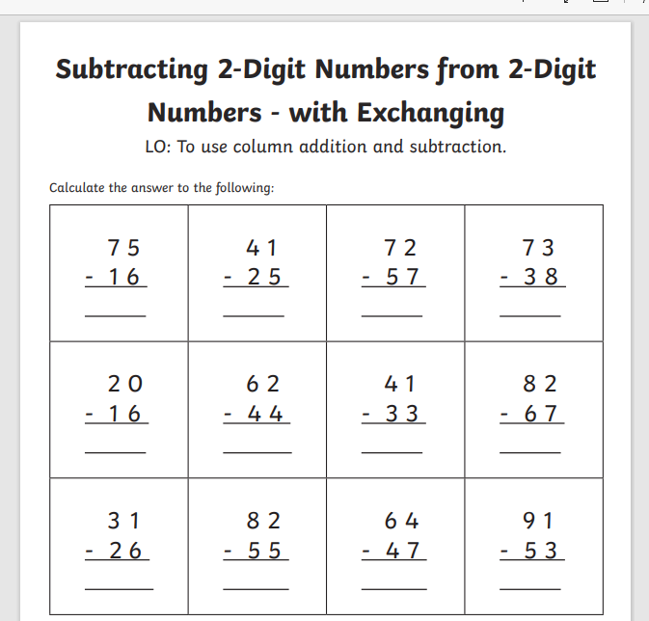

Remember to show your working out. If you need to exchange a TEN you must show that happening in your sums. Look back at videos from last week to remind you.
Write a self assessment comment about this work.
_____________________________________________________________________________

