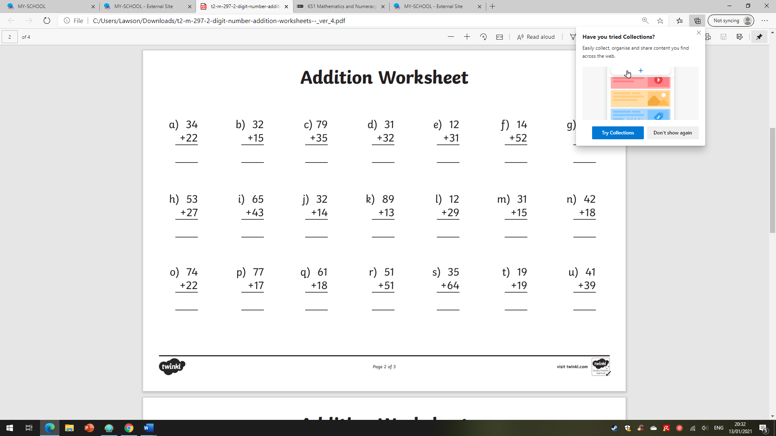
Write a self assessment comment about how you are finding addition with regrouping?

_________________________________________________________________________

