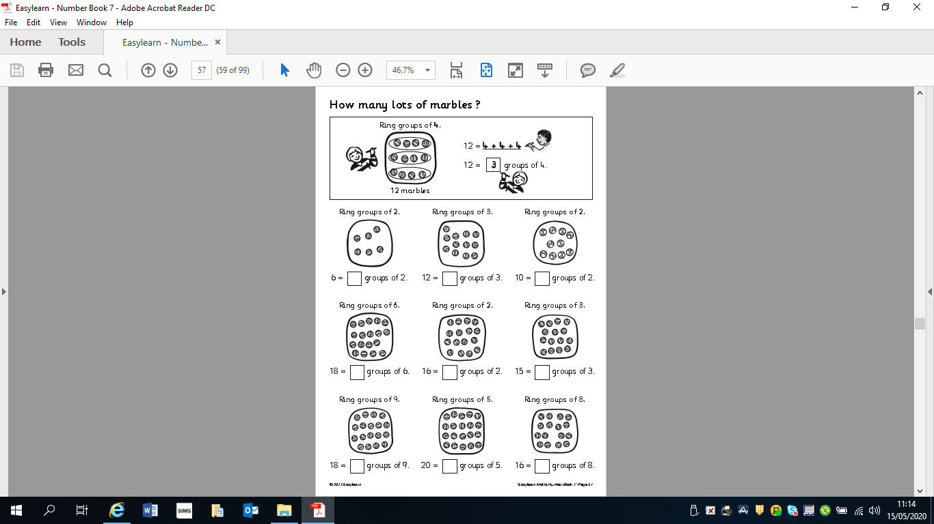
Can you write the division sum under each set of marbles eg.
1) 6`÷3=2

