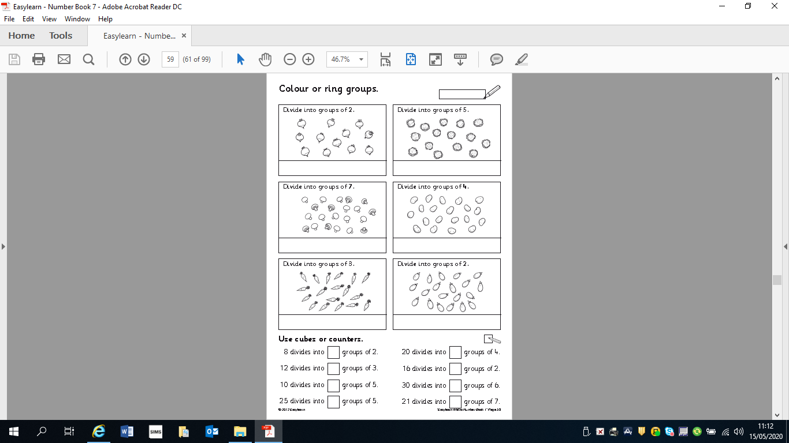
Write the division sum under the picture eg 1) 12÷2=6

