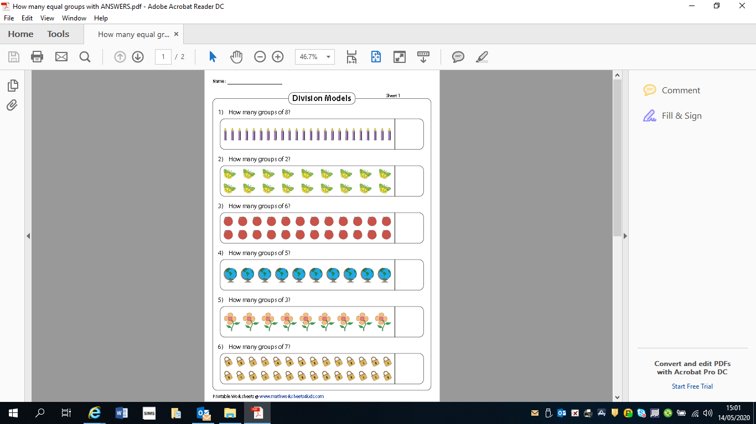
Draw a circle round the equal groups. Write the division equation/sum beside each question.

Eg 1) 24 ÷ 8 = 3

