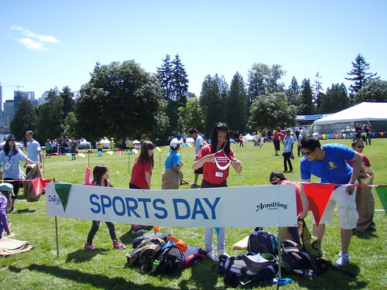Today is the first day of June!
We would probably be having our Sports Day in school!!

So….you can practice doing some of these Sports Day activities….and count at the same time! Remember to count as loud as you can!!

Bounce a ball 12 times .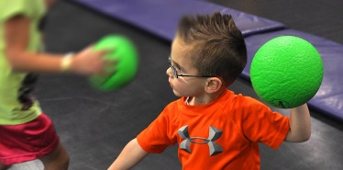
Hop 13 times! 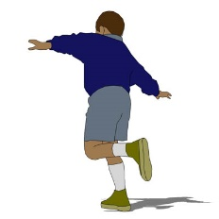 Throw a ball 16 times 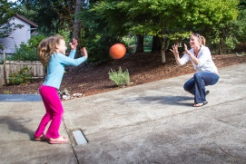

Jump 11 times!  Clap 17 times! 

