We are going to do some estimating today!! Remember- estimating is when you look at a group of things for a short while, and then make a good guess at how many things are there-
DO NOT COUNT THEM!! Counting is a different skill!! 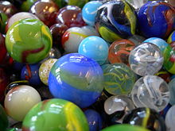
Ready??
Here are some objects. Look at them for about 3 seconds. Then look away. Say how many you think are . Look back. Count them. Remember, in this game you’re a winner if you get it right OR if you are close!!



Here’s the next group!! Remember-no counting!!
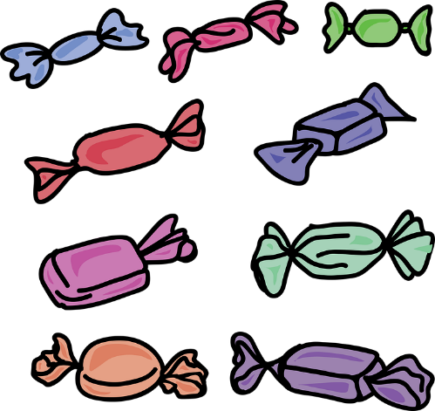

How did you do so far? Here’s the last group! No counting!!


