We are going to play a game called…. Guess my number!!!

All my numbers will be TEEN numbers….remember them?? They start at 11 and go to 19…say them out loud now
11…12…13…14…15…16…17…18…19…
They all have one ten…and some ones…ready to play???

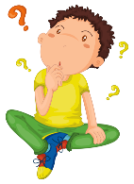 I’m thinking of a number.
It has one ten and 5 ones. What is it??

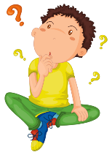I’m thinking of a number.
It has one ten and 8 ones. What is it?

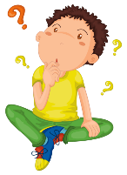I’m thinking of a number.
It has one ten and 3 ones. What is it?

I’m thinking of a number.
It has one ten and 9 ones. What is it?

