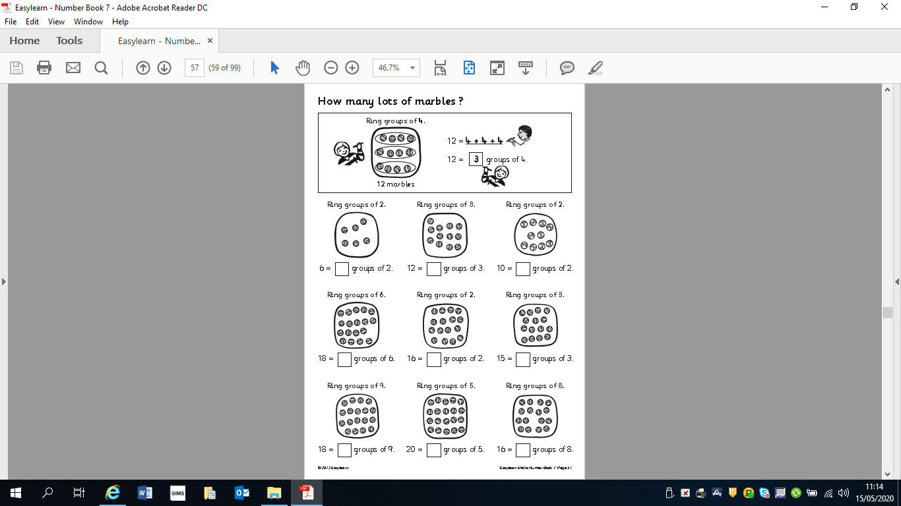
Can you write the division sum under each set of marbles eg.
1) 6 ÷3 = 2

