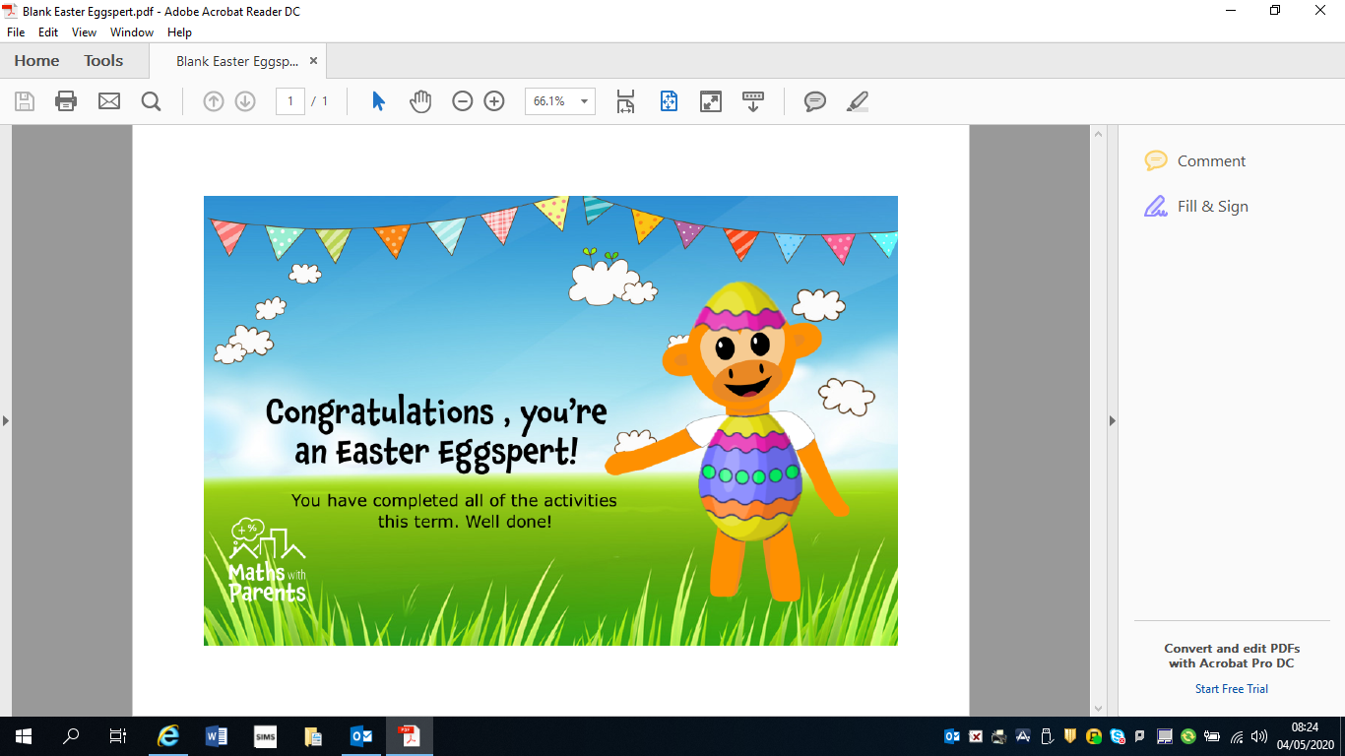

Well done to Ben, Leah and Mia!!

Congratulations!
3 students from P3 Room 6 have won Easter Eggsperts certificates for completing 100% of the Maths with Parents activities set this term. This is brilliant WOW !!!

