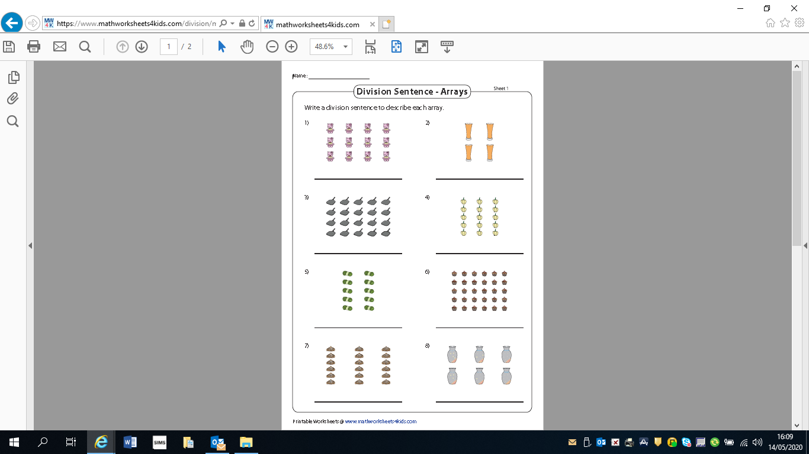
You could write 2 different division equations/sums/sentences for each array depending on how you group your array rows or columns.
Eg. 1) 12÷4 =3 and 12÷3 = 4

