Weekly Overview: Week 3

Dear parents and pupils,
Welcome back! We hope you have had a fantastic Easter holiday and are looking forward to seeing your learning this week again. Whether it be a picture of you working on set home learning tasks or another activity you are completing in addition we would love to see photographs of you all. Remember to send them to:

Rm 13 Mrs McKnight - lmcknight474@c2kni.net
or
Rm 14 Mr Ryden - dryden451@c2kni.net

We have collated some wonderful activities for P7 pupils this week. Please see the list below as a guide to help support you. Please don not feel you must complete these activities all in one day but instead allow your child to complete a variety of activities throughout the week.
If you have any questions or queries about any of the Home learning tasks the please do not hesitate to contact us.

Many thanks
Mrs McKnight and Mrs Ryden

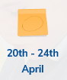
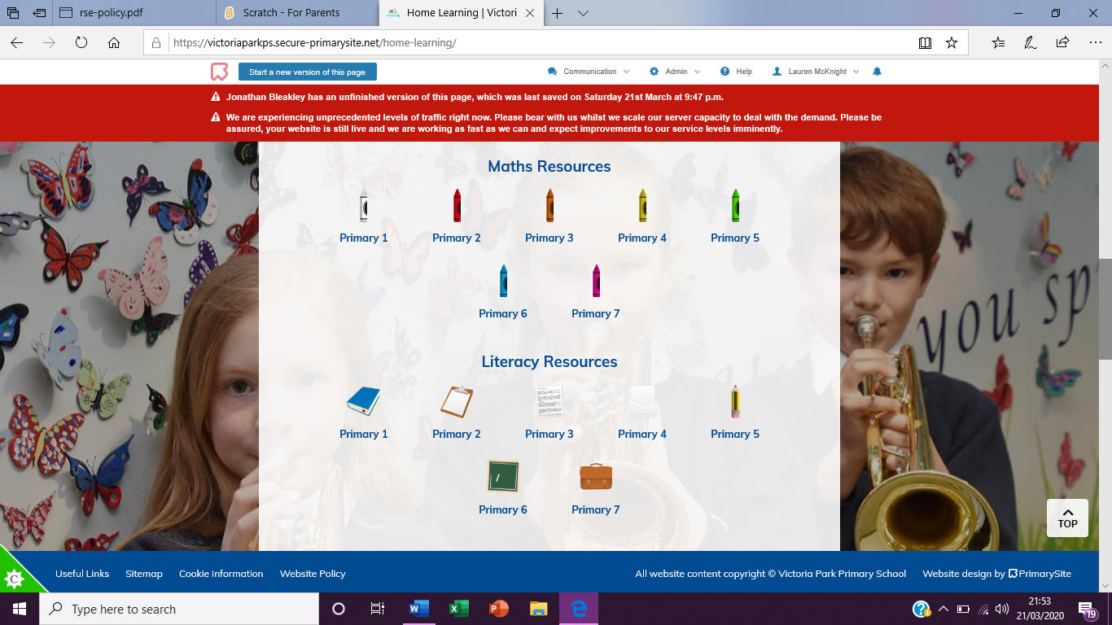
Literacy

- Writing: Balanced Arguments https://victoriaparkps.secure-primarysite.net/blanced-arguments/

- Punctuation: Brackets https://victoriaparkps.secure-primarysite.net/brackets/

- Spellings: https://victoriaparkps.secure-primarysite.net/spellings-4/

- Reading: Bug club - suggested reads, 1- 2 books per week. Pupils have been allocated a selection of books by their class teacher and can complete interactive guided reading activities and games through the app based on the books they read. Earn coins and rewards daily.

- Listen: David Walliams free audio stories online: https://www.worldofdavidwalliams.com/elevenses/

Numeracy

- Divison: https://victoriaparkps.secure-primarysite.net/division/ activities and interactive videos. Please watch video tutorials before allowing pupils to complete activities.

- Corbett Maths: 5 a day mental maths activities and challenges. Please watch video tutorials before allowing pupils to complete activities.

- Times table rocks: download the app and login to challenge each other and your teacher!

- Maths with Parents: sign up to the correct class using the links and guidance below to view video explanations & activities: https://mathswithparents.com/KWeb?startTime=1584887525640#menu875323
Please watch video tutorials before allowing pupils to complete activities.

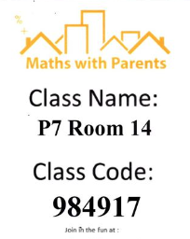
Rm 13: Mrs McKnight Rm 14: Mr Ryden
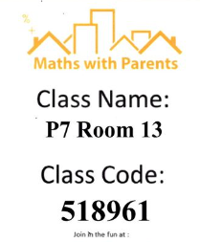

ICT
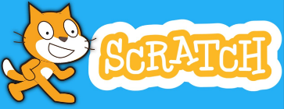
Scratch Online Learning: Week 3: https://victoriaparkps.secure-primarysite.net/20th-24th-april/

WAU

Rainforest: https://victoriaparkps.secure-primarysite.net/20th-24th-april-3/ Our P7 topic for this term is The Rainforest. This week we are looking at what rainforests are. Your child needs to watch the video and then complete the worksheet and crossword.

Stem Challenge: https://victoriaparkps.secure-primarysite.net/p7/ How Many can you complete? Why not get the whole Family involved in your learning too?

PE

Dance: Oti Mabuse is hosting live dance classes for kids at 11:30am every day until at least 30th March. You can find all previous and future videos here: https://www.youtube.com/user/mosetsanagape/videos

Fitness: The Body Coach Joe Wicks is hosting a live 30min PE lessons, at 9am Monday to Friday on his YouTube channel, for children of all ages. https://www.youtube.com/playlist?list=PLyCLoPd4VxBvPHOpzoEk5onAEbq40g2-k

Please encourage your child, where possible, to go outside to get some fresh air. Kicking a ball in the garden, a walk in the park adhering to social distancing suggestions are all key to keeping us healthy and allowing the opportunity of a digital detox.
Dates for your Diary
• 1.00pm – Music with Myleene Klass – https://www.youtube.com/channel/UCQh2wgJ5tOrixYBn6jFXsXQ

• 1.30pm – Dance with Darcey Bussel – https://twitter.com/diversedancemix/status/1241098264373592065

• 2.00pm – History with Dan Snow (free for 30-days) – https://tv.historyhit.com/signup/package

• 4.00pm – Home Economics with Theo Michaels (Mon/Wed/Fri) – https://www.instagram.com/theocooks

• Non-daily events include: Science with Professor Brian Cox, Robin Ince & Guests https://cosmicshambles.com/stayathome/upcoming-schedule

Best Free Apps for Key Stage 2

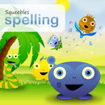
Squeebles Spelling Test
Squeebles Spelling is a spelling app which allows parents and teachers to set up completely customised tests for their children. As well as allowing parents to record the words their children need to spell in their own voice, it features a cast of fun characters, a mini game that children get to play as a reward for doing well in their spellings, the ability to add unlimited player accounts and much more.


DoodleMaths
DoodleMaths is an excellent learning tool for use in school or at home that covers key stage 2. It provides essential data to the teacher or parent of not just what their student or child is good at, but more importantly, areas of weaknesses. It is extremely intuitive, but help is at hand by pressing the “more” information icon. The user is then guided audibly through the options and how to use the app.

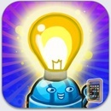
Fun Science Lab
Although the app looks very child like, you will find the experiments compelling as well as fairly testing. The app provides 9 interactive levels with 3 levels of difficulty in each. Each success is rewarded with a medal and you can track your scores in the collection book. The app also provides in app instructions and diagrams if you get stuck.


Geo Challenge – Flags, Maps and Geography Learning Game for Kids
The Geo challenge app gives students a fun way of learning about geographical details. This interactive app provides a collection of games that provide young ones an easy way to understand about the geographical data. The spinning globe enables students to explore the countries and details such as flags, capitals and population. The other options are to learn about flags using the flash cards and questions and also to learn about shapes of the countries using the jigsaw mode.

Lightbot - Programming Puzzles
Lightbot is a programming puzzle game that uses game mechanics that are firmly rooted in programming concepts. The app can be used in both KS1 and KS2 in the ICT lessons to design, write and debug programs that accomplish specific goals. Teachers can use the app to explain what algorithms are and how they can be implemented as programs on digital devices.

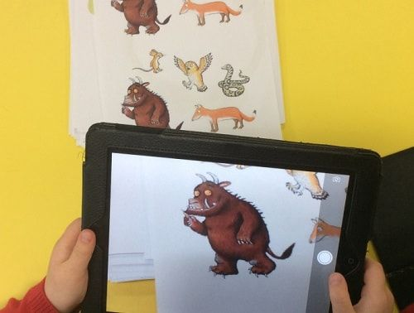
Puppet Pals
The main advantage of Puppet Pals is it takes just three steps to create an animation: choose characters and backdrops, drag them on to the stage and press record. The app records speech and animation in real time and voilà, you and your children have created a little film. There are pre-installed characters and backgrounds but it is easy to bring in your own drawings or photos as well. It is such a simple process and children get immediate feedback which encourages them to experiment.

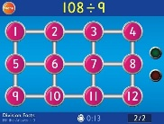
Hit the Button
Hit the Button from TopMarks.com is one of my favourites because even those children who hate maths seem quite happy to use it on a regular basis. It consist of a series of tests dressed up as a game with quick fire questions on number bonds, times tables, doubling and halving, multiples, division facts and square numbers. It encourages children to have a go. Regular use will improve confidence, memory and test scores.

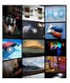

Science360
This is an app created by the National Science Foundation. It is exclusively built for tablet users only to showcase advanced science, engineering news images, and videos for children. All content available is authentic, high-quality, and updated every week. The content is also produced by the NSF or gathered from scientists and universities around the world. The cool 360-degree view allows kids to explore 3D images from every angle.

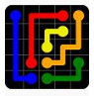

Flow Free
This puzzle game is interesting for both adult and kids. There are 2,000 puzzles available for free.

