Space Art Lesson 6
This week are staying crafty and creating the moon!
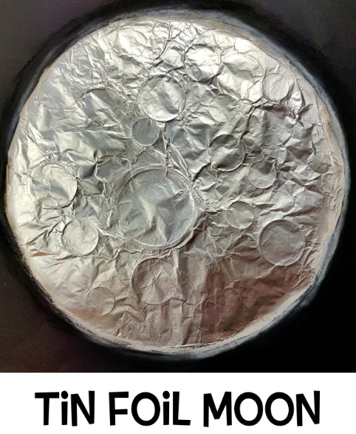
You will need tin foil, coins, scissors, glue and paper.

Step 1
Cut out a circle of tin foil (draw around a plate to get the shape).
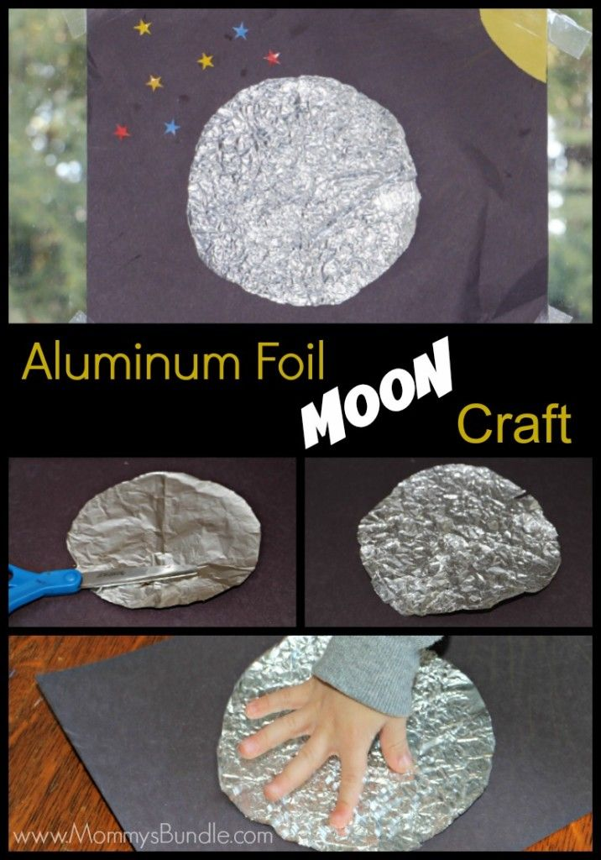
Step 2
Use coins for the moon’s craters. Place the coins under the foil and rub your finger lightly around the edges of the coins to reveal the circle shapes in the foil.
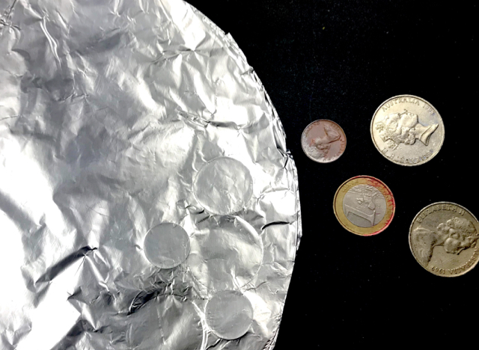

Step 3
Remove the coins and stick your moon onto a piece of black card or paper. Don’t worry if you don’t have black paper – you could paint or colour in a piece of white paper. Now you can decorate around the moon with stars. You could add in some planets or rockets, aliens or an astronaut!
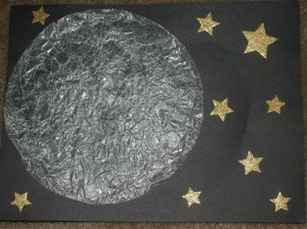
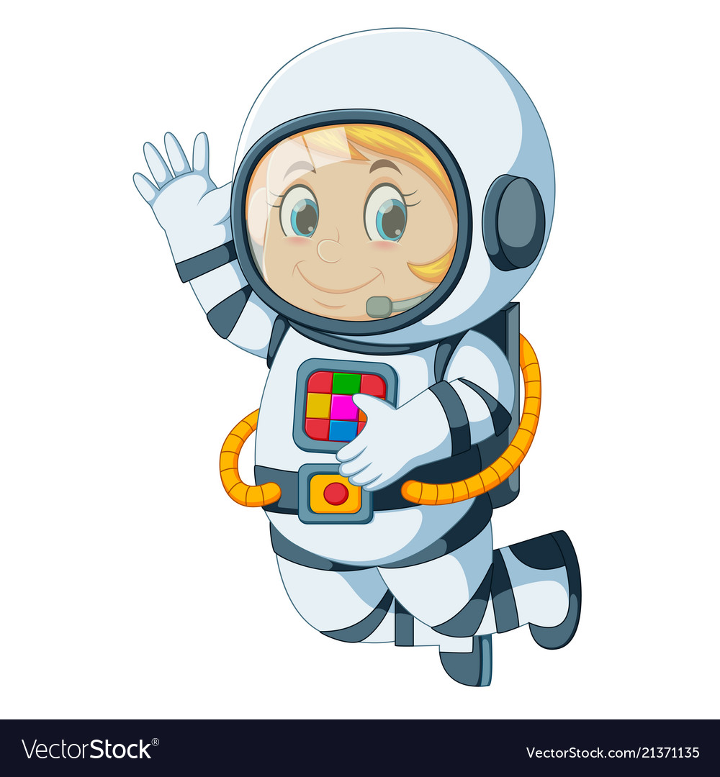
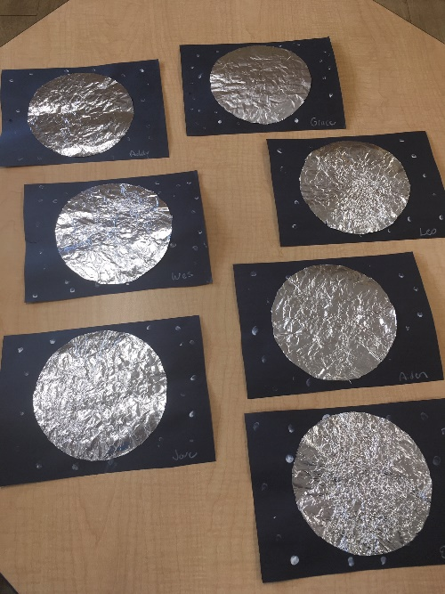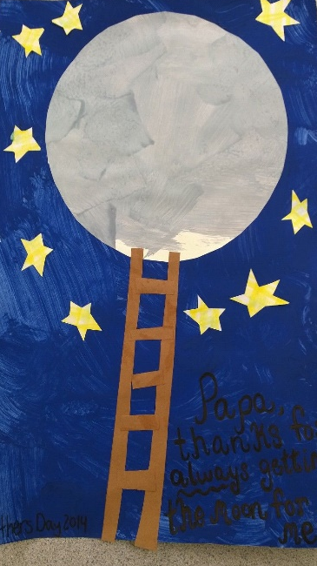
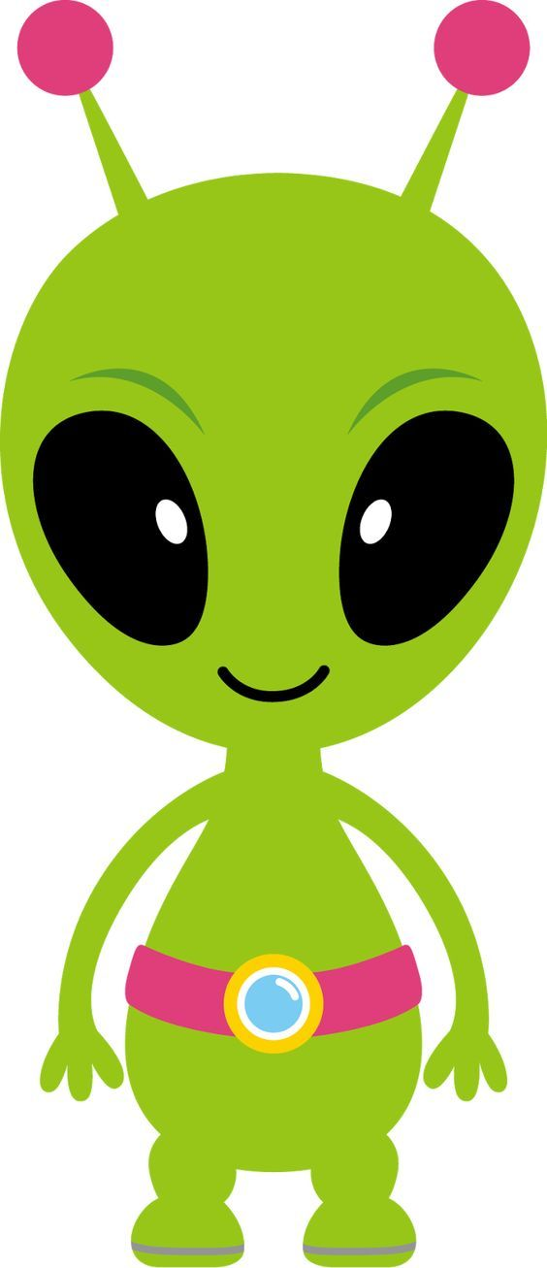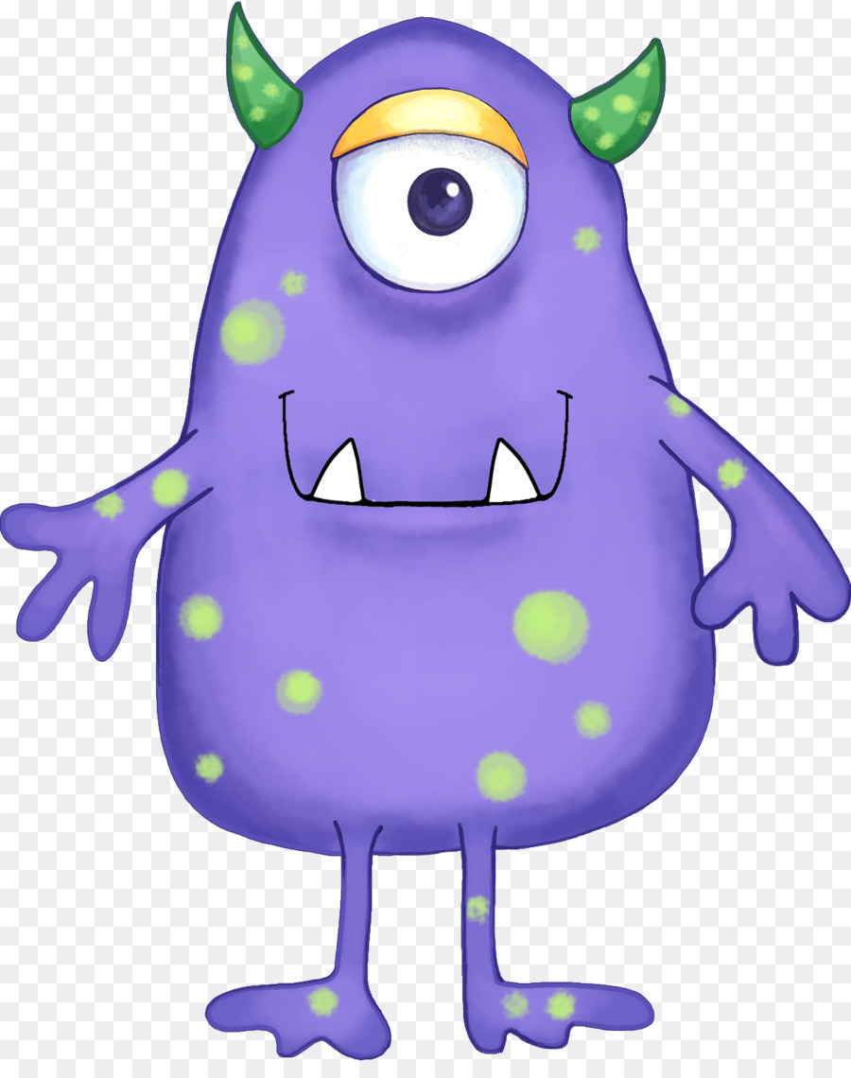

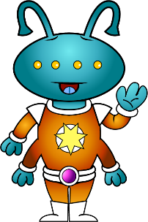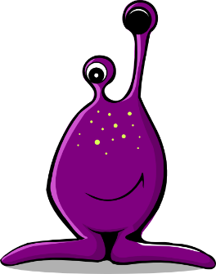

Remember to send pictures of your fab art work to your teacher. We would love to see it!

