Space Art Lesson 5
This week are staying crafty and creating rockets! You have a choice of which rocket you would prefer to make. Or you can take bits from all the ideas and make your own! There are 4 options to choose from. Be creative and have fun.

You will need a kitchen roll or toilet rolls, scissors, glue, card or paper and some clothes pegs. You can use felt tips, crayons, paints, colouring pencils or a mixture for the decorating.

Option 1
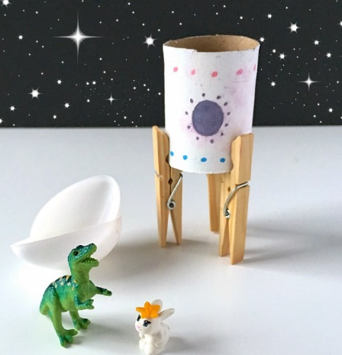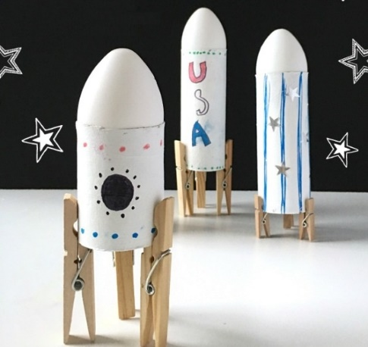
To make the cone at the top cut out a circle of paper.
Cut a line into the middle.
Fold the ends over to make a cone and stick with glue or tape.

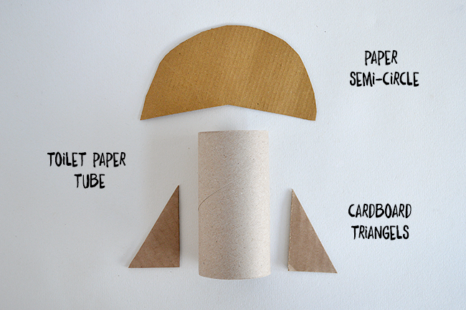
Option 2
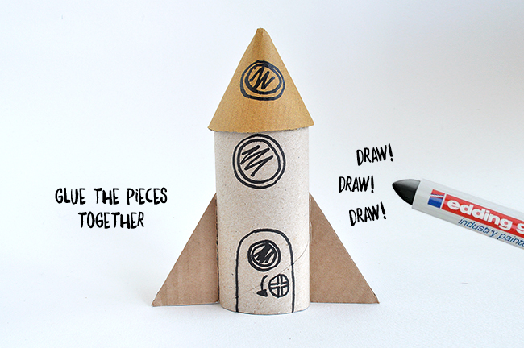

Option 3
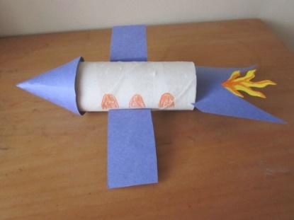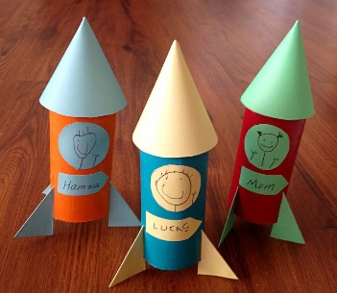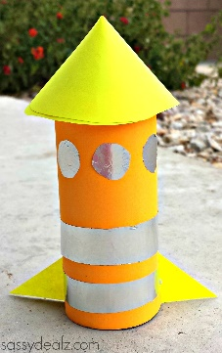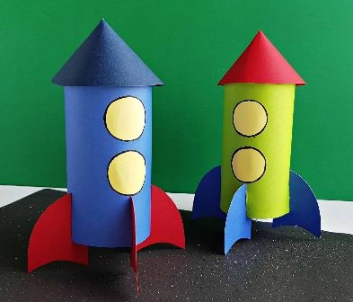

Option 4
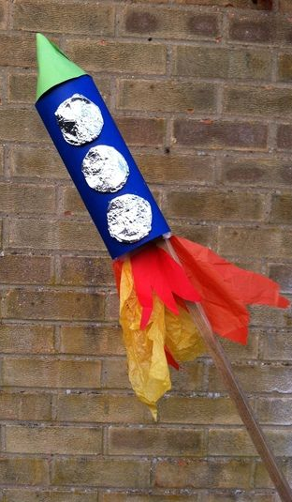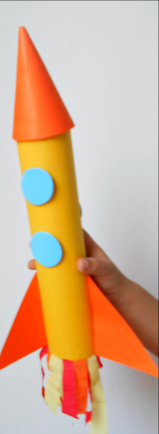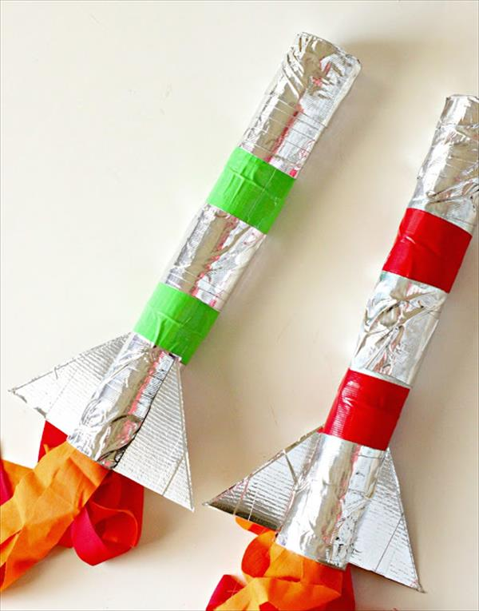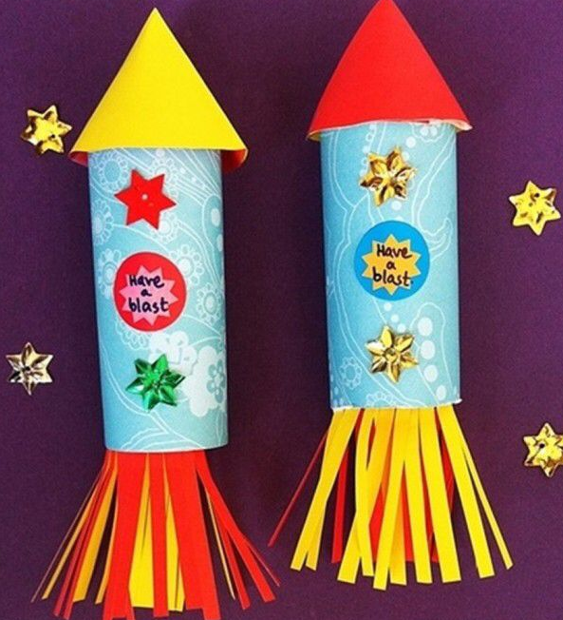

Remember to send pictures of your fab art work to your teacher. We would love to see it!

