Space Art Lesson 4
This week are getting crafty and creating a space themed wreath. You have a choice as to which style you would prefer to make.
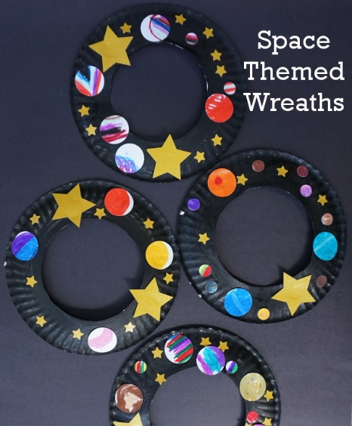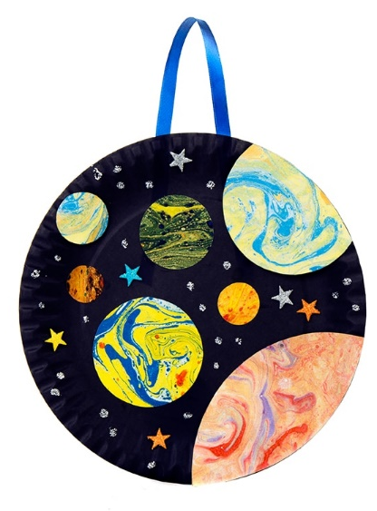
A B
You will need a paper plate, scissors, glue, card or paper and some string or ribbon. You can use felt tips, crayons, paints, colouring pencils or a mixture for the decorating.
Option A instructions
First you need to ask a grown up to cut out the centre of the paper plate.
Then paint or colour in the outside of the plate black.
Next draw stars and planets and decorate them. You could draw around a cup to give you a circle. If you prefer you could design these on the computer and then print and cut out. (To get the marbled effect in the pictures check below for instructions)
Finally stick your stars and planets to your paper plate. Cut a piece of string or ribbon. Tie the ends together and stick to the back of your space wreath. Now it is ready to hang up. Well done!
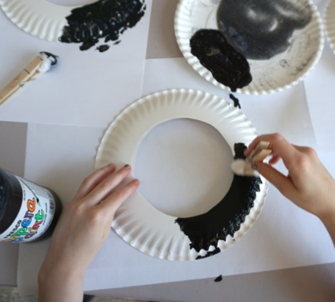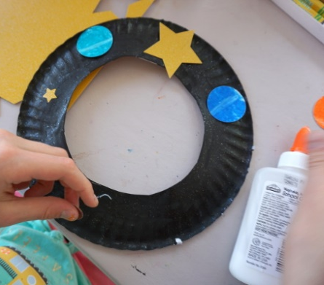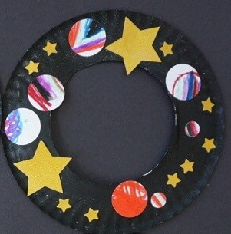

Option B instructions
First paint or colour in the plate black.
Next draw stars and planets and decorate them. You could draw around a cup to give you a circle. If you prefer you could design these on the computer and then print and cut out. (To get the marbled effect in the pictures check below for instructions)
Finally stick your decorations to your paper plate. Cut a piece of string or ribbon. Tie the ends together and stick to the back of your space wreath. Now it is ready to hang up. Well done!
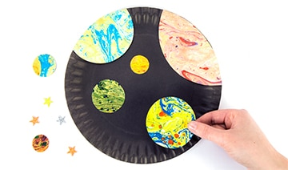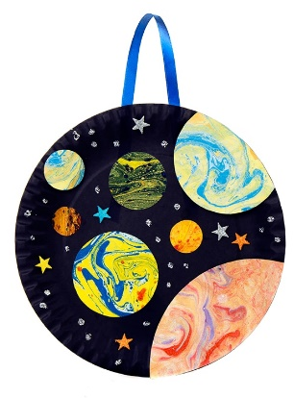

If you would like to get the marbled effect on your planets you need – paint, marbles and a tray, cardboard box or an old tin/biscuit box.
First squirt in the colours of paint you want to use at one end of the tray.
Next place your paper in the tray.
Then add the marbles and holding the sides of the tray roll the marbles through the paint and over your paper.
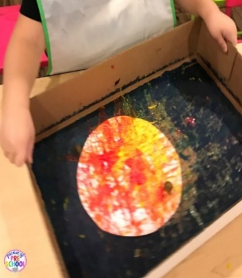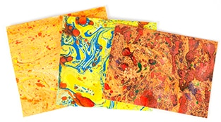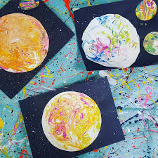
Remember to send pictures of your fab art work to your teacher. We would love to see it!

