Space Art Lesson 3
Have a go at drawing or painting a shooting star.
You can use felt tips, crayons, paints, colouring pencils or a mixture of them all.
If you prefer you can use a paint package on your computer to make a shooting star picture.
Or you could use chalks and draw a shooting star in your driveway or on paving in your garden.
Have a look at the video to help you. https://www.youtube.com/watch?v=UaqnNHFtCX0
https://www.youtube.com/watch?v=jBX0H4DjdKo
Below are some ideas to help. Have fun!
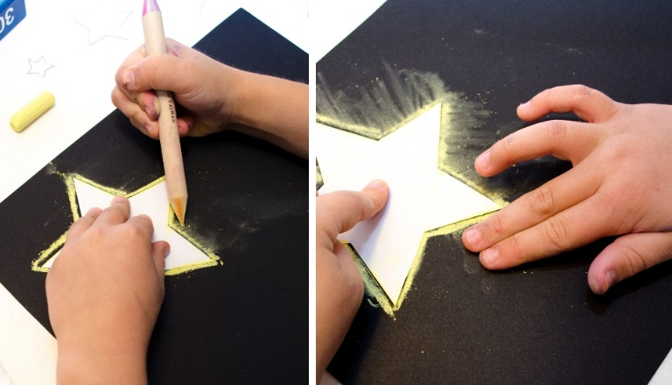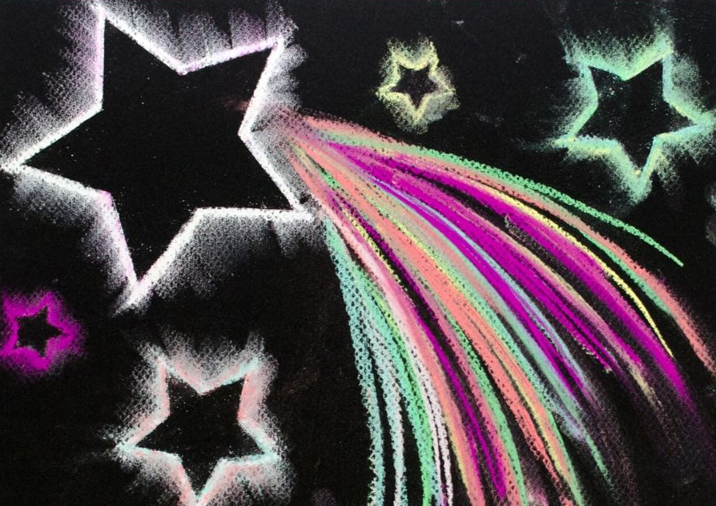
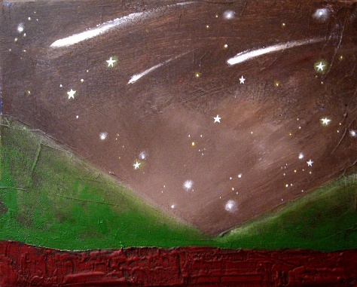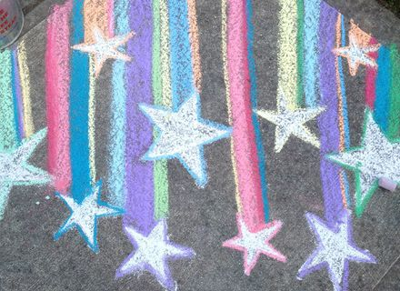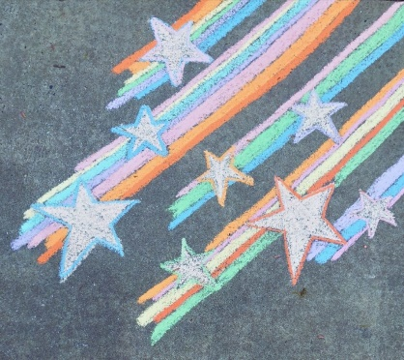
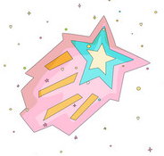
Remember to send pictures of your fab art work to your teacher. We would love to see it!

