Space Art Lesson 2
Have a go at drawing or painting a rocket.
You can use felt tips, crayons, paints, colouring pencils or a mixture of them all.
If you prefer you can use a paint package on your computer to make a rocket picture.
Or you could use chalks and draw a rocket in your driveway or on paving in your garden.
Have a look at the video to help you.
Below are some ideas to help. Have fun!
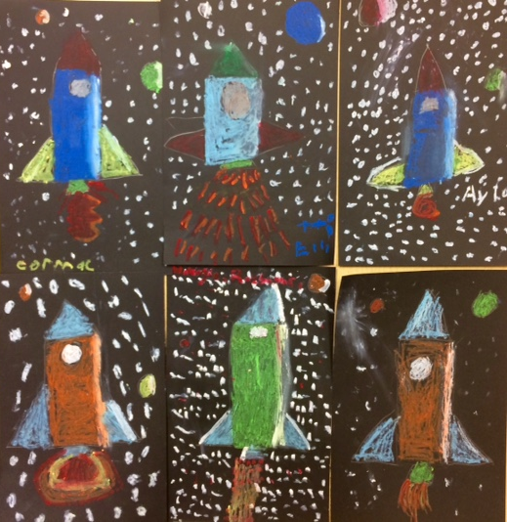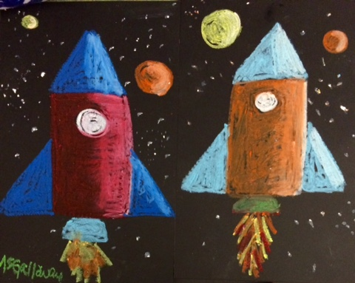
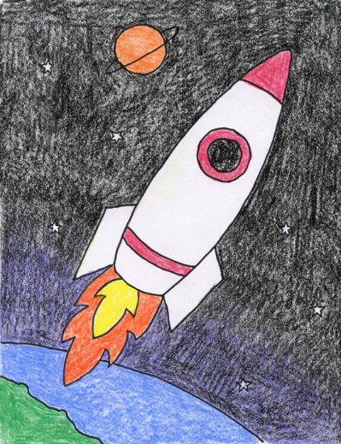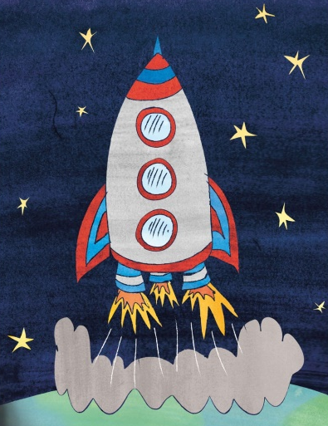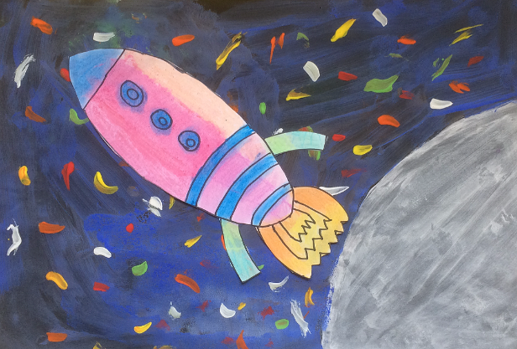
Remember to send pictures of your fab art work to your teacher. We would love to see it!

