The Outdoor Classroom Part 2
Parent Booklet
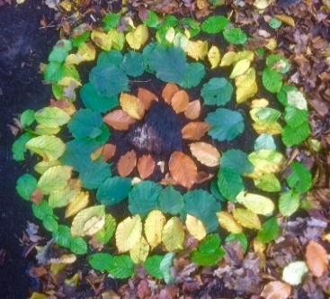 |  | 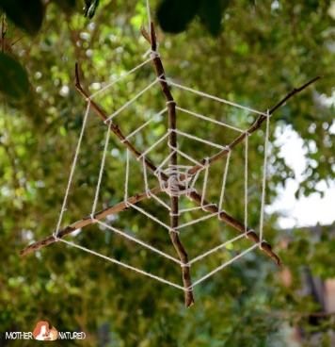
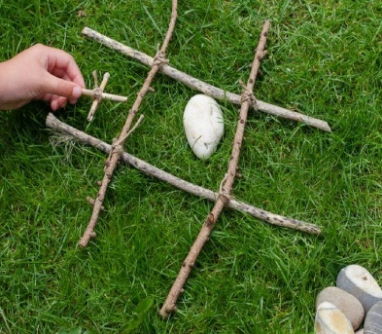 | 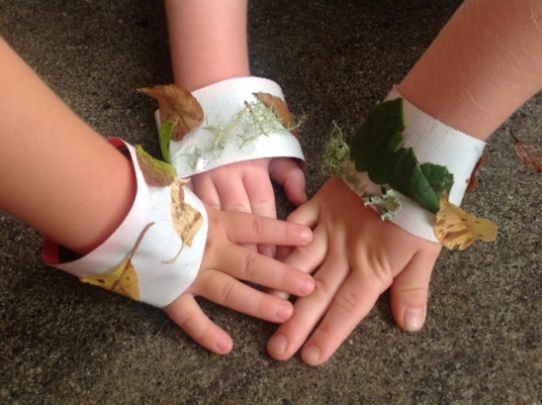 | 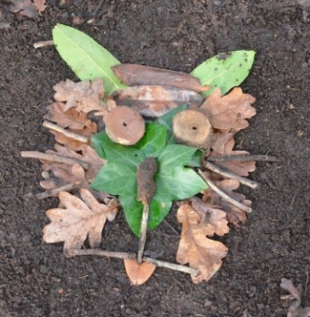

Following on from the Parent Booklet for Outdoor classroom ideas. Here are some new activities for your children to attempt with other family members in the garden or park. Use your daily dose of fresh air to collect natural materials and complete these activities at home. If you don’t have your own green space, most of these can work indoors, on a balcony or on the front drive. There is no written work involved but adult supervision and help is required for all activities. Remember to take lots of photographs of your work and share with your teachers. We can’t wait to see your creations!
Have fun! 

The Outdoor Classroom Part 2

Contents
3D Maps
Natures Board Games - Noughts and crosses
Natural Art
Art, Nature and You!
Goblin Villages and Mini Dens
Bottle Filter
Shelters for your toys
Natural Mobiles
Dream Catchers
Ice Sun Catchers
Nature Bracelets
Memory Game
Self Portraits
Painting With Nature
Spider Webs
Make a Bee Bath
Butterfly Buffet
3D Maps
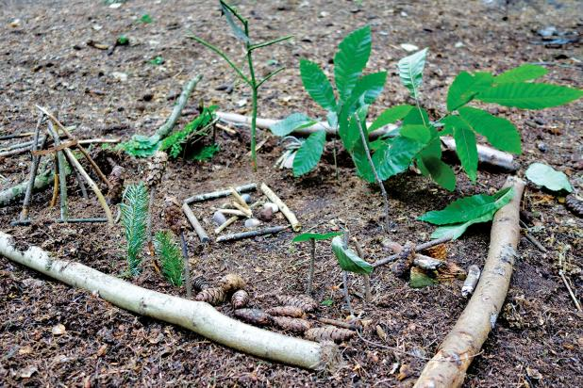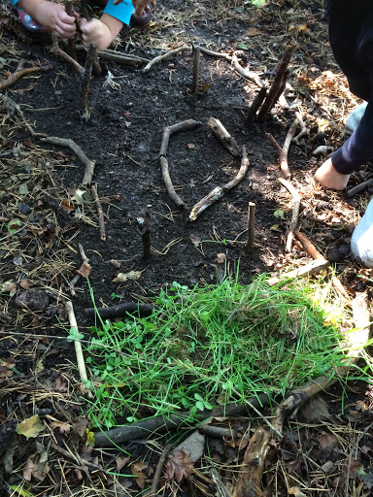
Materials – Whatever can be found on the ground – stones, twigs, leaves, feathers, acorns, conkers, pinecones etc.
Step 1 Walk around your garden or local park during your daily exercise. Look out for any distinguishing features – a big tree, crane, hedge, path, gate, stream.
Step 2 Decide on names for these features – the wise oak tree, the wiggly jiggly path, the rickety old gate, the bendy quiet stream.
Step 3 Using large sticks mark out a square. Use natural materials to create a 3D map of the area within the frame. Once it’s finished share with your family, talking them through the map and its key features.

Natures Board Games - Noughts and crosses 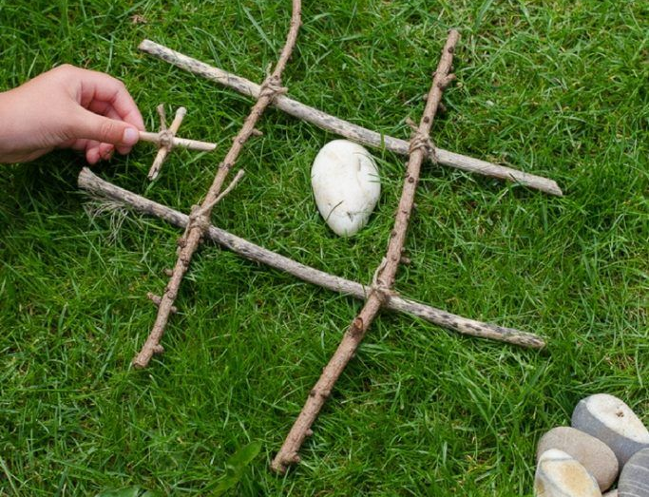 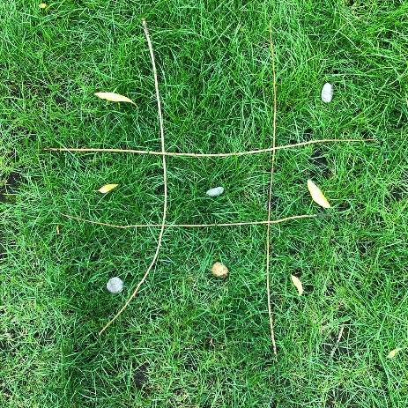
Materials – 4 sticks, 2 sets of 5 objects to use as counters (stones, leaves, pinecones, conkers)
Step 1 Lay the sticks to form the table.
Step 2 Decide on your symbols/objects to represent the noughts and crosses.
Step 3 Play

Natural Art
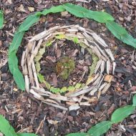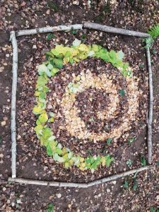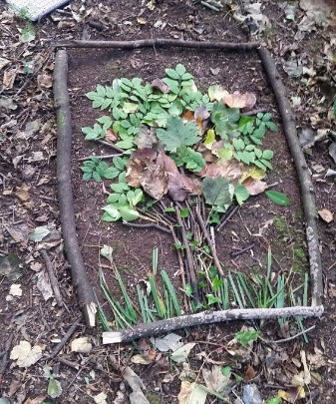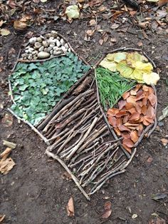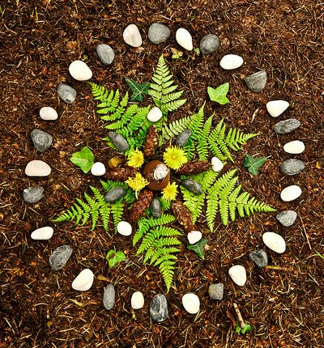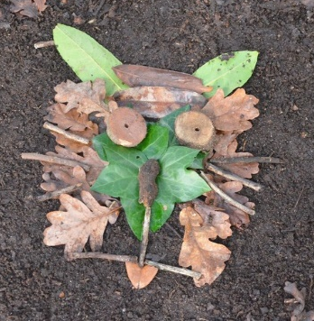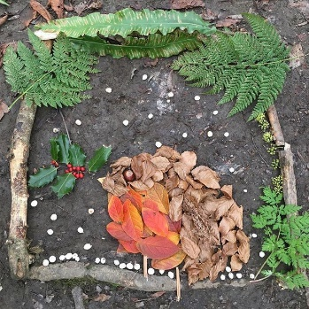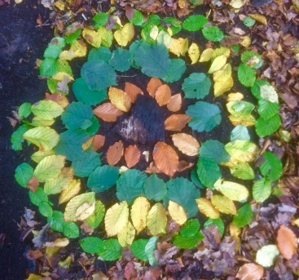
Nature provides some wonderful materials for making art- there are stunning colours, shapes, textures and sizes all around us. We can find materials in our gardens to make beautiful pieces of temporary art which will be returned to nature. Take a photograph to remember.
Step 1 Gather materials you find on the ground. Don’t pull leaves off trees, break off branches or flowers which are growing. Look around at what is already available. This makes your art work unique and creative.
Step 2 Decide where you are going to create your picture and start.
Remember – art does not have to look like something we recognise, sometimes it is just about making something interesting or beautiful.
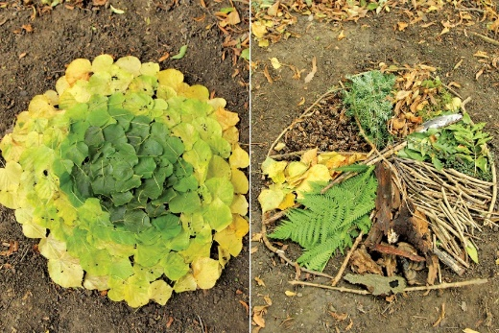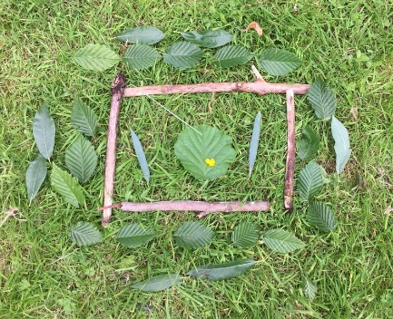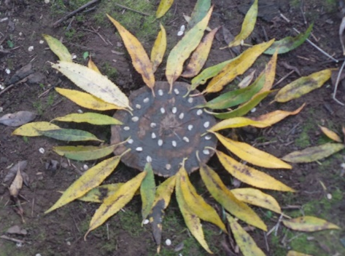

Art, Nature and You!
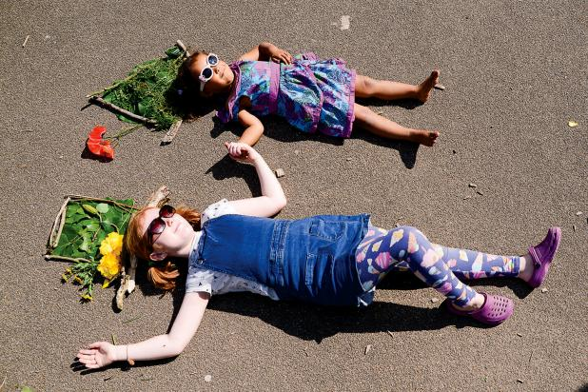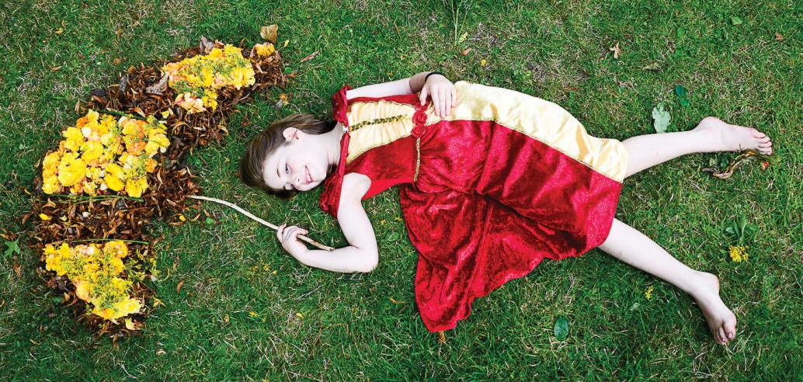
Art is everywhere you look so why not be part of your amazing art work?
Step 1 Gather materials you find on the ground. Don’t pull leaves off trees, break off branches or flowers which are growing. Look around at what is already available. This makes your art work unique and creative.
Step 2 Decide where you are going to create your picture and start.
Step 3 Use your imagination! You could create hats, umbrellas, a self-portrait, a pair of wings, make a cup and a teapot and lie down next to it to pour a cuppa, make a big piece of cake and lie down next to it to take a giant bite or make a giant spider and lie down next to it in a running away position.

Goblin Villages and Mini Dens
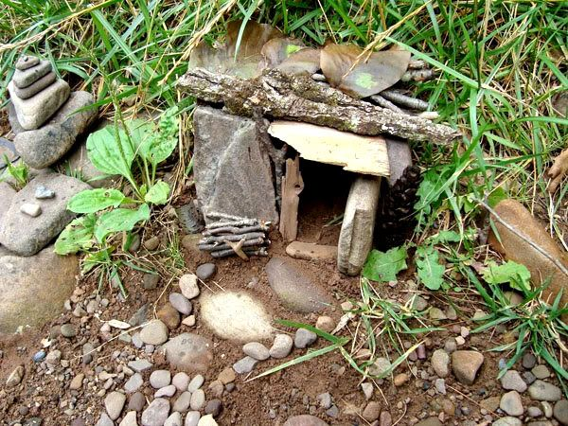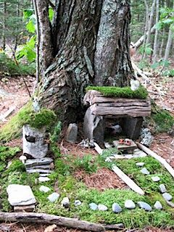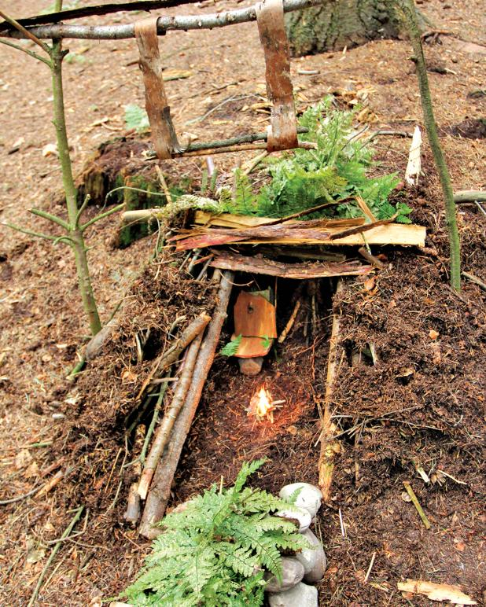
Start this activity with the story below which explains why we don’t see goblins around anymore. Then get creative. Decide what to build-a house, post office, dance hall, a whole magical kingdom! Use natural materials to build tiny dens. Add leaves on sticks for mini trees, pebbles lined up as bridges, moss for roofs etc.
The story of the goblin village
Have you ever seen a goblin? No? Well, that’s because they no longer come here. Here, where we stand, there used to be a goblin village. It had houses that were joined by epic bridges and magic gardens. It had sweet shops and dancehalls where goblins would gather at the end of every day for a good old boogie! But then one day a dragon, a very friendly but really quite big dragon, who lived all the way up the hill, heard about these dances. He loved to dance and desperately wanted to join in the fun.
So, on one particularly rainy day, he put on his dancing shoes and ran down from the top of the valley to find the dancehall. But the rain had turned the ground into a muddy, sloppy mess and the dragon’s shoes were meant only for dancing, not for running, so he slipped all the way down. He slipped past all the trees, through the forest, down the hill and landed in a heap, squashing the whole village. Not a building was left standing. The goblins had no choice but to move on, and now no one knows where they live. It’s terribly sad. I wish there was some way we could help….
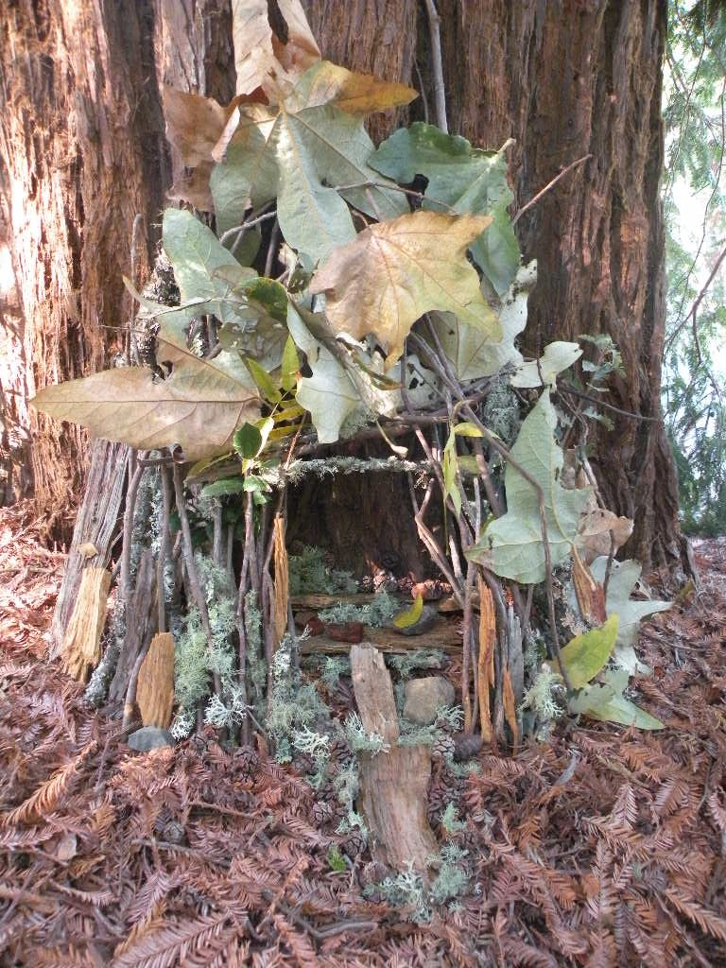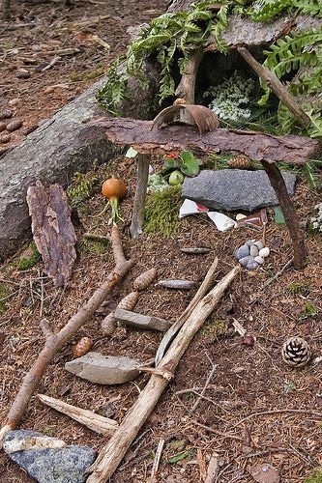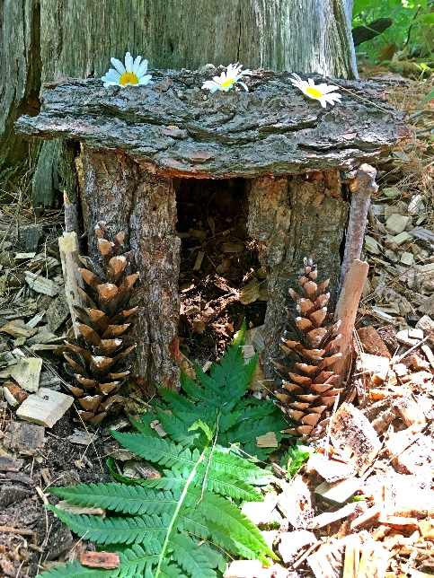

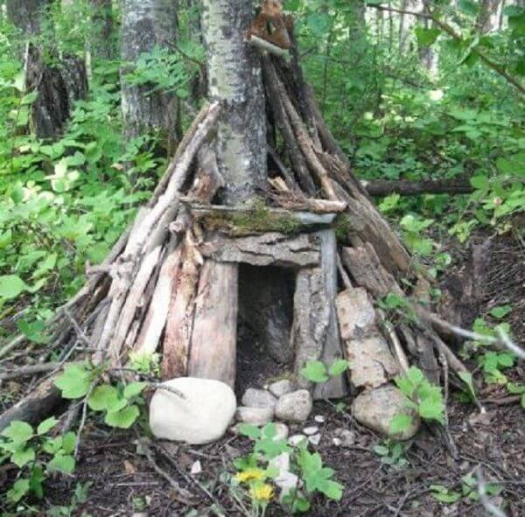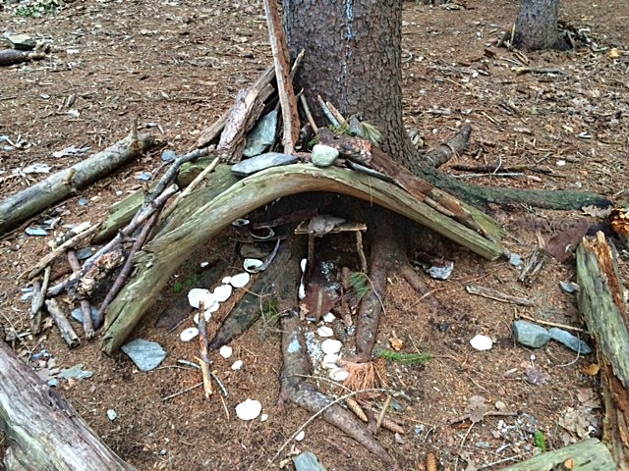
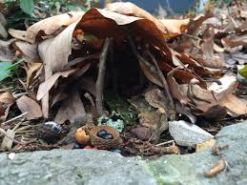
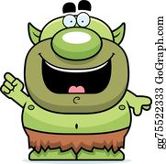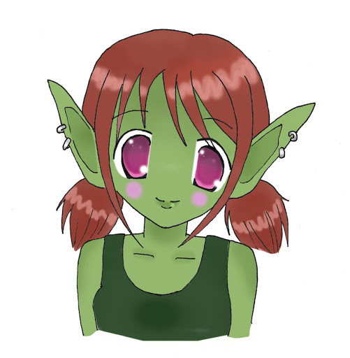
Please build us a new village?
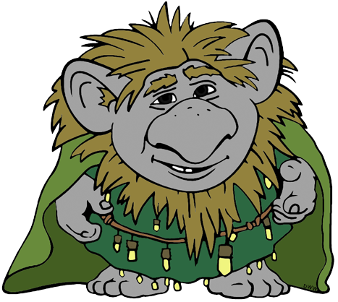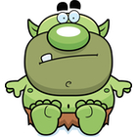

Bottle Filter
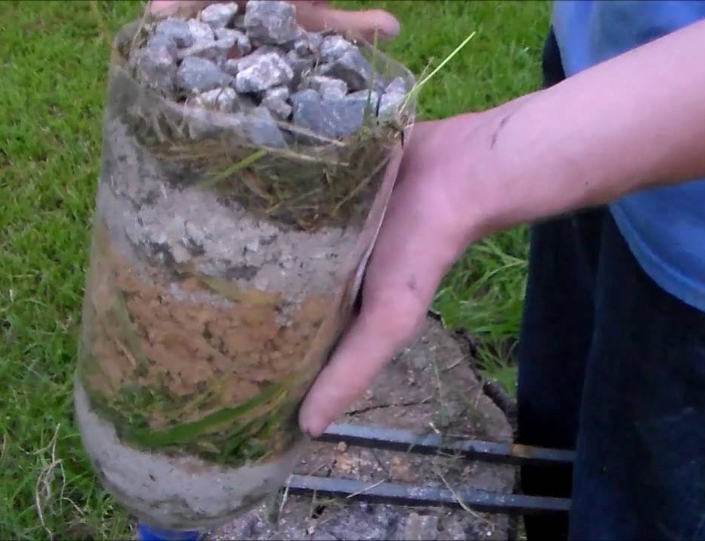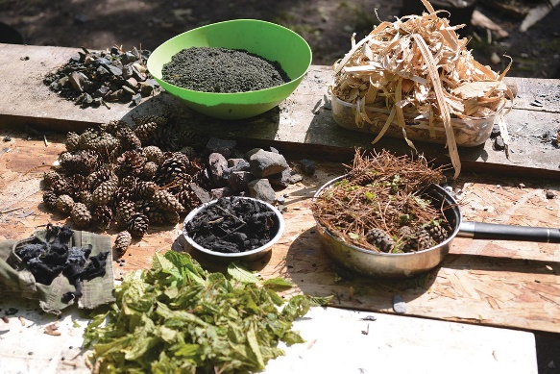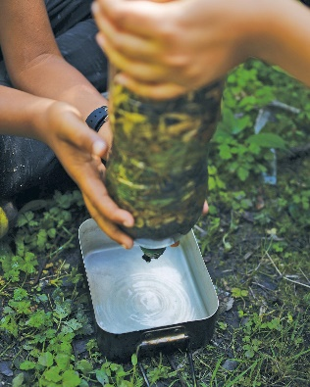
You can use this fun filter to make even the dirtiest water from a muddy puddle clear. You’ll need to search your garden or nearby park to gather up a range of natural materials to make up the many layers. The filter won’t remove chemicals or bacteria, so don’t be tempted to drink the water, however clean it looks.
Materials Plastic bottle, a plastic or metal container, a piece of cloth, crushed charcoal, gravel, grass, leaves, wood shavings, pinecones. You don’t need all of the loose materials, just a combination of small bits with some larger pieces.
Step 1 Cut the bottom off the plastic bottle and remove the lid. Wedge the cloth into the neck of the bottle, then fill it with layers in this order –charcoal, gravel, grass, leaves, wood shavings. Make sure everything is compacted down tightly. It is important to keep the layers in this order because the larger particles in the water will be filtered out first through the wood shavings, while the final layers of crushed charcoal will remove the smaller bits of debris and clean the water.
Step 2 Pour your muddy water slowly through the bottle filter into another container. Be careful not to spill it over the edges, as this will contaminate your water. Pass it through the filter several times until it runs clear.

Shelters for your toys
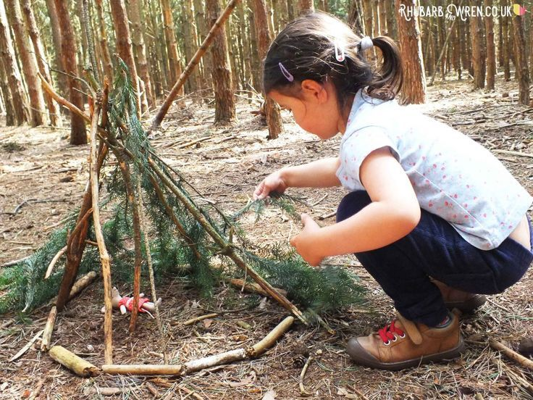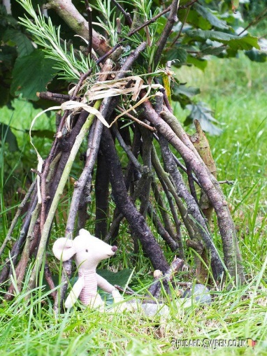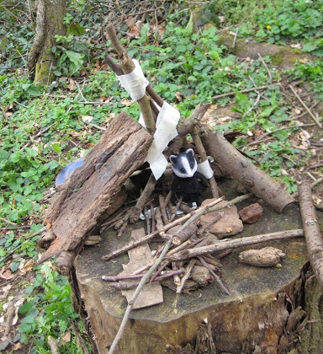

Gather materials you find on the ground to build tiny dens for your favourite toys. Don’t pull leaves off trees, break off branches or flowers which are growing. Look around at what is already available. This makes your den unique and creative. Add moss for roofs, tie sticks together to make a tent like structure.

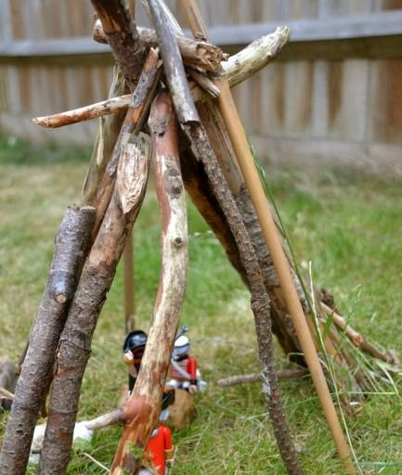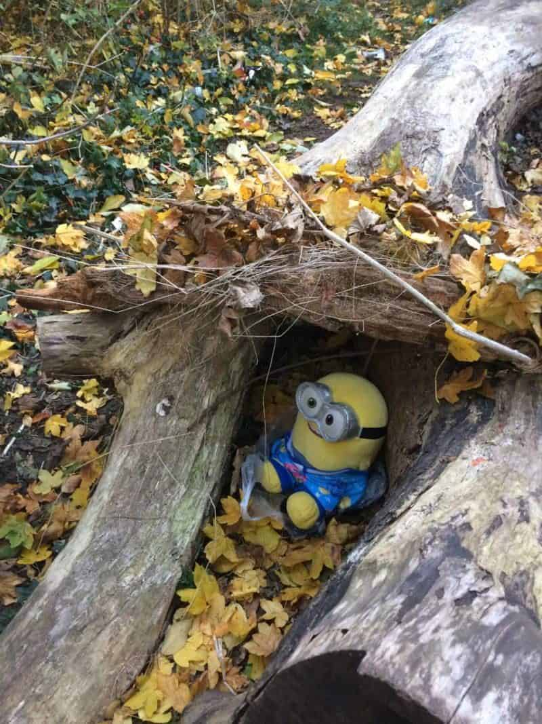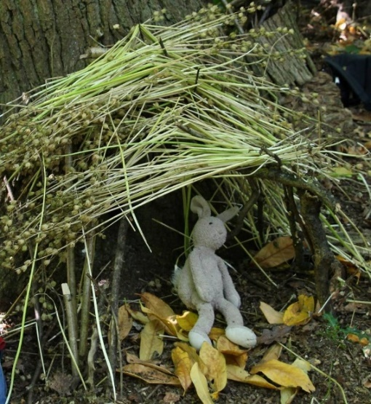

Natural Mobiles
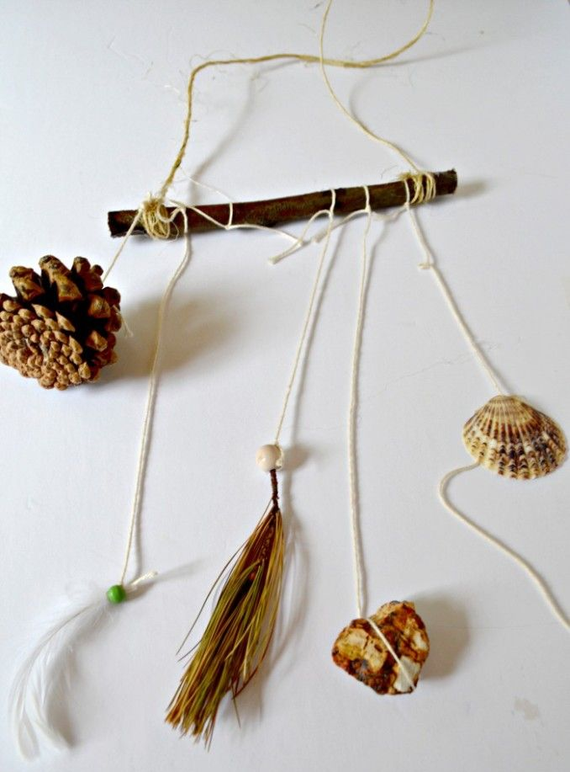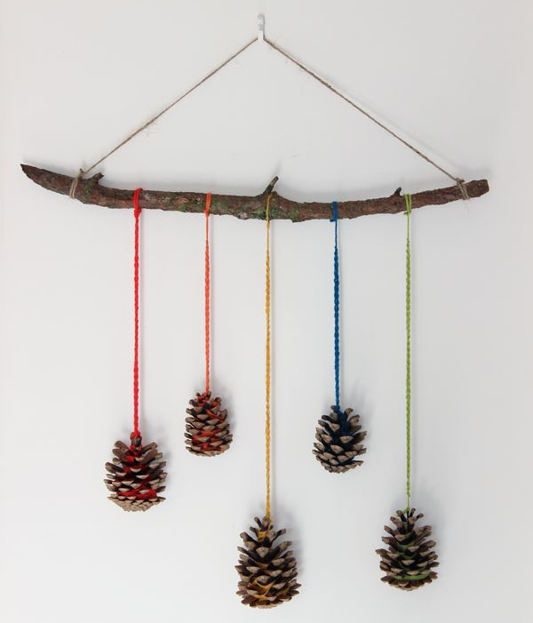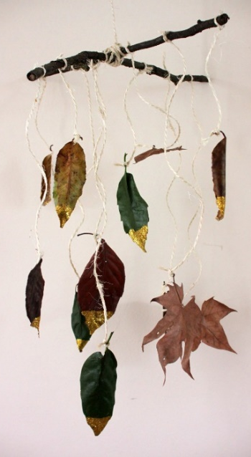
Get creative and make a mobile to hang from a tree or as a decoration for inside the house.
Materials Sticks, string or coloured wool, leaves, feathers, pinecones, shells, conkers.
Step 1 Gather materials you find on the ground.
Step 2 Use the largest stick to hang your objects from. Make each piece of string a different length and tie to an object and then the stick.
Step 3 Tie a piece of string to each end of your stick to make a handle to hang your mobile from.
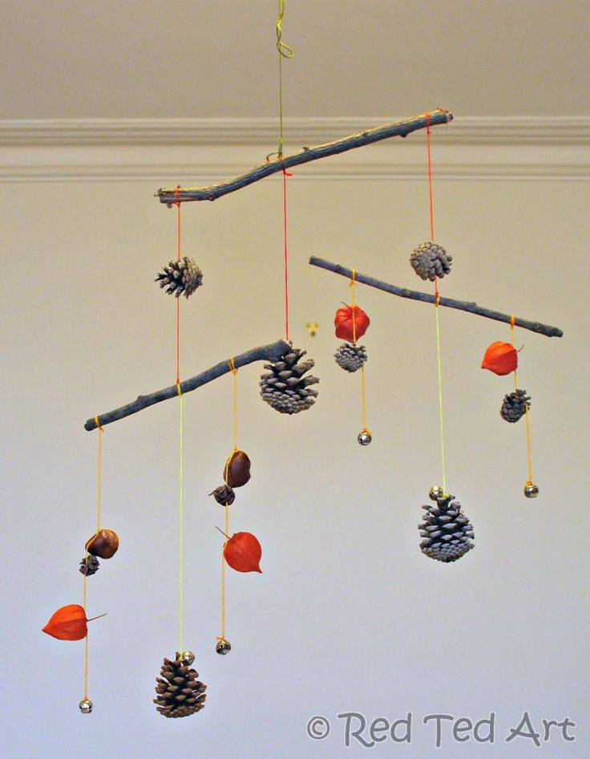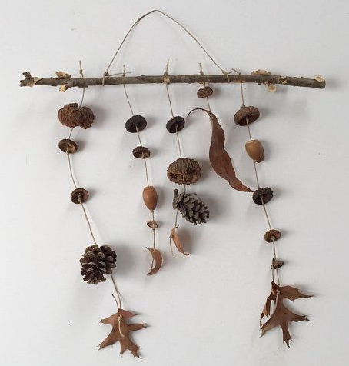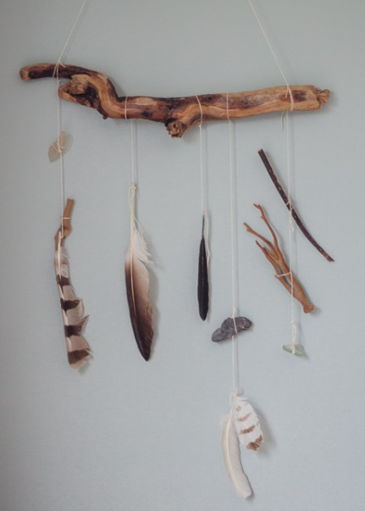

Alternatively – you could collect lots of sticks and make a wind chime.
Dream Catchers
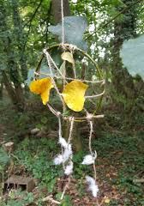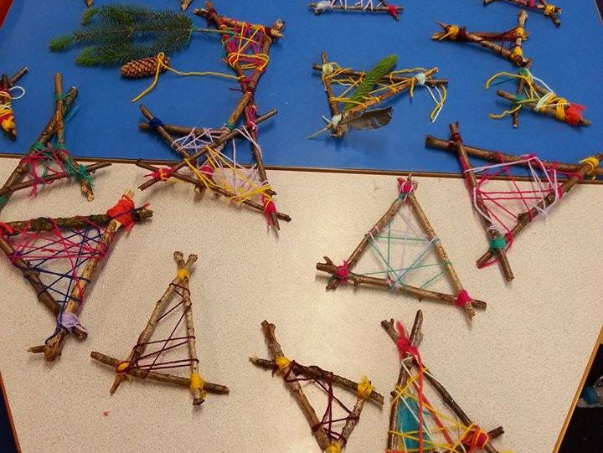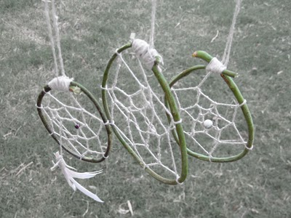
Materials Sticks, coloured wool and feathers or leaves to decorate.
Step 1 Place 3 sticks into the shape of a triangle and tie the ends together.
Step 2 Thread wool between the 3 sticks to create your own unique pattern.
Step 3 Tie longer pieces of string to the bottom of your dream catcher and tie feathers or leaves to the ends as decoration.
Step 4 Tie a piece of wool to the top of your dream catcher and hang it from a tree.

Ice Sun Catchers
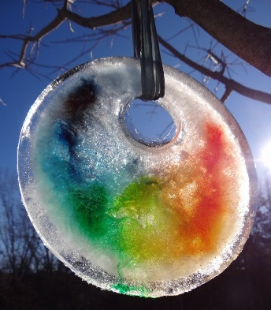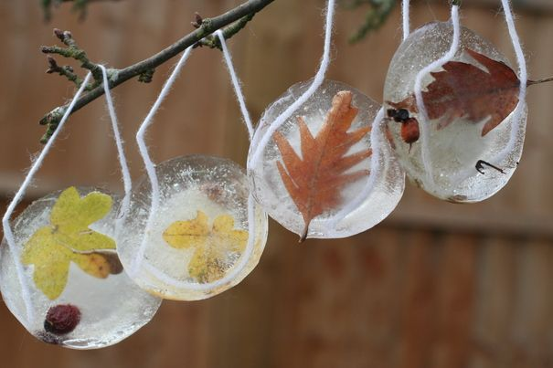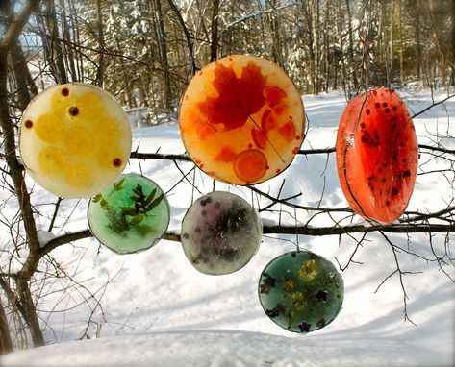
Materials Muffin baking tray/tin, string or wool, leaves, petals, pieces of chopped fruit, water.
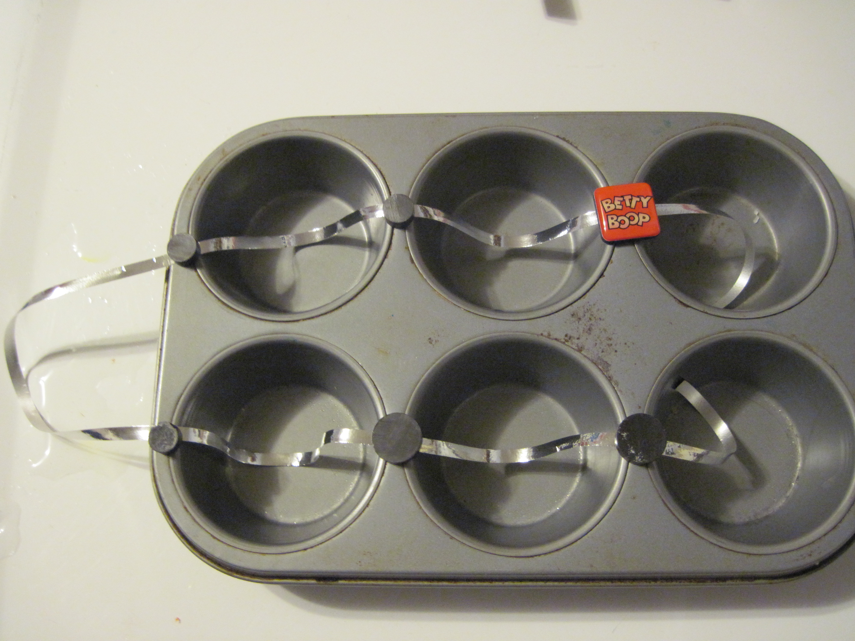
Step 1 Place a piece of string into the muffin tray.
Step 2 place your leaves and petals into the muffin tray and fill with water. Add food colouring if you wish.
Step 3 Place in the freezer for a couple of hours.
Step 4 Remove from the freezer and hang from a tree. Watch the sun light bouncing off the ice.
How long does it take to melt?
Is there a difference on sunny and cloudy days?

Alternatively If you want to go bigger you could use a cake tin and a plastic cup or a plastic bowl and ribbon.
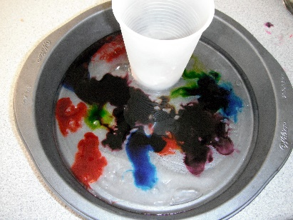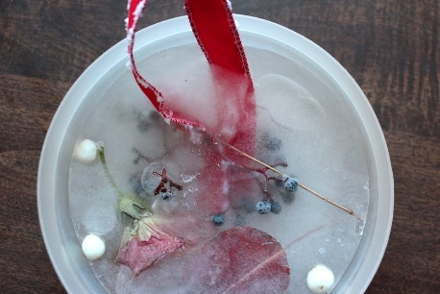
Or if you want to go smaller use ice cube trays. 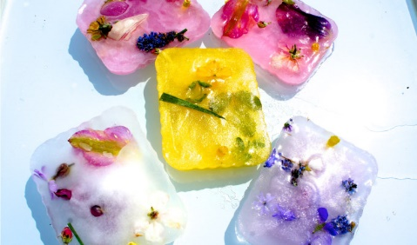
Nature Bracelets
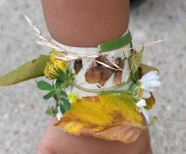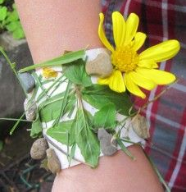
Materials Paper, double sided sticky tape (if you don’t have any just double over some cello tape or use glue when you get home)
Step 1 Cut the paper to fit your wrist and secure.
Step 2 Attached the double sided tape.
Step 3 As you are walking along look for different colours on the ground and stick to your bracelet. Remember not to pick flowers that are still growing or any berries.

Memory Game
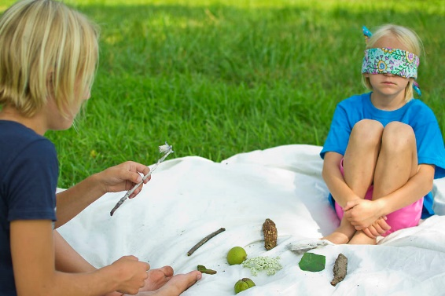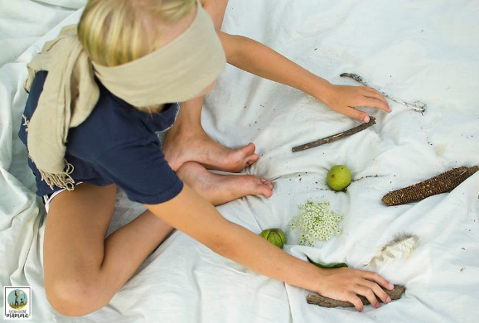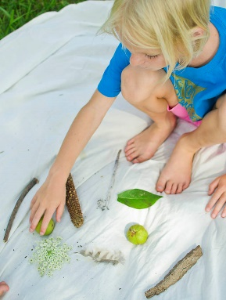
Collect as many different objects as you like. The more you have the harder it is! Spread everything out and try to remember what you have. Take it in turns to blind fold someone and remove on of the objects. Untie the blind fold. Can that person work out what is missing?
To make it harder take away 2 or 3 objects.

Self Portraits
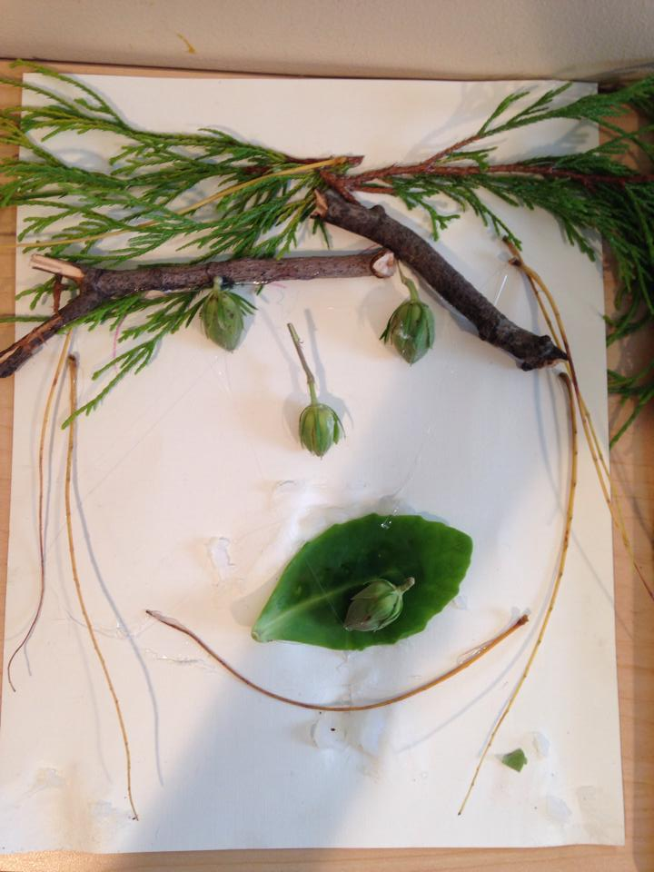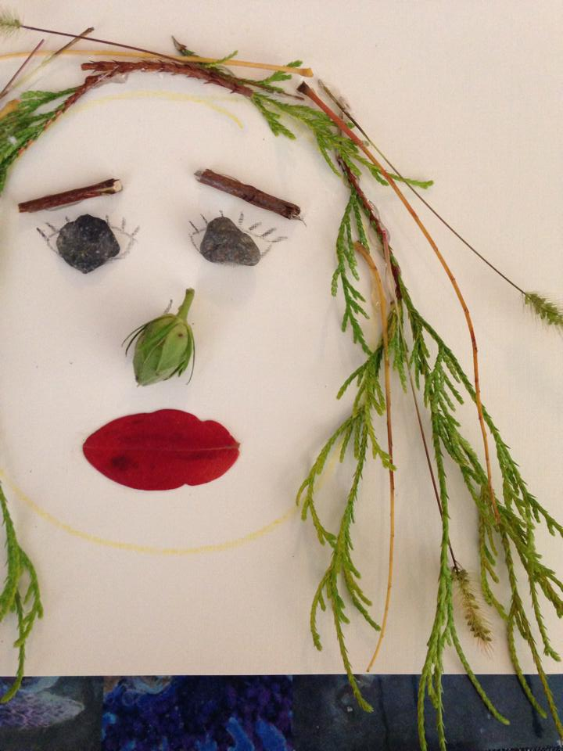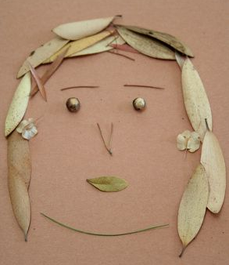
Nature provides some wonderful materials for making art- there are stunning colours, shapes, textures and sizes all around us. We can find materials in our gardens to make beautiful pieces of temporary art which will be returned to nature. Take a photograph to remember.
Materials A piece of paper and objects collected from the ground such as twigs, leaves, pebbles.
Step 1 Gather materials you find on the ground. Don’t pull leaves off trees, break off branches or flowers which are growing. Look around at what is already available. This makes your art work unique and creative.
Step 2 Start your picture and remember that nothing is stuck down so you can change your plans and move things around and no one will know.

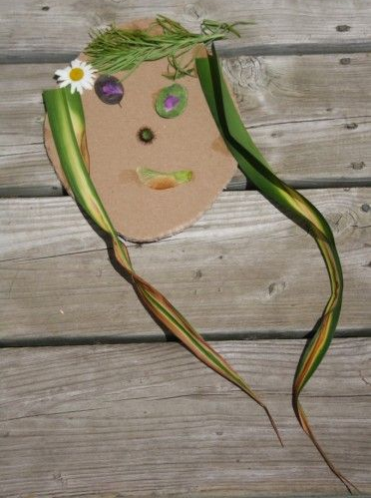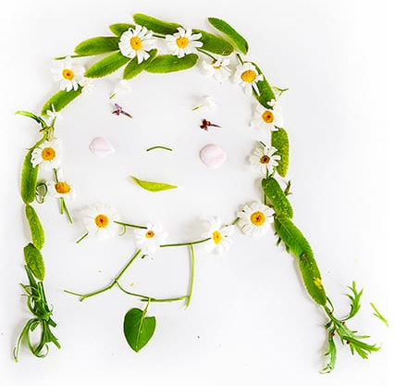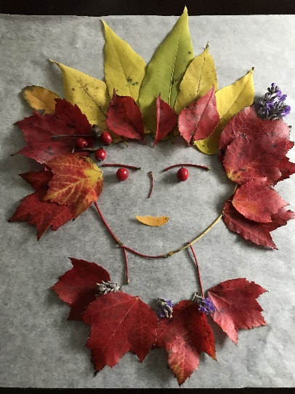

Painting With Nature
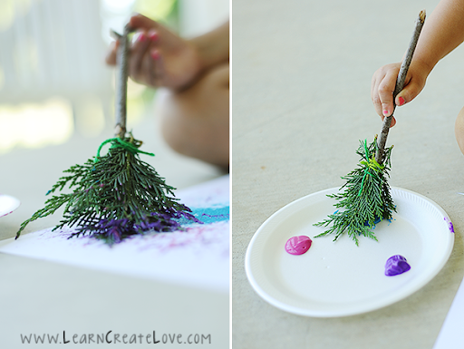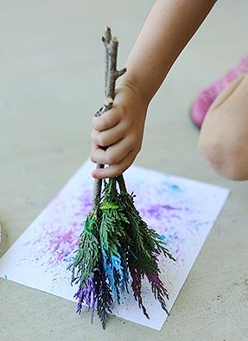

Gather leaves, twigs, flowers and feathers. Tie them to sticks to make a paintbrush. Add paint and you are ready. Have fun!
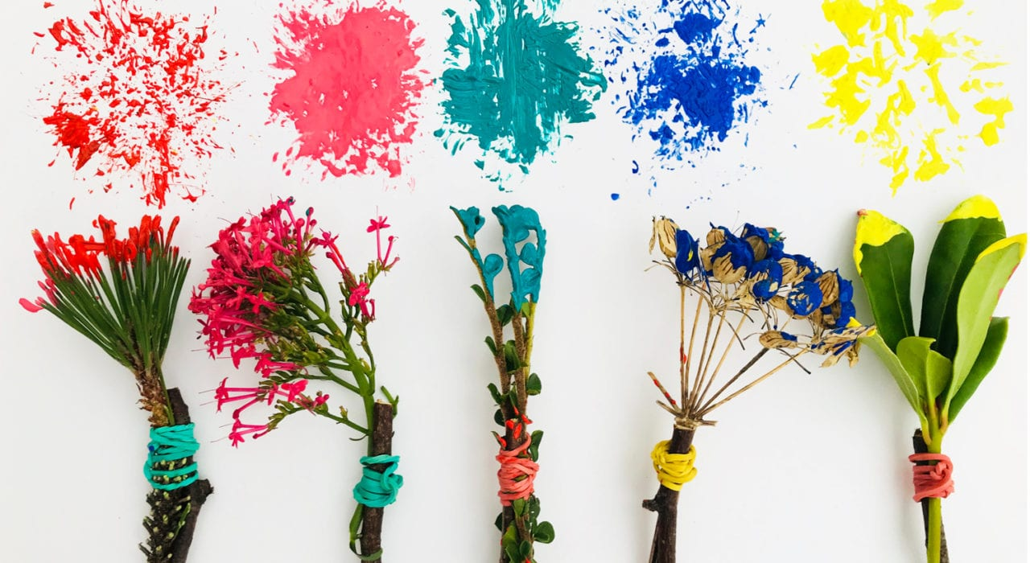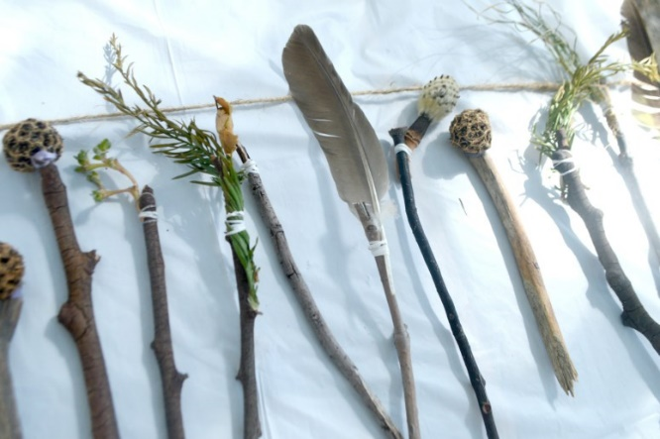
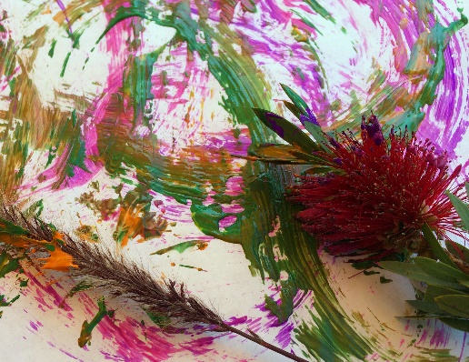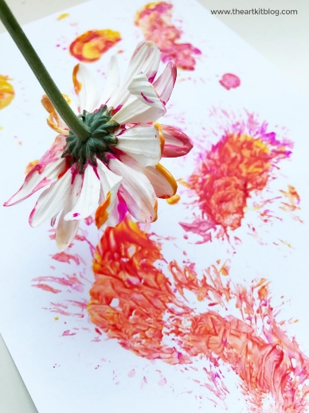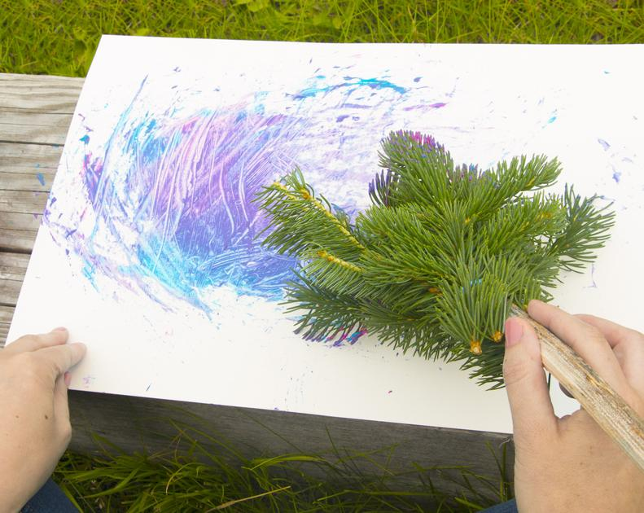
Altenatively Use pinecones. 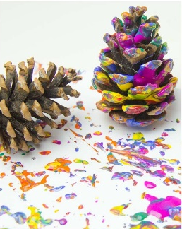
Spider Webs
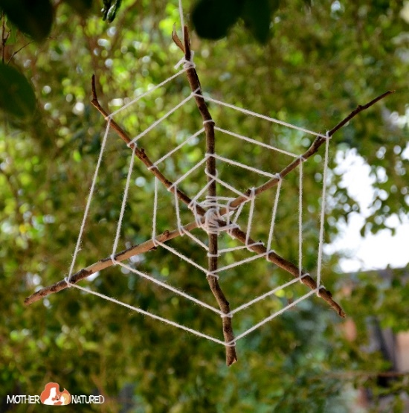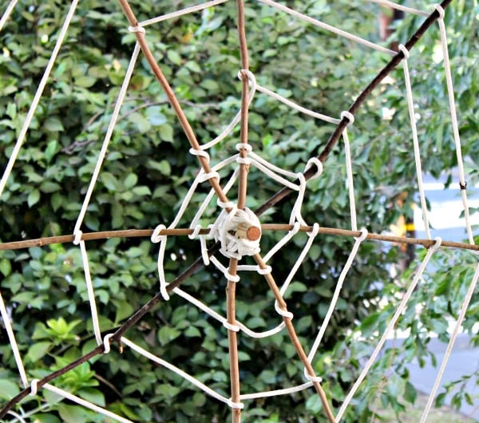
Materials 3 or 4 sticks and string.
Step 1 Place your sticks in a star shape and tie together in the centre.
Step 2 Work from the centre out. Loop your string around each stick to form the web (rows). Once you have completed a circuit move out and start a new row. Continue until you reach the end of the sticks. Tie a knot to secure and hang from a tree.
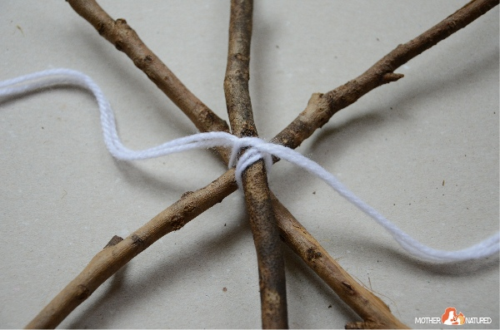

Make a Bee Bath
Honey bees are like miniature super heroes. They fly at a speed of about16 miles per hour and beat their wings 230 times a second. They also help flowers, fruits and vegetables to grow. Why not make them a place to get a drink and have a bath.

Choose a spot in the garden or on a balcony that is protected and shady.
Add rocks to a shallow dish or bowl. Add some water so that the top of the pebbles sit above the water, to give the bees a place to perch.
Change the water daily and clean the bee bath weekly.
If you like you can decorate the pebbles.

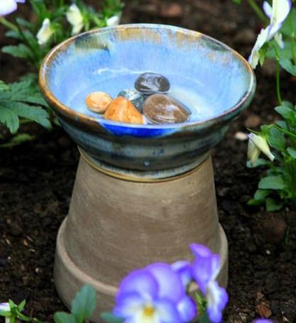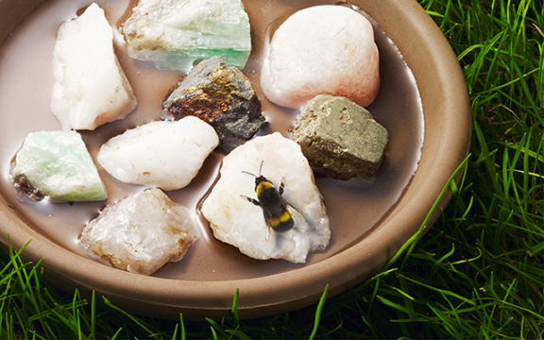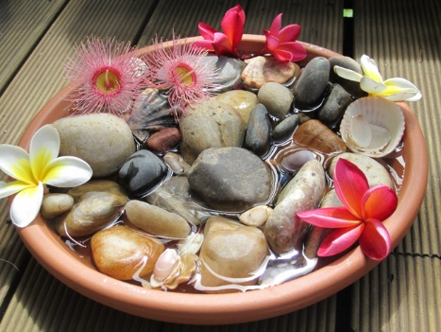

Why do bees need water?
*They use water to dilute their honey to make it the right consistency and to thin out honey that has crystallised.
*Water helps with their digestion.
*They need it to keep the hive cool. They had water to the hive and fan it with their wings, cooling it down.
*
The bee babies need it too. The nurse bees that feed the larvae need lots of water to create the right baby food (this is called royal jelly).

Butterfly Buffet
Ever wondered what to do with an old mushy banana?
Why not use it to create a buffet for butterflies? Mush the banana while it’s still inside its skin, then cut slits along the top. Leave it outside, near some flowers, for butterflies to feast on. They also love rotten apples and squishy strawberries – try putting out plates of each to see which attracts the most butterflies. If wasps visit your buffet too, don’t worry – if you leave them alone, they’ll leave you alone too!




