
Science activities
in the
Outdoor Classroom

Dear Parent,
Given the exceptional circumstances we are currently facing the following short, fun ideas are intended for use in your garden or local park. There is no written work involved.
Your supervision and help is required for all activities. Answers are provided.
Please feel free to pick and mix any of the activities to suit your children and send us photos of your children having fun in the Outdoor Classroom!
Enjoy!
F. Dunn
Tree Survey
Put a tally or a tick below if you find any of these on your walk today.

Beech  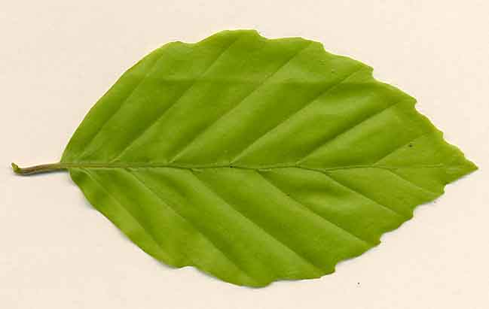 | Lime  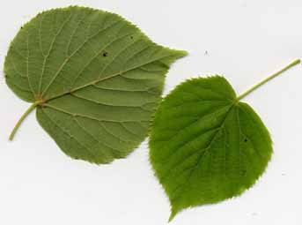 | Pine  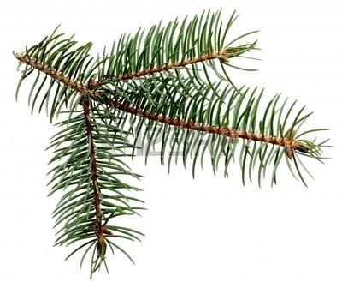 | Maple  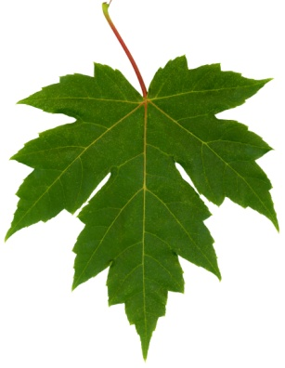
Birch  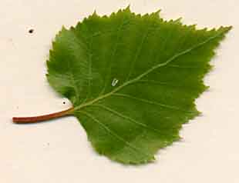 | Oak  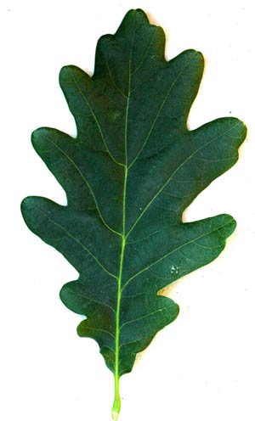 | Ash  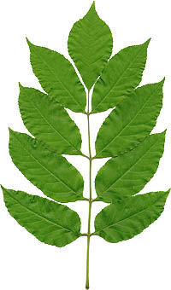 | Hawthorne  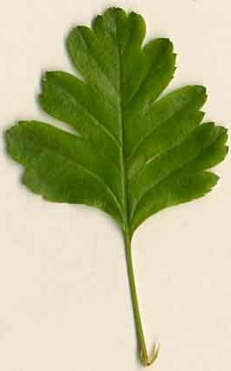

Leaf Rubbings
Find 4 different leaves and using a crayon take rubbings.
Which one do you like best? Why?
Name of leaf: | Name of leaf:
Name of leaf: | Name of leaf:

Bug Hunt
Put a tally or a tick below if you find any of these.

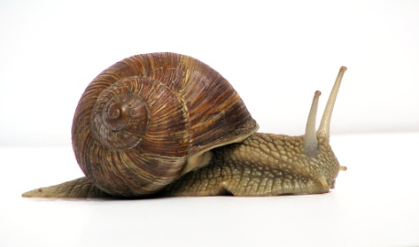 | 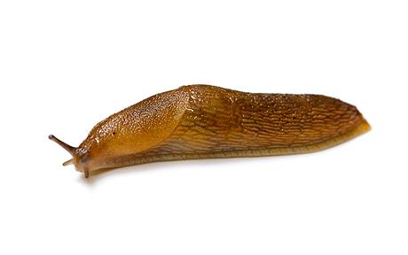 | 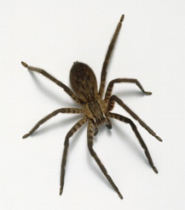 | 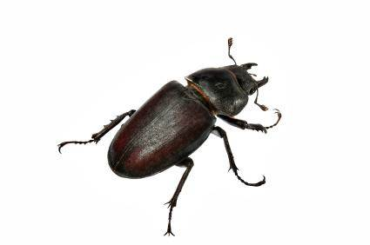
snail | slug | spider | beetle
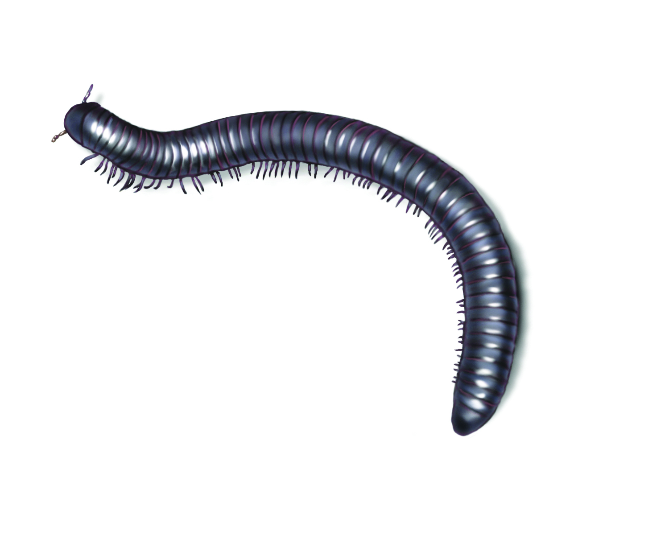 | 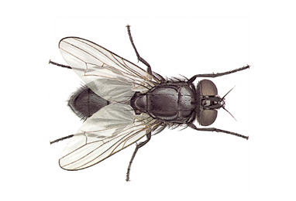 | 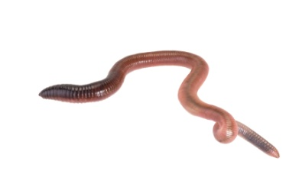 | 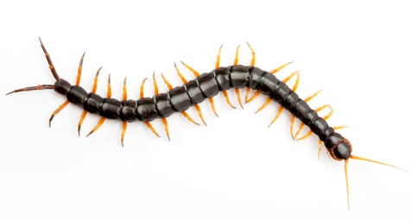
millipede | fly | earthworm | centipede
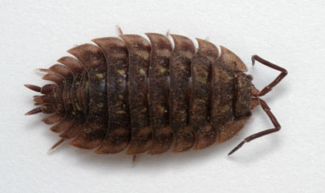 | 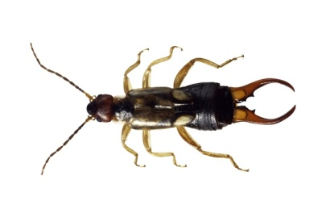 | 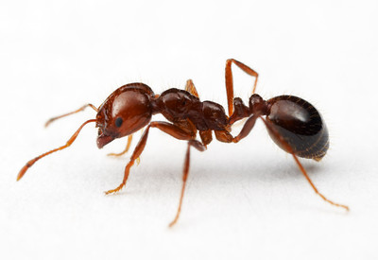 | 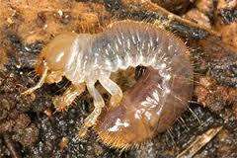
woodlouse | earwig | ant | insect larvae

 Outdoor Science Activities 
Activity | Hints and tips for parents 
Crocus Light- On a sunny day find a blooming crocus and look carefully at the petals. Cover the flower with a shoe box for 5 minutes. Remove the box and look at the petals. What happened to them?  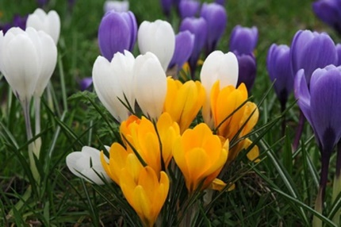 | All plants react to sunlight but a sun-flower always faces the sun and moves very slowly facing the sun. Crocus flowers are very sensitive to light and when covered with the box, receiving no light, the petals will close. When you remove the box within a few minutes you can watch the petals slowly open.  Plants need sunlight to grow and survive.
Dandelion Elastic  - Break the stem of a dandelion plant.  - Squeeze the sap from the stem and use it to coat the end of your finger up to your first knuckle.  - Let the sap dry for a few minutes.  - Gently roll the dry, rubbery sap off your finger as you would roll a sock off your foot.  - Pull the sap in different directions. What happens to the sap?  Activity | Sap is a juice that flows through plants, carrying food and water to all plant parts. The dandelion sap dried to form an elastic material. When it dried, it became stretchable, like a rubber band.  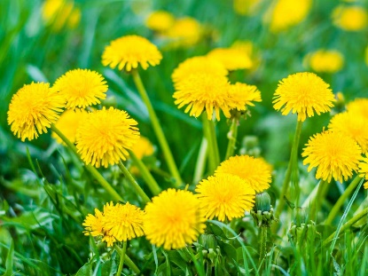  Hints and tips for parents
Tree Hugging-Working with your brother or sister, one child is blind folded and led to a tree. They must use their senses to touch, smell, listen etc. Then they are taken back to the starting point and blind fold is removed. Can they find their tree? | -Observation  -Using senses  -Recalling information
Spinning Spider – What types of webs do spiders weave? Find a spider web. Be sure the spider is not there. Lightly shake a small amount of flour or talc on the web. Hold a sheet of black paper behind the web and press it carefully against the web so as not to break it. Lift the paper away and look at the print made. Spray the print with hairspray to protect it. Look carefully at the design the spider wove. What type of design did it imprint?  Activity | Spiders spin elaborately patterned webs. They secrete a liquid from the back of their bodies that turns into a solid thread when it hits the air. When a spider begins weaving it begins at the centre, and then builds spokes that point out from the centre in all directions. Finally the spider spins the strands around the spokes to form the web. The strands contain a sticky substance that holds any insects which comes into contact with the web. The spider feels the insect trapped in its web by the vibrations the insects movements send along the strands of the web. There are 3 main types of webs-garden spiders build an orb web (spoke formations like a bicycle wheel), the house spider builds a sheet web and the funnel web (looks like a circle of webs wrapped around each other) is found among dead leaves on the ground.  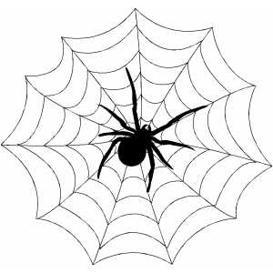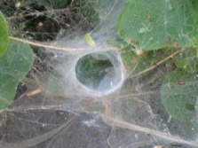  An orb web a funnel web  Hints and tips for parents
Why is grass green?-chlorophyll test. Place a sheet of paper on the grass. Step onto the paper and twist your foot into the grass. Lift up the paper and examine it. What do you see on the paper? | You see green smudges on the paper where the grass rubbed on the paper. Grass and other plants are green because they contain a pigment called chlorophyll. This is needed for photosynthesis, which enables plants to make their food.
Secret Place-What can you find living under a rock? Carefully turn over a rock that has been undisturbed for a while. Notice any insects that rush away. Watch the animals to see where they are going and what they are doing. Examine the soil beneath the rock with a magnifying glass. What do you find? Identify insects. Put rock back exactly as you found it. | Many insects live in dark, moist places. The soil under rocks provides the perfect environment for these insects. The living things you find under the rock differ depending upon the location of the rock and time of year. Small insects you might find would be ants, millipedes, worms, centipedes, slugs, caterpillars, spiders and beetles. The insects moved quickly to escape the light.
Shadow Watch-What happens to shadows after a few minutes? Place a sheet of paper on the ground next to an object/plant. Draw an outline around the objects shadow with a coloured pen. Leave the shadow for a few minutes. Return to shadow a draw an outline again with a different coloured pen. What do you notice?  Activity | A shadow is made when an object blocks the light rays falling on it. As the earth moves the angle of the sun’s light on the object changes causing the shape of the shadow to change. The difference in the 2 outlines you drew is an indication of how much the earth moved since you drew the shadow.  Hints and tips for parents
Bark Investigation-Using a magnifying glass examine the bark of different trees. Look for different textures, colours, interesting features or characteristics. Record findings and take bark rubbings. | The bark is the outer wood of the tree trunk and branches. It protects the tree and helps keep water inside. Bark is a dead layer of the tree that cannot grow. As the tree grows the bark cracks and falls off. Each tree as a unique pattern of cracks and ridges.
Tree Age -How can you determine the age of a tree without counting the rings? Look at the branches of a pine tree. Notice the groups of circles of branches around the tree. Count the groups of circles that go completely up the tree to determine the trees age. | Each year a pine tree adds a new circle of branches around its trunk. By counting the circles of branches you can determine the trees age. But inspect the trunk carefully to make sure no one has cut off a row of branches.  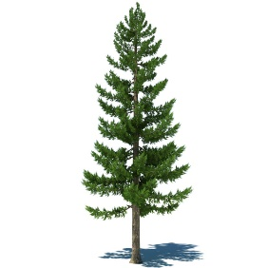
Mirror Walk -Children walk along a tree lined path in single file. Each child holds a mirror (pointing sky wards) under their noses. They will think they are walking on the treetops and try to jump from branch to branch. | You need a mirror.  Stay close to your child.  

