Monday 15th June 2020

Plan for Titanic Project
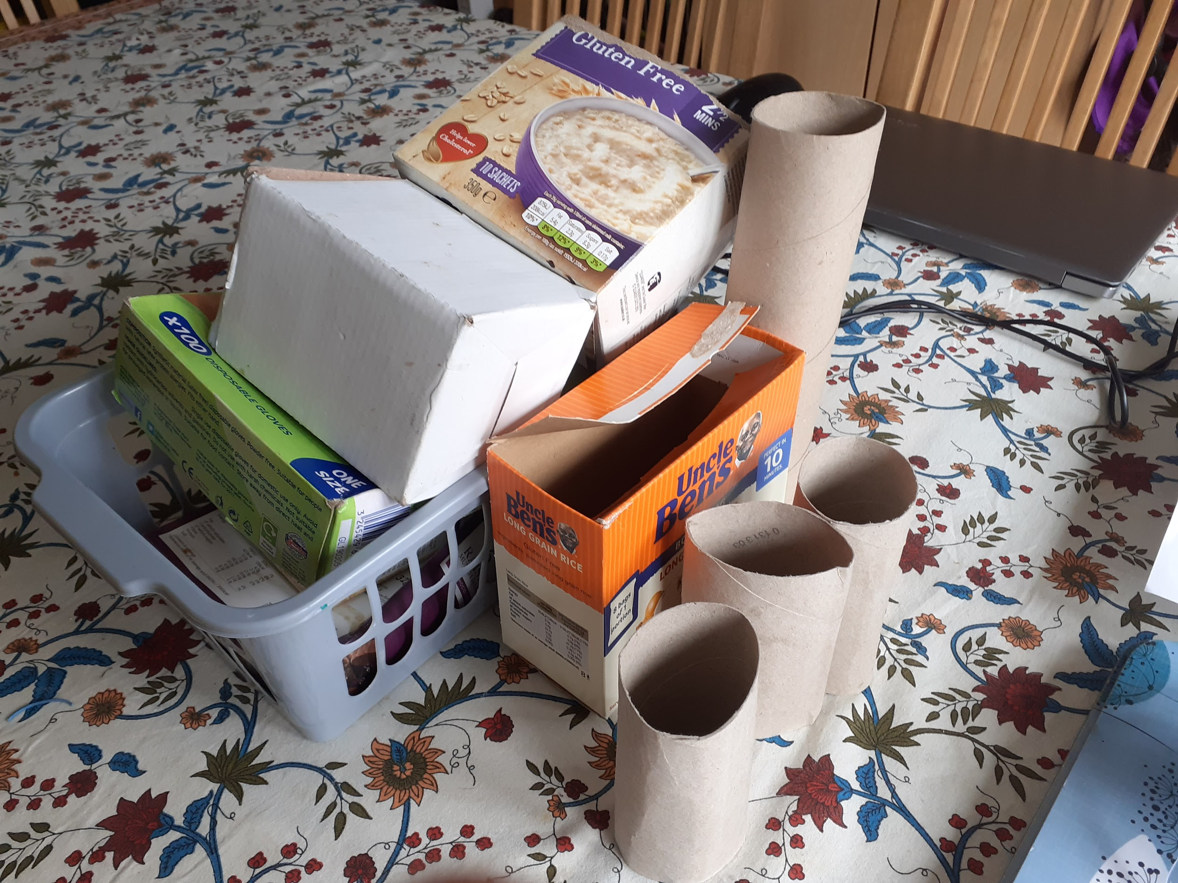

- First of all I went outside to go and get boxes from the recycling bin.

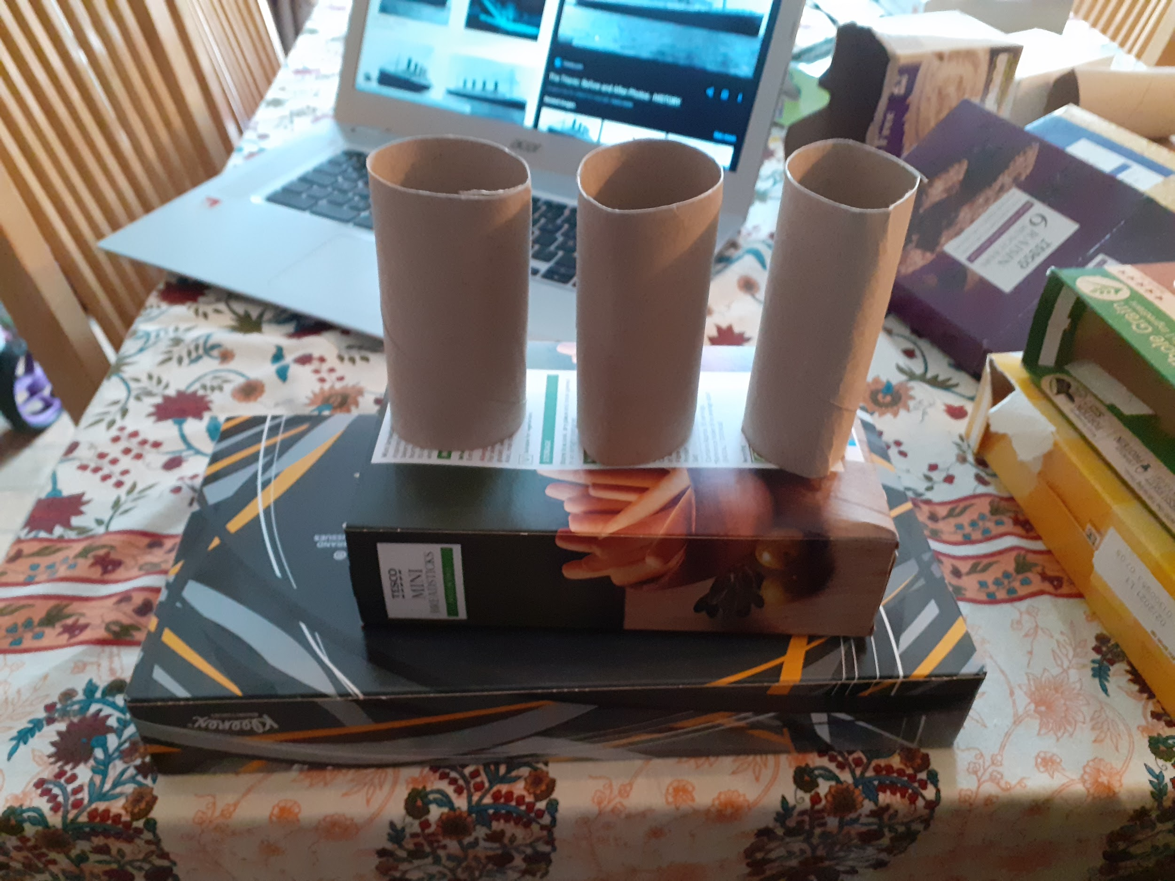
- I tried different ways to build it with the boxes.

- I glued parts of the ship together.

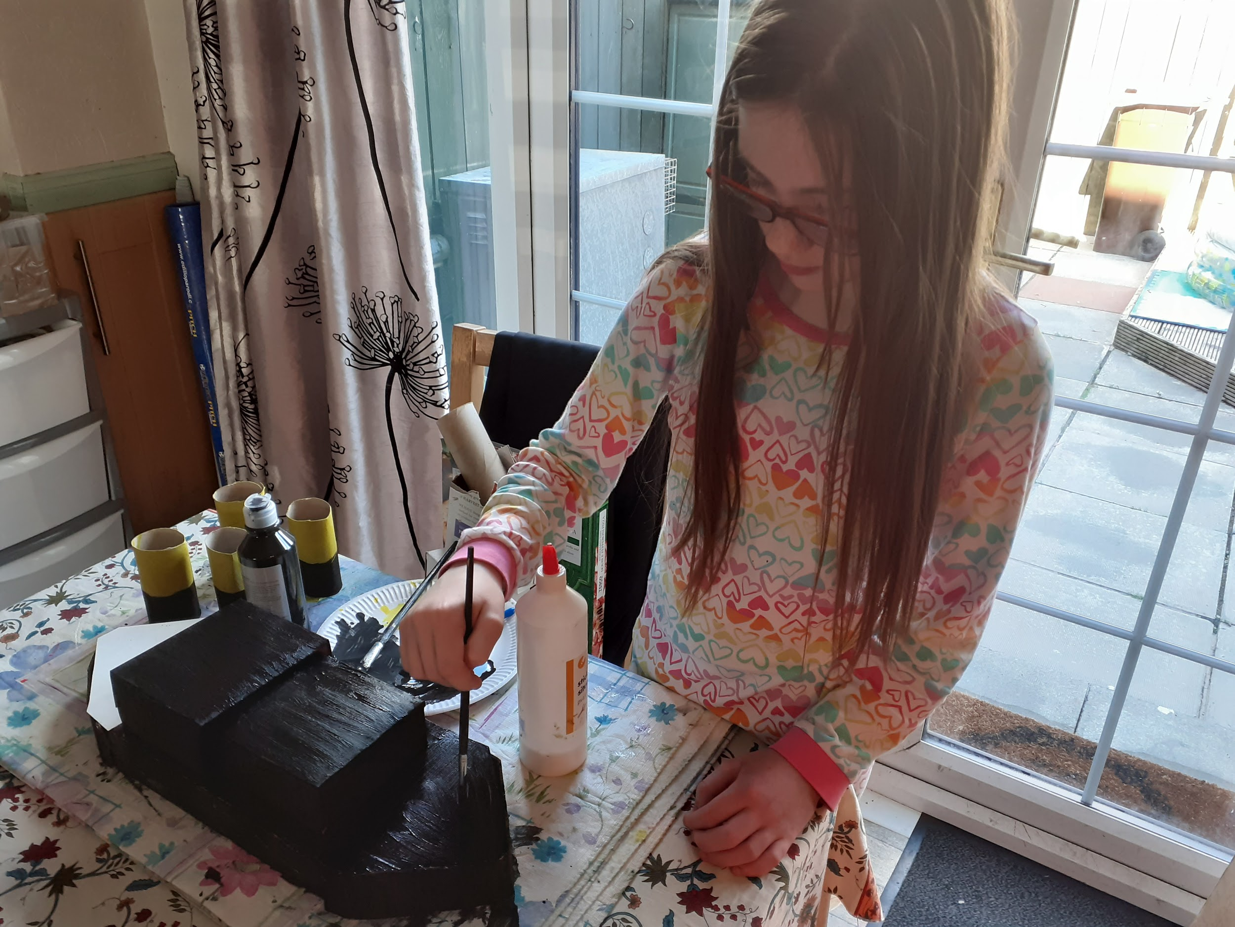
- I started painting the main parts of the ship.

- I waited for the paint to dry.

- Then I did the details on the ship.


