Building RMS Titanic in Minecraft

Materials:

Construction
104 red concrete
100 black concrete
104 yellow concrete
122 white concrete

Items
96 stone buttons

Nature
6 cobwebs

Method:

1. Firstly, make this shape out of red concrete.

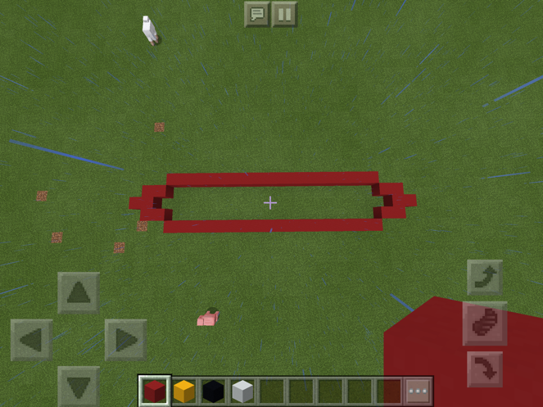

2. Fill in the bottom.

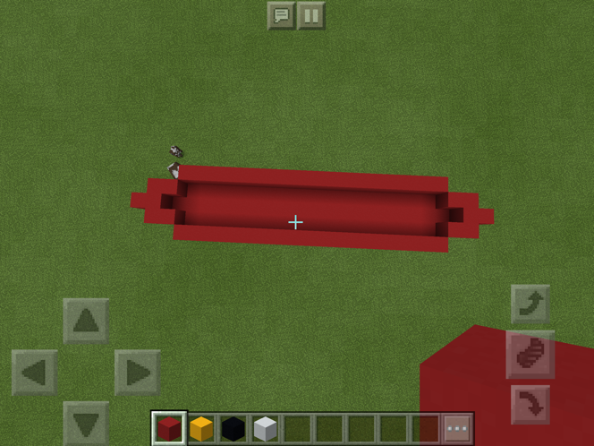

3. Then build another 2 layers with black concrete.

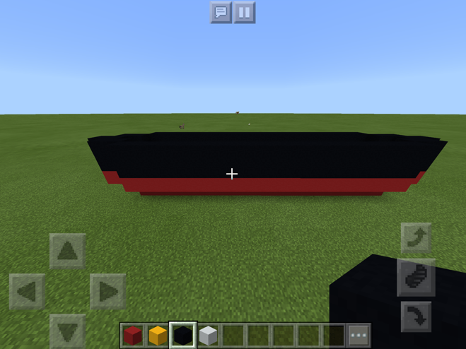

4. Cover it with yellow concrete.

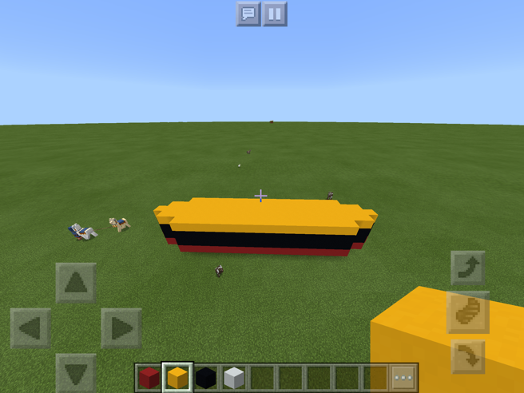

5. Build another layer with white concrete.

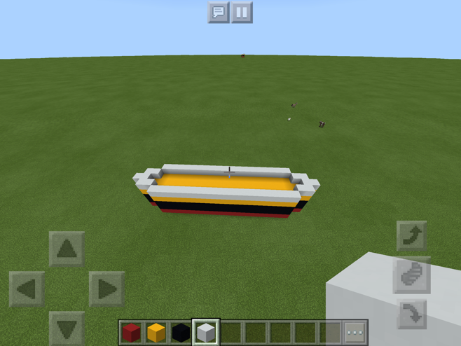

6. Next, fifth block in, make a 10 by 3 chunk which is 2 high.

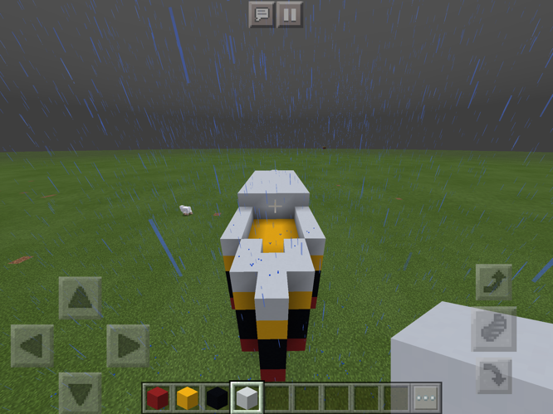

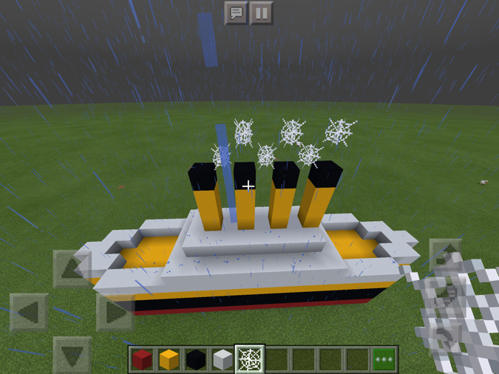
7. Then, one block in make a 3 by 8 chunk, 1 block high.

8. Then again, one block in make 4 pillars
made out of yellow concrete, 3 blocks high with 1 block of black concrete on top.

9. Place 2 cobwebs diagonally from each one except the fourth.

10. Finally, place stone buttons on the black layers.

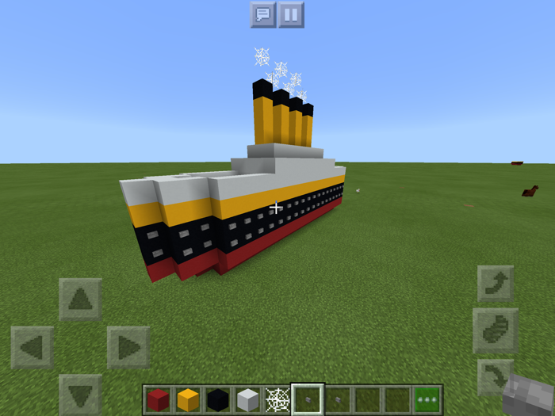

Optional

11. Make a 30 by 11 hole which is 1 deep

12. Fill it in with water buckets or you can just do it in an ocean biome.



