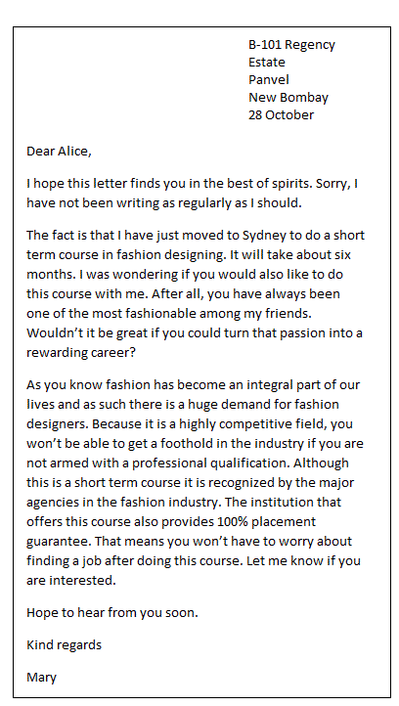

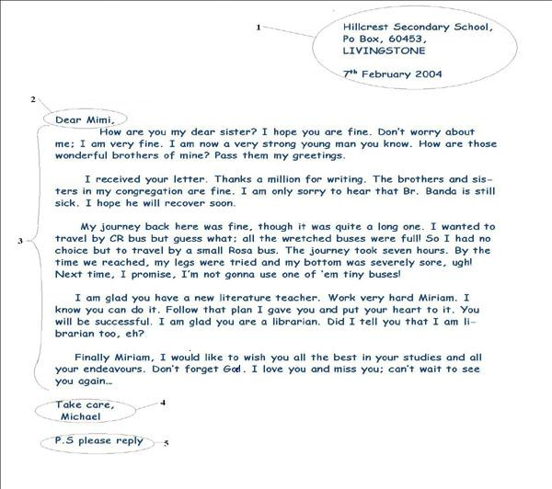
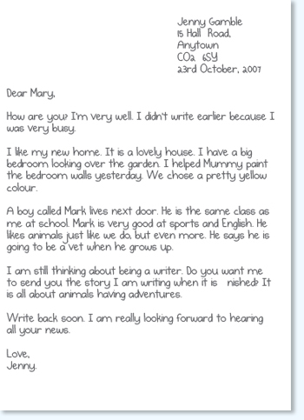

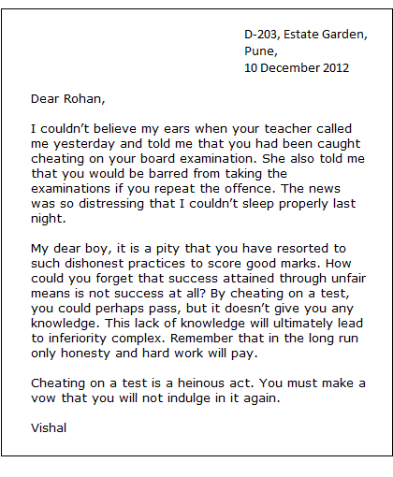
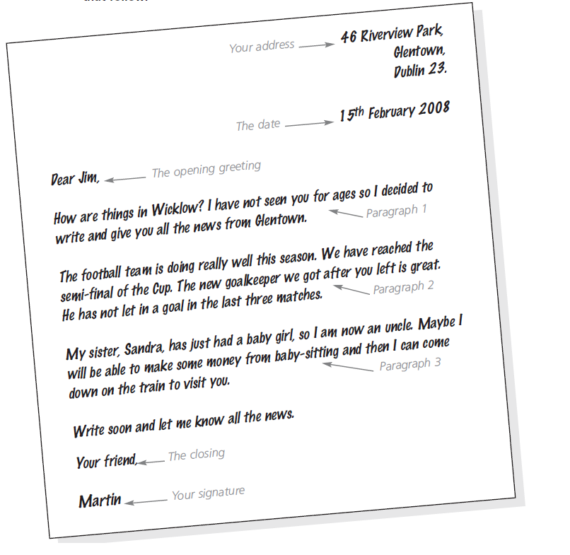
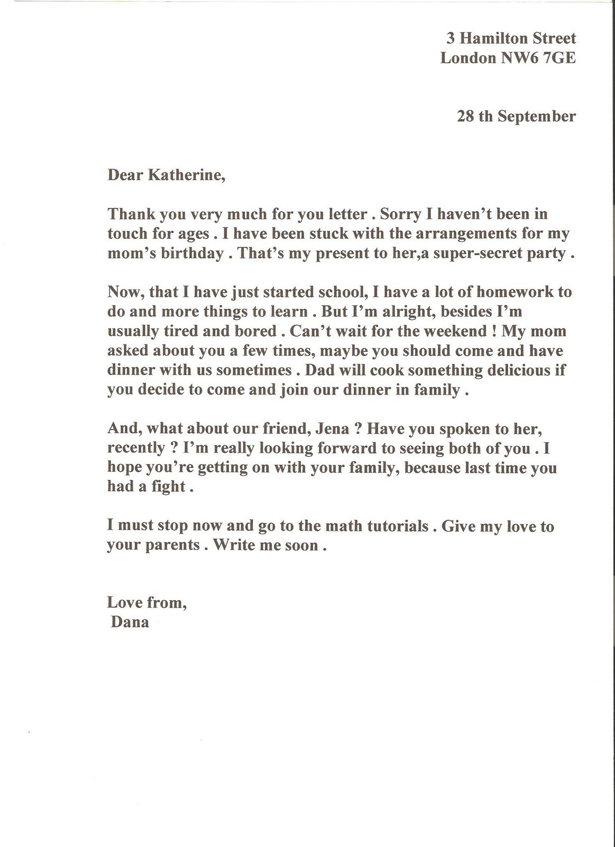

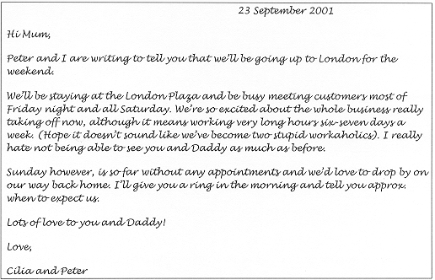

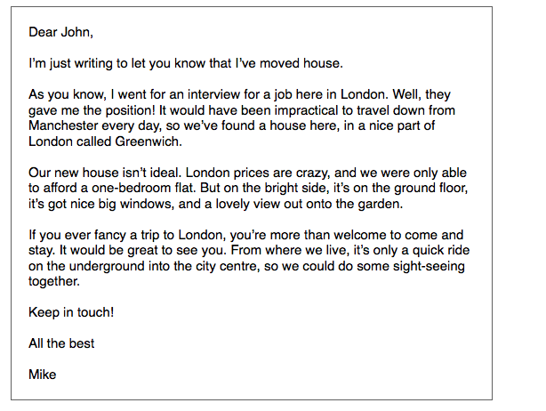

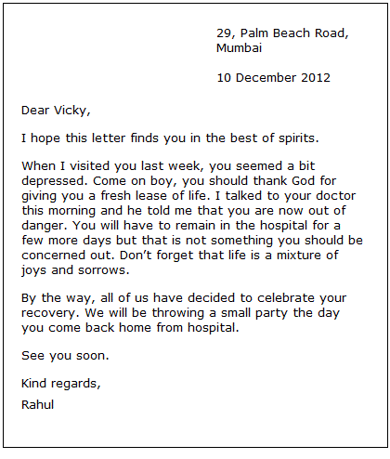

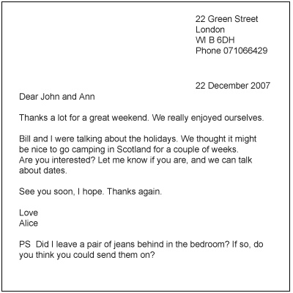

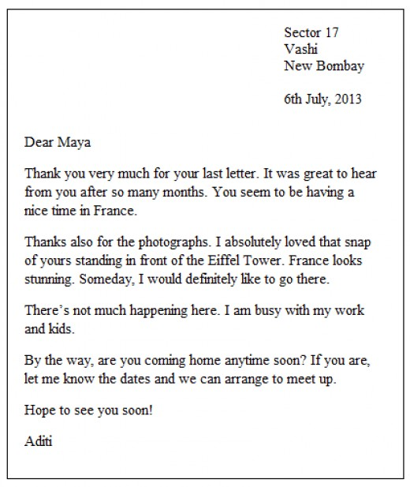

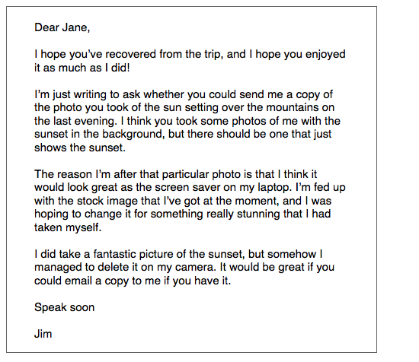

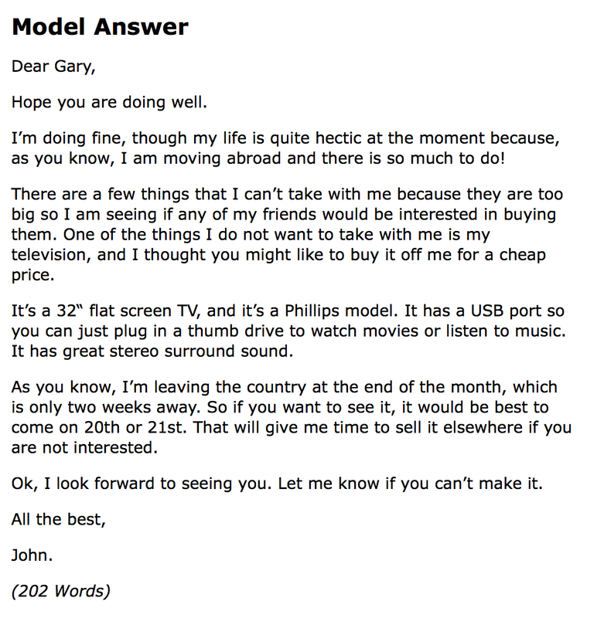
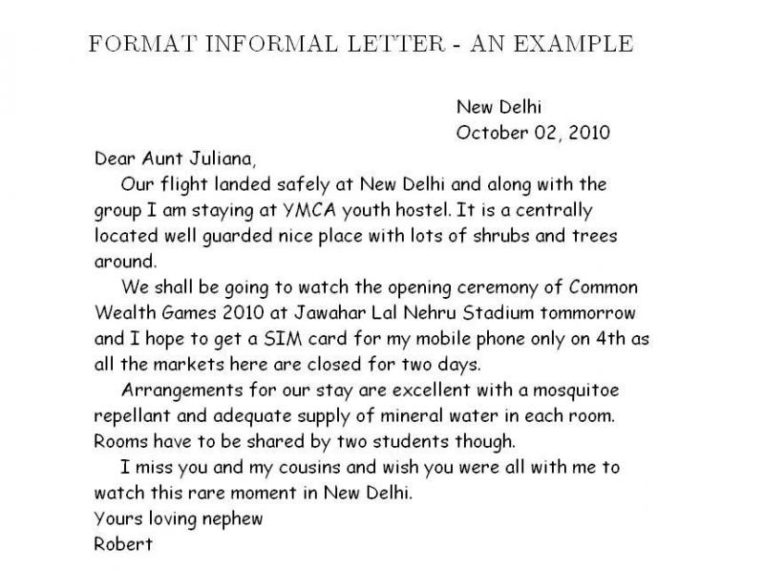

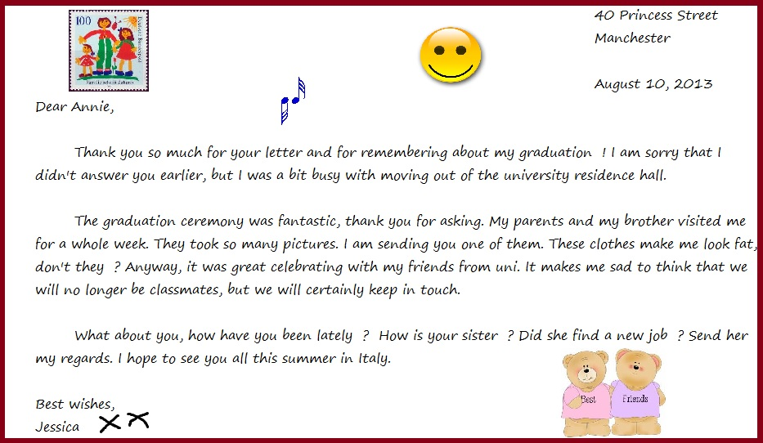

22, Green street
Preston
Lancashire,
Pr5 4BB
20 July 2012

Dear Peter
My name is Andy and I am 9 years old. I live in Preston with my mum, dad and brother.

We have 2 cats. They are called Bubble and Squeak. Do you have any pets? Bubble likes to hunt. He is always bringing home birds and mice!

My favorite hobby is music. I play the piano and violin. I also like reading and films.

I hope you will write to me soon
Andy

Dear Mimi,
How are you my dear sister? I hope you are fine. Don't worry about me; I am very fine. I am now a very strong young man you know. How are those wonderful brothers of mine? Pass them my greetings.

I received you letter. Thanks a million for writing. The brothers and sisters in my congregation are fine. I am only sorry to heat that Br. Banda is still sick. I hope he will recover soon.

My journey back here was fine, though it was quite a long one. I wanted to travel by CR bus but guess what; all the wretched buses wee full so I had no choice but to travel by a small Rosa bus. The journey took seven hours. \By the time we reached, my legs were tired and my bottom was severely sore, ugh! Next time, I promise, I'm not gonna use one of 'em tiny buses!

I am glad you have a new literature teacher. Work very hard Mariam, I know you can do it. Follow that plan I gave you and put your heart to it, You will be successful . I am glad you are Liberian. Did I tell you what that I am librarian to, eh?

Finally Mariam, I would like to wish you all the best in your studies and all your endeavors. Don't forget God. I love you and miss you; can't wait see you again..

Take care
Michael

22 Green Street
London
WI B BDH
Phone 07 1021531

10 January 2013

Dear John and Ann
Thanks a lot for great weekend we really enjoyed ourselves
Bill and I were talking about holidays. We thought it might be nice to go camping in Scotland for a couple of weeks. Are you interested? Let me know if you are, and we can take about days

See you soon I hope. Thanks again

Love
Alice

PS Did I leave a pair of jeans behind in my bedroom? if so, do you think you could send them on?

Dear Ma,

How are you? How’s Dad? And Ben? Is Ben alright? Has he tripped and broken his leg yet again? I can just imagine poor clumsy Ben falling and crying his eyes out. The poor lad does need to be more careful in his wandering. Very soon he’ll turn ten and start calling himself a big boy!

I’m feeling quite excellent here. The academic requirements keep me so busy! I hardly have time to miss you. Though, sometimes, I do miss eating with you people very much. I can’t wait for vacations to begin! I’m going to gorge on all your dishes like there’s no tomorrow!

I’ve started to develop a keen interest in architecture and am even taking an introductory course in it this term. Who knows, I might even major in it! Hopefully, though, my interest in architecture shouldn’t wane—the way it did for medicine, remember, Ma?

I hope Dad’s doing well. And please don’t skip your meds, Ma. I miss you guys a lot and I cannot wait to see you.
Love,

Johnny



