Friday writing activity week 1
A biography is another form of recount writing, when information is gathered about someone and presented in an interesting way.
A biography is written by someone else, not the person the biography is about.
An autobiography is written by someone about themselves.

Biography
This week for your writing task, you need to choose a celebrity and create a fact file about their life. You can decide on your own categories. These might include name, age, place of birth, career details, special achievements, awards received etc. You may wish to sketch or print out a picture of your celebrity to accompany your work.
The start of an example is below...
NAME: Tulisa Contostavlos
AGE: 23
Date of Birth: 13th July 1988
Occupation: Singer/Songwriter and X Factor Judge.
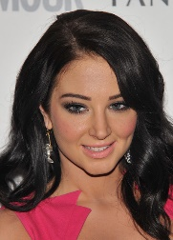

Try to think of a variety of additional fact file categories you could include about your chosen
I hope that you enjoy your task.
Mrs McDougall and Mr Gullen

