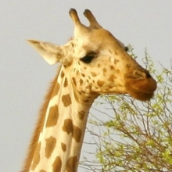
African animals
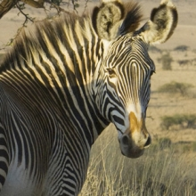
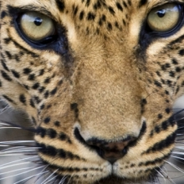
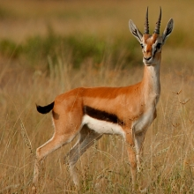
T | K | R | A | V | D | R | A | A | B | O | G | F | F | E
Y | N | H | C | R | A | N | E | A | F | Z | D | M | L | L
L | I | A | E | N | E | U | B | D | Z | D | E | L | F | I
J | U | T | H | I | T | O | R | R | A | P | E | B | Z | O
G | Z | E | N | P | O | M | S | T | U | Z | B | F | R | N
Y | P | E | T | N | E | G | T | K | A | D | R | S | M | A
Y | T | H | K | B | K | L | I | G | T | M | E | W | Z | J
U | V | C | U | C | W | J | E | R | A | R | G | E | B | H
I | L | E | O | P | A | R | D | Y | A | K | I | D | Y | P
A | K | F | M | A | R | C | C | K | E | F | T | U | B | R
P | R | I | B | I | T | I | O | L | M | K | F | Y | W | J
K | H | A | I | I | H | D | W | U | P | W | N | E | I | O
C | T | A | N | W | O | A | X | I | K | U | T | O | T | K
C | A | N | N | R | G | Y | A | N | N | T | R | U | M | I
X | Z | Q | P | Y | O | D | R | E | J | D | P | B | K | O

AARDVARK | BABOON | BAT
CHEETAH | CHIMP | CRANE
ELEPHANT | GAZELLE | GIRAFFE
LEOPARD | LION | MONKEY
PARROT | TIGER | WARTHOG
ZEBRA

