East Newspaper 16th April 1912
TITANIC DISASTER
By Cameron Gallagher
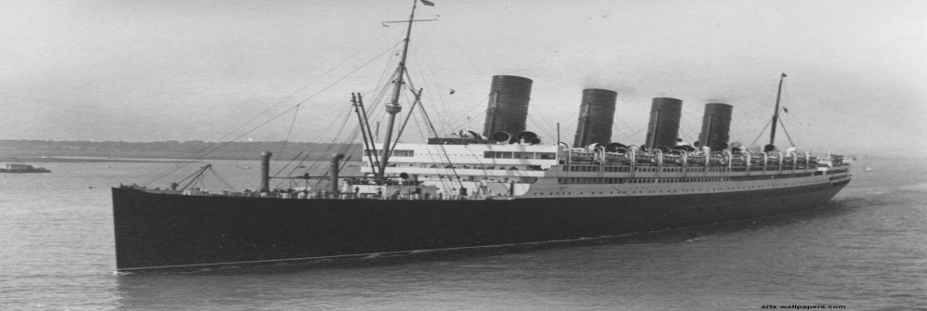
GIANT WHITE STAR LINER SINKS AFTER COLLISION WITH ICEBERG.
Titanic the largest ship ever made with cutting edge technology carrying 2,240 passengers on board the ship left Southampton on April 10th going to New York hit an Iceberg just four days into the trip and sunk. 1,503 people died including passengers and crew. Titanic was built in Belfast, Ireland it took 3 years and cost millions of dollars to build.
On Sunday 14th April at 11:40pm the Titanic traveling at 22.5 knots hit an iceberg in the Atlantic Ocean near Canada. Around 1,500 people have died and only around 700 have survived as there as not enough lifeboats for everyone to use.
A survivor said “if the captain, Captain Smith had of slowed down the ship the disaster might not have happened”. There are many stories about how the disaster happened but we have no further information at this time.
We will bring you more information on the Titanic’s final journey in the next fe days.

