Name: Date:
The sinking of the Titanic – who was to blame?
Captain Edward Smith | The passengers | J. Bruce Ismay
He was the captain of Titanic. Despite ice warnings, he sailed quickly because he wanted to compete with other passenger ships. He did not believe that modern ships could sink so took the risk. He wanted to cross the Atlantic faster than the Olympic, Titanic’s sister ship. At the time of the collision with the iceberg, the Titanic was sailing at full speed. | Many passengers refused to board the lifeboats when Titanic started to sink because they did not believe that the ship would sink. Newspaper articles calling Titanic ‘unsinkable’ may have influenced them. | He was in charge of the company that owned Titanic. He pushed the captain to travel faster and faster despite iceberg warnings because he wanted it to be a record-breaking journey. There may have been a fire on Titanic, which could also have made him push the captain to get to America faster. He also decided that the ship should have only 20 lifeboats instead of the 32 needed.
Jack Phillips | Captain Stanley Lord | Quartermaster Hichens
He was the senior wireless operator and was busy sending a backlog of messages from passengers. This may have led him to ignore a message from Cyril Evans onboard the SS Californian, sailing 20 miles from the Titanic, about an iceberg sighting. He did, however, continue to send out distress messages until the ship sank. | He was the captain of the nearby ship the SS Californian. He turned the radio off at 11.15pm so did not hear the distress messages. He also saw the emergency flares from Titanic when it was sinking but decided that it was just a party and did nothing. They could have rescued a great number of passengers. | When the iceberg was sighted he ordered the ship to turn hard-a-starboard. This steered the ship directly into the iceberg rather than away from it.  Some say that he followed orders but that they may have been confused, thinking that the ship needed to turn right rather than the tillers, which would have turned the ship left.

Thomas Andrews | David Blair | The shipbuilders
He designed the Titanic with watertight compartments but due to the desire for larger rooms, the seals did not come up high enough. This meant that water rose over the top of the compartments making the ship sink much faster and allowing less time for passengers to be rescued. | He was going to be on the Titanic crew but in the end was not on the voyage. He had the key for the cupboard holding the binoculars, which meant that the lookouts didn’t have binoculars, which might have helped them to spot the iceberg sooner. | They used poor quality iron for the rivets, which did not hold the ship together when it hit the iceberg. Stronger rivets could have reduced the amount of damage and kept the ship afloat for longer.


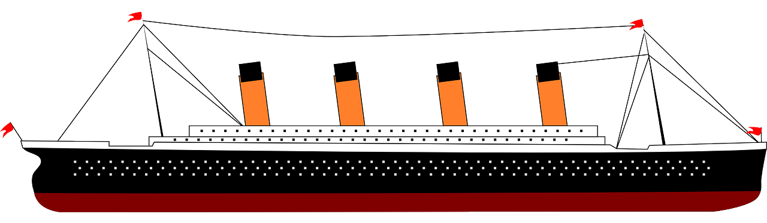
Teaching notes

Ever since Titanic sank the public have been fascinated to discover the reasons why the collision with the iceberg was fatal for so many people. Even more so, they wonder how it could have been avoided.

Look through these cards and see whether you think that the people involved are blameless or should take some of the blame.

Then take the cards of the ones that you think must take a share of the blame and order them from most responsible for the sinking to least responsible for the sinking.

You may choose to arrange them as a diamond nine with the most responsible at the top:



