“The Greatest Ship Ever Made”
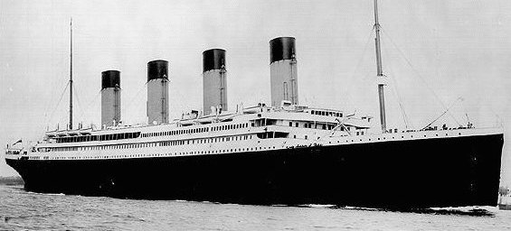
They called it ‘Unsinkable’; the largest ship ever made with cutting edge-technology that would dominate any sea it chose to enter -The Titanic was truly considered to be the greatest ship ever made when it was sent on its maiden voyage in 1912. No-one could possibly have known what was to come, but what exactly was it about The Titanic that made it so special?
The Ship itself
White Star Line was the company that built the Titanic and was owned by J.P. Morgan, an American tycoon with a lot of huge amounts of money at his disposal. He would need it; the RMS Titanic would end up costing a monumental $7.5million when it was finally built.
It took 3,000 men two years to build the Titanic with three million rivets being used to hold its massive hull together! Although there were 4 funnels (smoke stacks) that towered into the sky, only 3 were operational; the 4th funnel was merely for looks. The ship measured a huge 269 metres in length and 30 metres in width – it was comfortably the largest ship ever built.
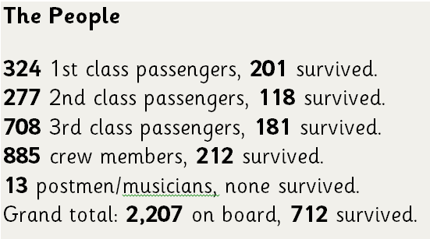
The Titanic was very expensive for ‘first-class’ travellers, the price of a single ticket was $4,700. (around $50,000 in 2016!) However, it was possible to travel on the vessel for a significantly lower amount if you were happy to go second or third class. The ship had a wide variety of things that made it stand out from other, lesser vessels. It had a Turkish Bath that travellers could bathe in, many restaurants of varying cuisines and even a gymnasium – a rarity in 1912.
With 2,240 passengers on board, the ship left the port of Southampton in 1912 on April 10th. With a destination of New York, The Titanic would reach the end of its journey in just seven days. However, all did not go to plan…
The Iceberg
To cut costs and to avoid changing how the ship was built, White Star Line only put enough lifeboats on the ship for half the people on the board; this would become an immediate problem just two days after it had set sail. There were 6 ice warnings received by Titanic on the day of the collision. They were all ignored by the wireless operator who was preoccupied with transmitting passenger messages.
On the night of the collision, because the moon was not out and the water was so still, it was very difficult to see any icebergs. A less calm water would have caused breakers around the iceberg making it easier to see it from afar.
The iceberg that the Titanic struck was not a very big one. It did not even come up as high as the bridge of the ship. However, what was unusual is that unlike the other icebergs seen during the journey, this one was far larger underneath the water. The iceberg caused a huge, unrepairable gash in the middle of the ship.
Collision / Damage
The Titanic was traveling 22.5 knots while cruising through iceberg laden waters. Just 0.5 knots from her maximum speed capability. The collision occurred at 11:40pm on Sunday, April 14, 1912.
Sadly, The Captain had ordered the engines reversed which had, surprisingly, sealed the Titanic's doom. Like all ships, the Titanic turned more quickly the greater her forward motion. Had the Titanic proceeded ahead and turned, it is most likely that she would have avoided hitting the iceberg all together. Reversing had made the ship become slow and unable to turn quickly enough!
The damage that the iceberg cut into the hull of the Titanic was around 70 metres long. Unfortunately, the "watertight" compartments of the Titanic's hull were not actually watertight. They were open at the tops, which aided in the demise of the ship. The ship could actually have stayed afloat if only four compartment had flooded… five became flooded with ice-cold water.
Survivors / Casualties
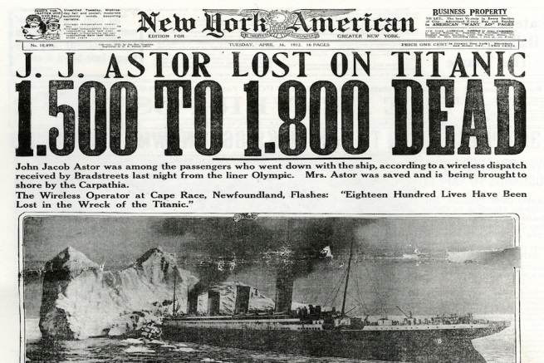
1,503 people died, including passengers and crew with only 705 surviving. There were simply not enough life-boats for everyone to use. In addition, a sad fact is that one of the first lifeboats to leave the Titanic carried only 28 people, it could have held 64 people.
Orders from the Captain were that, women and children were to board the lifeboats first. One man, Daniel Buckley, disguised himself as a woman to get aboard a lifeboat. As the ship went down, the band played music up to the last few minutes before the ship went under.
What remains of The Titanic?
More than 100 years later, The Titanic lies 2.3 miles down at the bottom of the Atlantic Ocean near Canada. The Titanic was rediscovered on July 14th, 1986. 74 years after it sank. Since the death of Millvina Dean, May 31st of 2009, there are no longer any living survivors of the Titanic tragedy. She was just nine weeks old at the time of the Titanic's sinking. April 14th, 2012 marked the 100th anniversary of the Titanic's sinking.
“The Greatest Ship Ever Made” was truly an amazing thing to behold. But it was also marred on its first voyage by a serious of mistakes. A lack of life-boats (that were then used incorrectly) doomed the journey from the start and mistakes by the Captain compounded the problem by failing to acknowledge the danger of sailing near icebergs. However, it did mean that all ships in the future had to be far safer and has remained important to people over a century later. James Cameron’s best-selling 1997 film evidence of how popular the story remains.

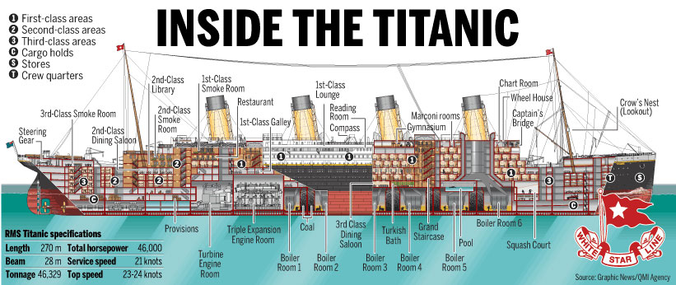

Name: __________________________________________________________________
LO: To find and retrieve information
- Why do you think ‘unsinkable’ is in inverted commas?
- What is the purpose of the first paragraph in this information text?
- How much did The Titanic cost to build?
- How many functional funnels did the Titanic have?
- How long did the Titanic measure in metres?
- How much would a first-class ticket cost in 2016?
- Name three things you could do while aboard The Titanic:
- How many crew members survived?
- How long should it have taken to get to New York?
- What was the maximum speed of The Titanic (in knots):
- How many compartments flooded?
- How many people could lifeboats carry?
- When was The Titanic rediscovered?

- Why is “that were then used incorrectly” in brackets in the final paragraph?
- Why do you think the information text ends on ‘What remains of The Titanic?’
- Give two ways The Captain could have avoided a crash:
- Define the word compounded
- Define the word voyage
- Explain why The Titanic sank

