L.I. I can spell words with silent letters.

A silent letter is a letter that you don’t hear when you say a word.
E.g.

Muscle Know Doubt ‘c’, ‘k’ and ‘b’ are silent.

Task 1:
Write these words in your book and circle the silent letters in each word:

should exhaust womb debut solemn whine gnarled hour listen knock
guess wreckage ghastly wrinkled scene design benign rhythm knickers castle

Task 2:
Sort the following words into the correct group in the table below:

guess fascinated ascend honest guitar rhinoceros muscle guard vehicle ghost school conscious science

Silent U | Silent H | Silent C
guess  guard  guitar | ghost  rhinoceros  school  honest  vehicle | fascinated  muscle  ascend  conscious  science
Task 3:
Write these sentences in your book and write the correct spelling instead of the picture.
- Eric used the to cut out pictures of 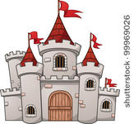 for his scrapbook.
scissors castle
- The 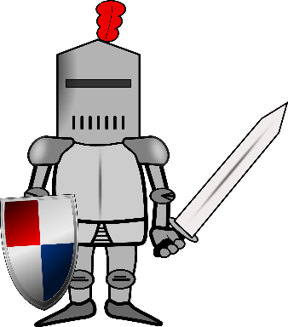fell off his horse and twisted his 
knight wrist
- 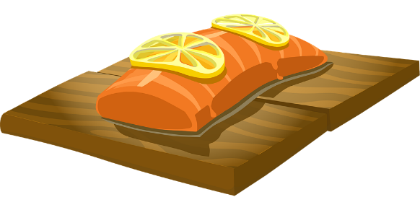is my favourite type of fish but it isn’t 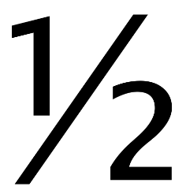 as good as cod. salmon half

- To 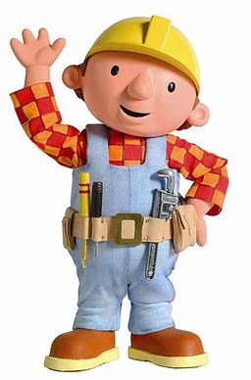strong you need to do lots of exercise.
This Photo by Unknown Author is licensed under CC BY-ND
build muscles
- I don’t  what you’re talking about.
know

Task 4:
Read these clues and spell the word that contains the silent letter.

- The season American people call ‘fall’. Autumn
- What you use to write on a blackboard. chalk
- Something your grandma likes to do with a needle and wool. knit
- You have 8 fingers and 2 …………? thumbs
- Poems have lots of …………words. rhyming

Task 5:
Use the letters to unscramble the words and spell a word with a silent letter in them.

- owh how
- ordpucba cupboard
- btsule subtle

