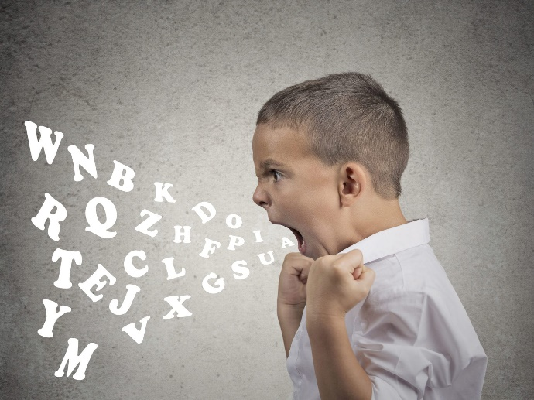
MANAGING
BEHAVIOURS
AT
HOME


IMMEDIATE feedback must be given for wanted and unwanted behaviours.
If your child does something good tell them immediately and implement the reward; don’t wait until dinner time. Equally, if a child does something less desirable tell them immediately and implement the consequence.
REWARDS AND CONSEQUENCES

Include your child in the process for defining House Rules; ask their opinion, help them negotiate rewards and consequences.
Let them make it their own by designing and colouring the sheet that will be displayed for all the family to see.
ESTABLISH HOUSE RULES

FEEDBACK

ROUTINE cont.

ROUTINE

CONSISTENCY

Every time your child behaves in a positive or negative manner you must consistently respond, having the same reaction every time.
If you become persistent in your reactions you are more likely to see change, however change won’t happen overnight it may take weeks, possibly even months.

Constantly assure and give your child feedback.
If you are leaving them to complete a task on their own check in with them every 20-30 mins praising wanted behaviour. Always follow through with consequences for unwanted behaviour and help them identify what went wrong.

Help your child understand when a task/activity is coming to an end by giving them:
Verbal warnings: e.g., 15 mins left of art, 10 mins left of art, 5 mins left of art, finish up
Visual warnings: traffic light system, present green circle showing 10 mins left, amber 5mins, red finish up.

Just like the rule making, involve your child in making a check list/timetable for the day/week using their own words/handwriting; for very young children using pictures/cartoons may be more helpful.
When the adult asks the child what’s next on your list, it gives them ownership and likely to trigger a better response than being told what to do next.
Get to know your child and adapt sessions to 20 min slots if necessary, spending more time on the ones they enjoy. If your child is particularly energetic give sometime between lessons to burn off steam, race around the garden or cycle to the top of the street and back. For those children who may be less energetic 10 mins on an iPad or game with a countdown timer making them aware of boundaries. Also try to split
Routine is probably the single most important factor. Children need routine to help them feel grounded, in control and emotionally balanced.
At home Mon-Fri try to make things as school like as possible; establish a timetable. If your child has trouble concentrating don’t expect that they will be able to do maths work for two hours.
COUNTDOWN

CHECK LIST/TIMETABLE

THINK AHEAD

LOVE REWARDS

Focus and praise more the behaviours you want to see rather than ‘nit-pick’ with the negatives. Where it is appropriate ignore the negative behaviours and put more emphasis on the positive behaviours.
When you tell your child that they’ve made you feel good because they care about you, it’s worth more to them than £1 to go to the shop or extra game time.
POSITIVITY

Physical rewards along with consequences can be incorporated into the establishment of rules as previously mentioned.
However, often more effective rewards are ‘love rewards’, when an adult rewards a child by telling them how proud they are of what they have achieved, or how much they have helped the adult etc

You know the scenarios where your child is most likely to misbehave or act out so make a plan for when this occurs and follow through.
Sharing the plan with your child may also be effective as they then become aware of the consequence before they make the choice to misbehave.


REWARDS AND CONSEQUENCES

POINTS TO CONSIDER:

- Rewards and Consequences should always be made clear so that the child can make an informed decision. It is unfair for something that was not previously discussed or agreed upon to be introduced after the matter, a bit like changing the rules halfway through a game. In adult terms, if a manager was to tell an employee to take the day off, have a lie in, go shopping and enjoy a nice meal however decided not to pay them for it at the end of the month, it becomes unfair; as the employee didn’t make an informed choice in the first instance and would probably have made a different choice if they had of known they were going to lose a day’s pay.

- Every single behaviour does not need to be rewarded; it may need a ‘work up’ system. You might agree with your child that in order to receive a new online game they should achieve X number of ticks/stars in that area.

- When initially establishing a rewards/consequence agreement you should put in place achievable goals for your child, if you set out with expectations of seven ticks ( a full week) of no bad language then you are setting them up to fail and therefore the chart becomes ineffective as the child feels its unachievable. Start small and build expectations by reviewing on a weekly/fortnightly basis.

IDEAS
REWARDS | CONSEQUENCES
> 15 mins on favourite game | > Load/Empty dishwasher
> 50p for money box | > Empty all the bins
> Sweet treat for a snack | > 15 mins less time for game
> Facetime with friend | > Bed 30 mins early
> Pick a family boardgame | > No sweet treat for snack
> 15mins 1-1 time with adult | > Tidy the cloakroom

LOVE REWARDS

TOP TIPS
- When you feel good about your child, TELL THEM!

- Praise more than you criticise; try to praise your child six times for every time you point out a negative.

- Praise little changes and successes; don’t get caught up on the big stuff.

- Embrace their differences; don’t expect your children to be good at the same things; help them become proud and confident of their achievements.

- Praise effort as well as achievement.

PRAISE FOR EFFORT
Praise effort as well as achievement it’s important to acknowledge that you see your child is trying.
Children who are less confident will need more praise than others.
When they see that their effort is praised just as much, if not more than their achievements they are likely to try harder.


CHANGING BEHAVIOUR
Children will more likely repeat behaviours which they have been praised for as they like the feeling that comes from it.
Look out for the behaviours you want to see, when you see it, praise it. Be descriptive about what you liked; “I like the way you spoke softly to your sister even though you were mad at her”.

