Timetable
Well done you have made it to week 6 of lockdown! There will have been some good days and some tough days and one day may merge with another! You may have started to find yourself in a natural pattern but don’t panic if not. I have listed below a few suggestions on structuring a day. In any class in the school the children can see a timetable. This helps them to know the order of the day and what is expected from them.
Home is a very different environment but often structure and routine can help everyone. There are lots of different ways to approach this. Here are a few tips and suggestions.
- Decide how detailed you would like to be:
You can have one for the whole week or do it one day at a time.
You can be specific with the times or simply aim for morning and afternoon. Allow flexibility, if an activity is going well you don’t have to change just because it is meant to be ‘snack time’
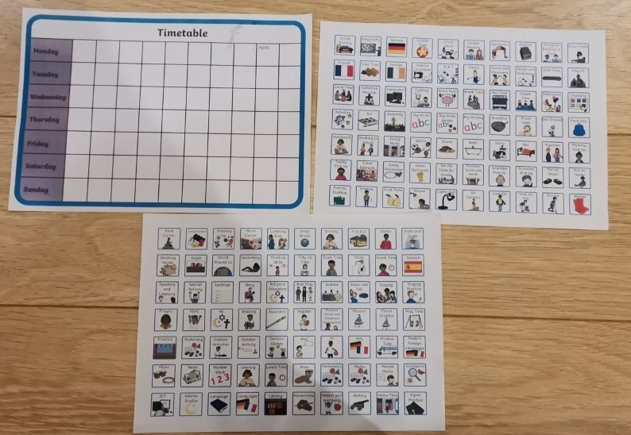

- Try to involve the child in making the routine, help give them a sense of ownership to their day and you may find they are more compliant. This doesn’t mean endless TV time! It could be you offer a choice e.g. before lunch or mid- afternoon. TV can be a tool but you decide how long. If they know that TV time is roughly the same each day then they know when it is coming. You might have noticed certain things work better than others e.g. more structured work in the morning, creative activities/exercise in the afternoon.

- Look at examples; you can download and print or do a DIY version. E.g. use post its – when the task is done you can just peel off. Pictures or colour coding may help for to make it clearer.

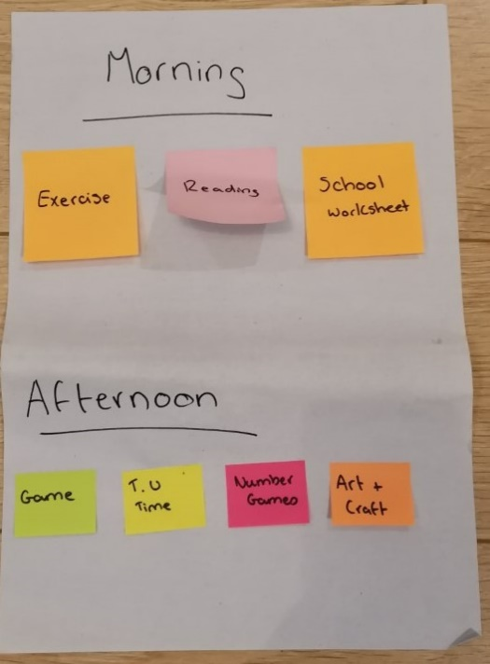
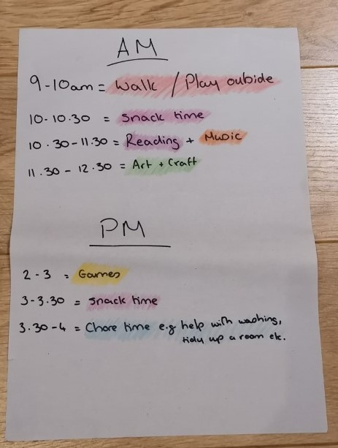

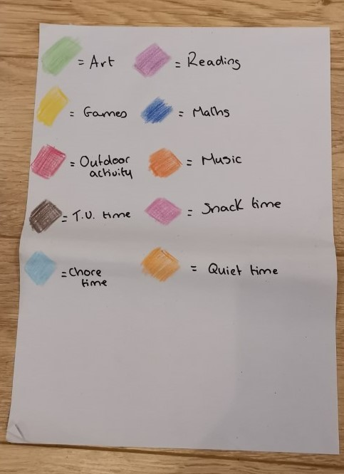

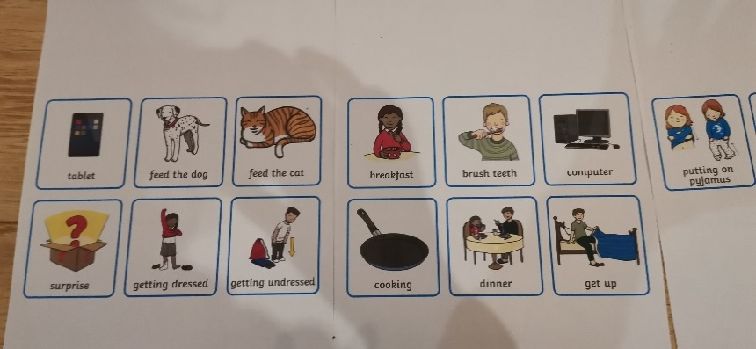

- Plan a ‘quiet time’ for everyone – we don’t usually have this much time together and there will be times web all need space. Young children often have a nap in the middle of the day to recharge. Big kids and adults may not need the sleep but a recharge time is useful. This could be time to read a book, do a puzzle, colouring in but should be activities that everyone can do relatively well independently. If kids are not used to this start small. Set a timer for 10 mins and aim to increase it gradually. Remember ‘it’s OK for children to be bored! This is good for developing imagination and creativity’. Note parents need the quiet time to so use this time to do something for you!

- Finally, we accept that these are very unique circumstances, don’t panic if things don’t go according to plan. If the day starts going pear shaped and everyone is getting frustrate/upset/angry take a break. Do something fun /relaxing. We are all learning at this time. If you need any help or assistance please do not hesitate to ask. Rhowe534@c2kni.net

For more Ideas:
- www.twinkl.co.uk
- Pinterest
- NI4Kids – Facebook or Instagram page, www.ni4kids.com
- www.busytoddler.com
- www.theimaginationtree.com

