
Family Support Newsletter- Autumn 2020
Welcome Back! There is no denying 2020 has been a very strange year – I still find it hard to believe we are into Autumn. The last 6 months have been challenging for us all in different ways. Hopefully we are moving towards some sort of normality as schools resume and I wanted to take this time to offer some support for the year ahead.
Community Support
Despite the pandemic there is still a wealth of support available in the community to assist with issues such as bereavement, counselling, behaviour support, financial assistance etc. Many of these services are done remotely at present but many organisations are hoping to resume face to face contact soon with relevant safety measures in place. If you need any help please contact me.
Programmes/Workshops
I am hoping to run some face to face parent groups during the year however numbers will be limited to allow for social distancing. These will include:
Families Connect: A fun interactive programme designed by Save the Children promoting a positive learning environment outside the classroom. Aimed at children P1-3 and their parents.
Parent Talk: A General parenting programme discussing issues such as boundaries, challenging behaviour, listening skills, and promoting independence. Designed by Care for the Family.
Workshops: I can offer more tailored workshops depending on need – there is a family support survey available, please see link below (also available on school website and Facebook page).
https://www.surveymonkey.co.uk/r/7D2N8F2
Active opportunities: Treasure Trail walks/ Sustrans Led cycle etc. I have run these in the past and they are a great way to meet other parents and discover easy fun activities to do locally with children. These are open to all however we may need to restrict numbers due to social distancing.
Useful Resources
During lockdown we all had to learn new ways of working and there are a host of different support resources for you and your child that may help many routine challenges. Please look under home learning and follow the links for ‘Activity, Health and Wellbeing’ or ‘Parent Support Resources’. I will update this section regularly and can also email anything you feel would be of use. If you feel you would like any further clarification with resources, please get in touch.
Take 5
One impact of the Coronavirus Pandemic is that all of us have thought a lot more about health. In particular, you may have seen a lot of information in the media about mental health or emotional wellbeing. This is often overlooked by parents for themselves, as naturally a lot of our focus goes to children or other family members. The Take 5 Campaign are a series of simple steps that you can take on a regular basis to look after your own emotional health and wellbeing. If you would like more information, please go to

https://www.mindingyourhead.info/
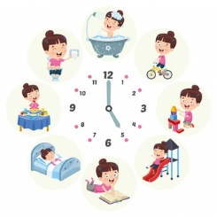
School to Home Routine
September is always a strange month as children get used new classes, new teachers, and possibly a new finishing time. It also takes time to adjust from the relatively relaxed routine of summer holidays to the structure of the school day.
This year however may take even more adjusting due to such a prolonged time at home. Initially there will be no homework or after school clubs so you may want to take this time to work out a new ‘home routine’ that works for you and your family. A good routine can help with any behaviour challenges as it provides a natural sense of security and predictability in a very unusual time.
A few ideas:
Connect: BIG HUGS NEEDED! Your child won’t have had the same physical interaction with their peers as they were used to so they need that physical interaction from home. Hugs, cuddles or whatever way you usually reconnect will be so important!
Be Active: Although they will still have PE and time in the playground, some games from before aren’t going to be possible e.g. tag. Please try to find an alternative way at home to incorporate a bit of activity – walk to the park, go for a bike ride, do a home obstacle course – the choice is endless – if possible please join in!
https://www.safefood.net/start/active-play-and-games-ideas
Relaxation /Creative Outlet: It is natural for us all to have some anxieties as we start back and there are many different ways to manage this. Colouring books/reading/breathing exercises etc. are just a few of the ways that can help. There are lots of creative ideas in the home learning section of the school website. Look under the Art, Activity, health and wellbeing sections for inspiration.
https://www.victoriaparkprimaryschool.co.uk/art-design-ideas/
https://www.victoriaparkprimaryschool.co.uk/activity-health-well-being/
Quiet/Rest Time: Most children won’t need a nap during the day beyond age 4 but they may need some ‘quiet time’. This is a time to recharge and process some of what has happened so far that day. Often this is time to themselves somewhere in the house without too many distractions. Ideally away from a screen is good- colouring, listen to an audiobook/music, reading, do a jigsaw puzzle etc. 30 mins of something peaceful for any of us can be a great boost for the rest of the day.
Play Games together: Time to play and have fun is essential for us all at this time, it may give us time to talk without feeling too intense. It can give a sense of safety and security for those feeling anxious – there are lots of different options – card games, board games, made –up games etc. It doesn’t have to be long - 10 mins can be plenty in some cases, maybe save the monopoly marathon for a weekend!
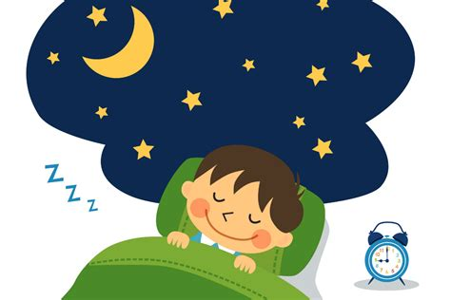
Sleep/Rest - Bedtime routine is so important and often one of the biggest ways to impact on your child’s anxiety levels along with overall health and wellbeing.
https://www.safefood.net/start/sleep

As a good rule of thumb children in primary school need between 9-11 hours sleep a night. If it is a constant struggle to get them up in the morning, then bring bedtime earlier!
Remember the sleep time is not the time they go to bed – the process of going to bed with bath/stories/supper etc. will probably start an hour earlier. Try to keep screens off for at least 45 minutes before you want them to sleep.
There may well be a few battles at home as you try to get the new routine established but please be consistent as it will be better for both you and your child in the long run.
If you are struggling with anything, don’t suffer in silence! Please ask for help.
Rhowe534@c2kni.net

02890 471274

