Home Timetable ideas
Home Learning begins again. Take a deep breath and give yourself a little planning time. We managed the 1st time and will do so again! Please see suggestions below. Speak to your teacher or myself if you are struggling – remember everyone is going through this together!
- Timing – 6 hours schooling in a class of 30 is not the same as working at home. You will probably find the work takes less time however there is the potential for other distractions. Set small chunks of time – aim for 20-30 minute stretches of work.
- Activities: Aim for 1 literacy,1 Numeracy and 1 World Around Us task each day. The time in between can be mixed with a range of other activities. If you have older children and younger could one read to the other? This can be a great confidence boost for the older child and may give you some space. Please see the arts and crafts section, health and wellbeing sections on the website for some other ideas.
https://www.victoriaparkprimaryschool.co.uk/art-design-ideas/
https://www.victoriaparkprimaryschool.co.uk/activity-health-well-being/

- Daily Schedule: Decide how detailed you would like to be: Each child may be different in what works – one may want to know lots of details, another might be more relaxed and will go with whatever is suggested.
- You can have one for the whole week or do it one day at a time.
- If you are also working from home, make this clear to kids, let them see your day and consider when is best to do certain activities. E.g. If they are going to need more help with a numeracy activity do this at a freer time and try to have the more independent activities e.g. craft/screen time/play. when you need to make phone calls. Thankfully as this has been the case before many employers have developed a range of flexible working practices, don’t be afraid to ask.
- You can be specific with the times or simply aim for morning and afternoon. Allow flexibility, if an activity is going well you don’t have to change just because it is meant to be ‘snack time’
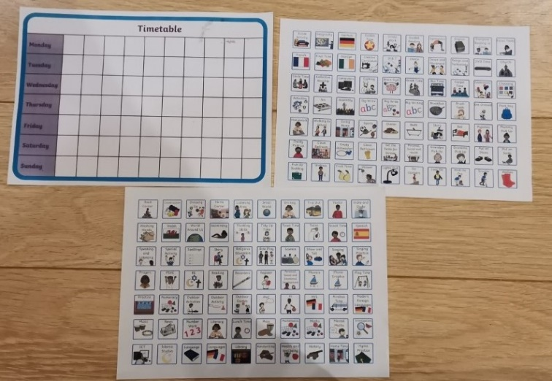
- More examples on our website https://www.victoriaparkprimaryschool.co.uk/support-resources-for-parents-and-visual-aids/

- Try to involve the child in making the routine, help give them a sense of ownership to their day and you may find they are more compliant. This doesn’t mean endless TV time! It could be you offer a choice e.g. maths 1st or literacy 1st. Screens can be a tool but you decide how long and the content. If they know that screen time is roughly the same time and length each day, often there are fewer arguments. You might have noticed certain things work better than others e.g. more structured work in the morning, creative activities/exercise in the afternoon.

- Look at examples, chat to other parents and see what works for them; you can download and print or do a DIY version. E.g. use post its – when the task is done you can just peel off. Pictures or colour coding may help for to make it clearer. What do you think will work for your child?
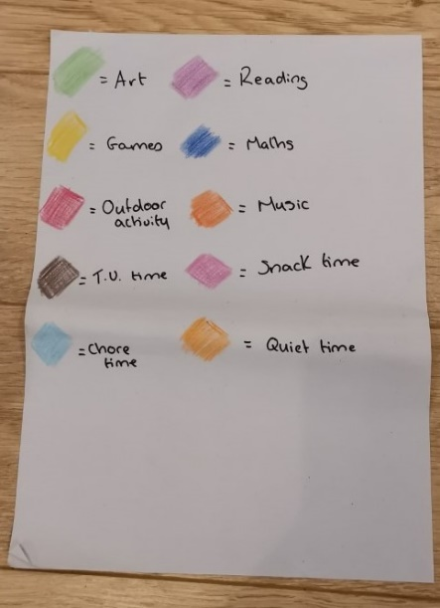
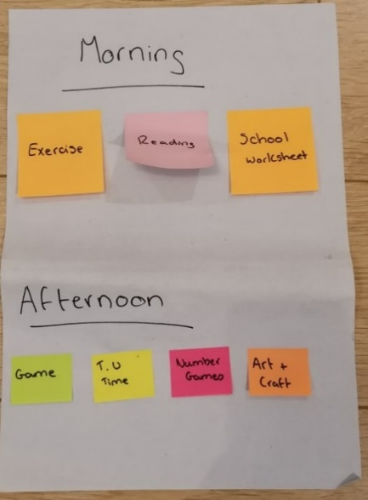
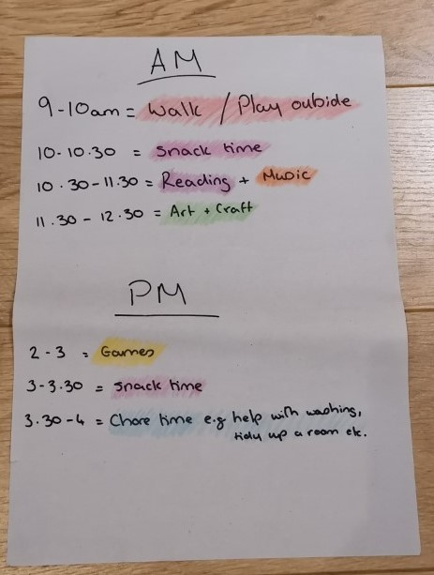

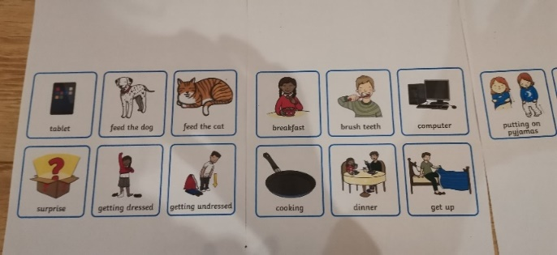

- Plan a ‘quiet time’ for everyone – we don’t usually have this much time together and there will be times we all need space. Young children often have a nap in the middle of the day to recharge. Big kids and adults may not need the sleep but a recharge time is useful. This could be time to read a book, do a puzzle, colouring in etc. but should be activities that everyone can do relatively well independently. If kids are not used to this start small. Set a timer for 10 mins and aim to increase it gradually. Remember ‘it’s OK for children to be bored! This is good for developing imagination and creativity. Note parents need the quiet time to so use this time to do something for you!

- Get Creative! Sometimes parents panic if they don’t do work exactly how it looks online but work with your child. If you have a very active child, then can you combine activity with maths for example? There were some great examples last time when I spoke to parents. Do spellings with play doh etc? If you are stuck on something, ask for help! There will be some things that you just have to do. Remember lots of positive encouragement can go a long way! We have a huge range of resources now at our disposal which were only being developed in March so you might find a different way of presenting something really helps.

- What did/didn’t work in March? We have all been through this before so you are better equipped than before (even if it doesn’t feel it). If everyone is quite sluggish in the morning, why not do something active – do your own daily mile/PE lesson/walk etc. If there are 2 of you in the house, then Tag team who does different activities.

- Bedtime/Wake up time: I know we aren’t as bound by school times now but routine helps everyone to cope so have a similar time for bed/getting up. So if bed time is usually 8:30 try to keep it this way during the week.

*If you do relax things be conscious as to how much. 30 mins later to bed or later getting up will be far less disruptive than bed at midnight and getting up at 10 am.

- Finally, we accept that these are very unique circumstances, don’t panic if things don’t go according to plan. If the day starts going pear shaped and everyone is getting frustrated/upset/angry take a break. Do something fun and relaxing. If the learning needs to be set aside one day, then pick it up the next day. These are not easy times. If you need any help or assistance, please do not hesitate to ask. Rhowe534@c2kni.net

Weekends

If you are able to take the time, why not create some fun ideas at the weekends. This may help the weeks pass by more positively. It may seem like a lot of the things we normally do are scaled back so how can you make the ordinary a bit special? If these are planned a little in advance, then they can be a nice way to mark the end of another week. Please see a few ideas below but the list is by no means exhaustive!

Ideas
Family Cinema Night:
- Everyone helps to clean/tidy the Cinema room space
- Make/sell ‘cinema tickets’
- Have a home popcorn/sweet station.
- All phones/tablets etc. put away or on silent just like you would at the cinema!

Restaurant Night
- Create a menu (even if it is a take away)
- Get dressed up
- Try something different
- Play some nice music – chat to each other!

Go to the Zoo/Farm/Safari
- Make tickets for entry
- Do you have any animal toys from young children still in the house? Could these be ‘hidden in a room/multiple rooms’
- Have a living room picnic, when all the animals are found etc.
- Go to a Zoo anywhere in the world – many started doing virtual visits during the March lockdown. Please see a few examples below. (If watching their live animal cams please be aware of time differences – a lot of American ones will only go live in the afternoon)
https://www.chesterzoo.org/
https://kids.sandiegozoo.org/animals
https://www.paigntonzoo.org.uk/
Bake Off Extravaganza!
I know it is January and we may want to scale back from all the Christmas indulgence but these are unusual times so if it works go for it!
- Each bake gets marks for presentation and taste – who will be the winner?
- Gingerbread shapes – I know Christmas has passed but these are a great option to do with kids, (We did many over the last year!) Get out any cookie cutters you have and enjoy making and decorating (note the dough usually freezes well so if you make a reasonable quantity you can repeat the activity). You could have prizes or certificates for different categories
- Turn it into a tea party – if you have young children invite the teddies etc. along!
Games Contests
These could be board games, minute to win it games, charades, treasure hunts, party games etc. Go big – it could be a marathon games weekend! Are there any games you have enjoyed playing as a child – can you teach your children now?
Giant Arts and Crafts
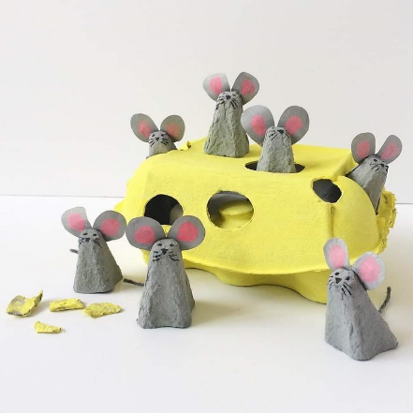
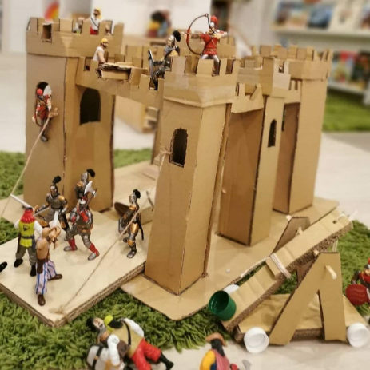
Do you have any large cardboard boxes/cardboard tubes (toilet roll/kitchen roll), milk cartons etc? Recycling can be a great source for creating your masterpieces. Please see a few examples below. (I can’t take the credit here, please see ‘Recyleandplay’ on social media. The possibilities are endless!) Children can be incredibly creative with very little. Get stuck in yourself – see what you can create together!
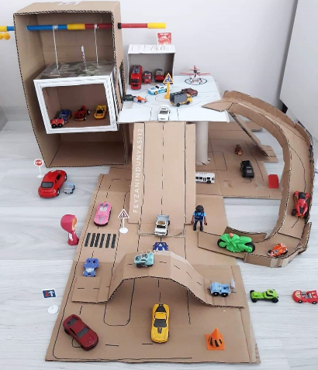



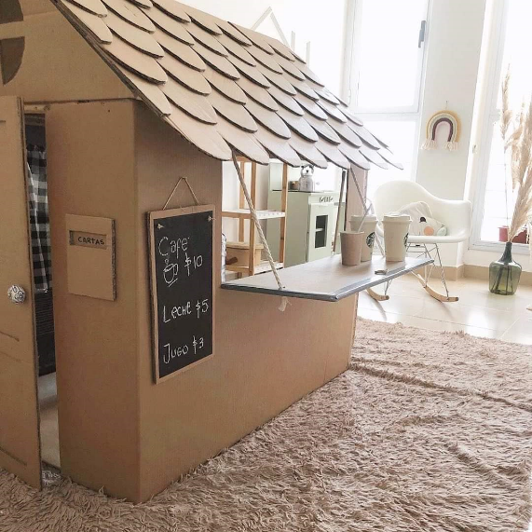

For more Ideas:
- www.twinkl.co.uk
- Pinterest
- NI4Kids – Facebook or Instagram page, www.ni4kids.com
- www.busytoddler.com
- www.theimaginationtree.com
- www.playhooray.co.uk

